Logistical Requirements and Field Plan

Number of fieldwork seasons | Four (2015-16, 2016-17, 2017-18, retro in 2018-19)
Deploying participants per season | 5-6 in 2015-16 and 4-5 in subsequent years
BFC/FSTP mountaineer | 1 requested per season (2-4 weeks)
Science Cargo: Weight of equipment N/B & S/B per season | 2000-3500 lb each way (highest in 2015-16 and retro in late 2018). COMSUR and Vessel, selected direct-shipped to CHC
Estimated AN8 fuel requirement | Eight 55 gal drums for science experiment  (3 seasons; typically cached via airdrop at AGAP-S)
Number of Twin Otter days | 5 in 2015-16, 4 per season in subsequent years
Number of days in the deep field | 4-6 per season typical
Site Name and Location | Ridge A: 81:40:25 S, 72:42:55 E (4040 m elevation)  AMIGOS: 81:54:47 S, 73:12:14 E (3999 m elevation)  Distance from South Pole: 500 nautical miles
Number of days at South Pole | 7-14 per season (acclimitization and testing)
Number of days at McMurdo | 7-14 per season (field camp checkout/training, camp closeout)
Communications requirement | 3 active Iridium SIM cards for data downlink (SBD, direct-IP)  2 Iridium phones, 1 HF radio only during field deployment
Facility construction/alteration | None.
Table 1: Operational Requirements at a Glance

Annual servicing of the experiment requires the swapping of the HEAT telescope/receiver module, PLATO-R engines, refueling (8x55 gal drums, for mean power consumption of 500W) and system-level testing. The servicing is typically carried out by 4 grantees at Ridge A in combination with one BFC/FSTP mountaineer. By swapping entire modules versus implementing field repairs, the time spent in the deep field is minimized: 4 days per deployment is requested based on previous servicings in 2013-14. In 2015-16, the one-time additional installation of AWS and AMIGOS-II monitoring equipment at Ridge A and a neighboring “cold sink” site 26 km away is requested in collaboration with Ted Scambos' team at NSIDC. Close support via Twin Otter with 3 hours ground time is requested at the AMIGOS cold site.

A typical deployment might be scheduled as follows:
- Science cargo shipped from Point of Origin to Port Hueneme (October 1)
- Point of Origin to Christchurch to McMurdo (10-14 December)
- Berg Field Camp checkout and Training (15-21 December)
- Arrival at South Pole, Acclimitization and testing (23 December – 2 January)
- Deep field deployment to Ridge A (3-8 January)
- South Pole: Science Cargo retrograde (9-11 January)
- McMurdo return, camp closeout (12-18 January)
- McMurdo to Christchurch to PoO (19-22 January)

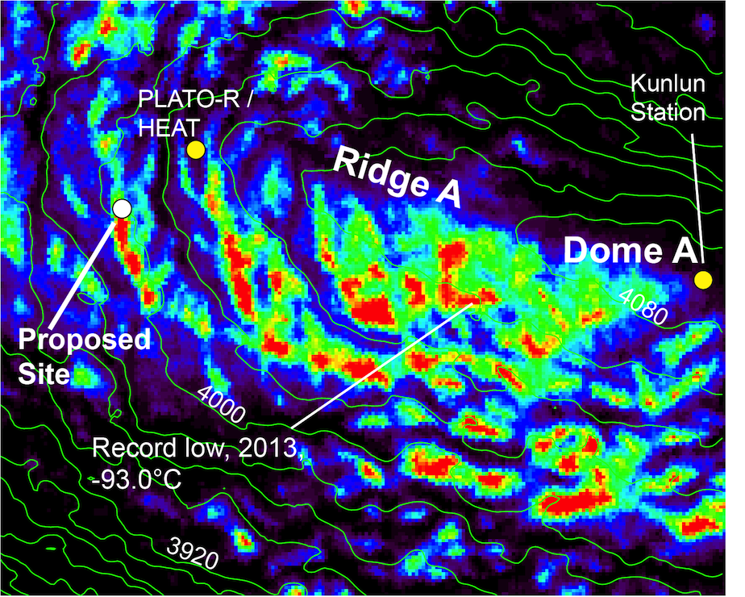
Figure 1: Close up of the proposed AMIGOS “cold sink” site in relation to the HEAT and PLATO-R installation and Dome A. The color scale represents the increasing occurrence rate of surface temperatures below -88C as determined by Land Surface Temperatures from the MODIS instruments on board NASA's Terra and Aqua satellites. Image courtesy of Ted Scambos.

