Priscilla,

Thank you for again conversing with me about this possible application.

It appears that we have settled on a 20’ diameter dome.

To recap our earlier conversation:
The dome, with a 24” sq access door, complete with drive hardware already installed (but no control software), and will consist of a base ring and four 94) shutters. The current cost is $54,445
Current crating cost is $2345
The complete dome (broken down) will fit into two shipping crates, each crate weighing 1,800 pounds and both crates will fit into a single 40 foot shipping container
The cost to ship the dome to Ohio had not been confirmed but for the sake of our estimate we will use $5,000 (the rental cost of the container as well as transportation, fuel surcharges & delivery)
As a worse case I will assume an assembled weight of 3,600 pounds for the dome.
The dome will remain fixed on the site and will not require rotation
We are estimating that the shutter will require two (2) motors to drive them and that the motors are 0.5 horsepower each
Typical (conservative) site assembly time is four (4) people two (2) days or 64 hours total and will require a crane on site in order to erect the dome
You require 50% down at time of order with the balance due at time of shipment
Fabrication time is approximately twelve (12) weeks but this may vary depending on current order/build schedules

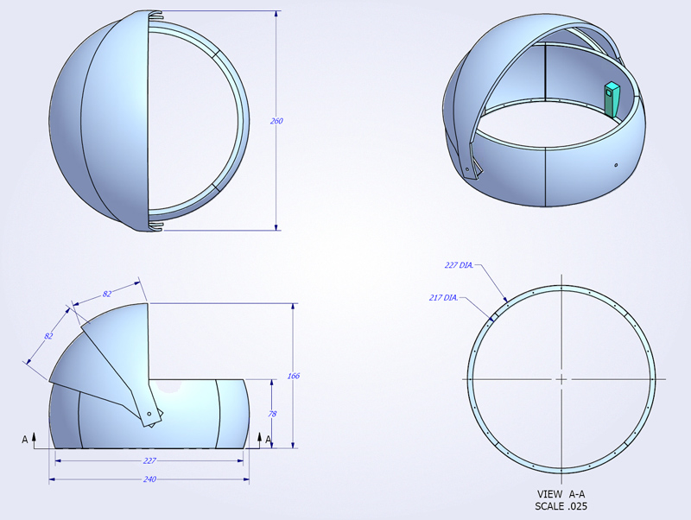
I have attached the sketch that is available from your website with a request that you research if a .dwg or .dxf AutoCAD file is available from your design group to be sent to us for our layout & planning efforts.

Thank you for your cooperation.

Regards,
Michael (Mike) P. Lytle
Sr. Specialist
Facility Planning Department

Middough Inc.
The Middough Building
1901 East 13th Street
Cleveland, Ohio 44114

Phone: 216.367.6141
Fax: 216.367.6020

www.midddough.com

The following is a recent conversation with Astro Haven:

From: Priscilla Brotherston [mailto:domesales@astrohaven.com]
Sent: Tuesday, June 30, 2009 11:39 AM
To: Lytle, Michael P
Subject: RE: 20' dome information verification & request

Hi Mike,

The shutters are also about 78 inches and they rig with about 1.5 inches of overlap so the high point would be approximately 81-82 inches tapering down to the 78 inches very quickly.

Good luck! I hope it works for you. Feel free to contact us if other questions come up.

Mike if you can keep me in touch, let me know how it goes. We hope to provide you with one of our beautiful 20 ft.

Regards,
Priscilla

