To: NSF MRI Coordinator

By signing below I acknowledge that I am listed as a collaborator on this MRI proposal, entitled “MRI-R2: Development of the Atacama Sub-millimeter Telescope Robotic Observatory (ASTRO)”, with Christopher L. Martin as the Principal Investigator. I agree to perform the tasks assigned to me, as described in the proposal, and I commit to provide or make available the resources therein designated to me.

Signed:

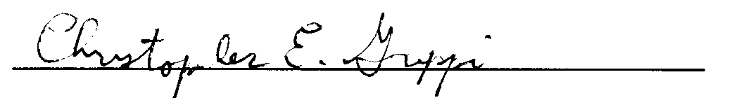

Christopher E. Groppi
August 5, 2009
Arizona State University

