To: NSF MRI Coordinator,

By signing below I acknowledge that I am listed as a collaborator on this MRI proposal entitled “MRI-R2: Development of the Atacama Submillimeter Telescope Robotic Observatory (ASTRO)” with Christopher L. Martin as the Principal Investigator. I agree to perform the tasks assigned to me, as described in the proposal, and I commit to provide or make available the resources therein designated to me.

Research Professor Arthur W. Lichtenberger
Director of the University of Virginia
Microfabrication Laboratories

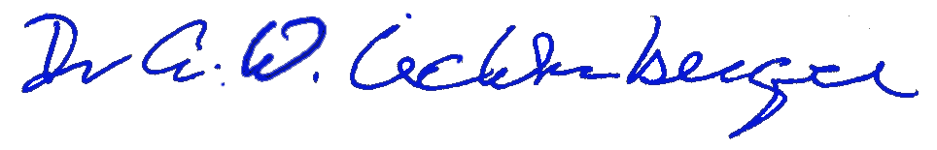
Signed:

July 19, 2009 University of Virginia
Department of Electrical & Computer Engineering
Charlottesville Virginia, 22904

