SwRI® Proposal 15-68081C

May 2014

***A Technical Proposal for***

**A 10M INFLATABLE LARGE BALLOON REFLECTOR (LBR)**

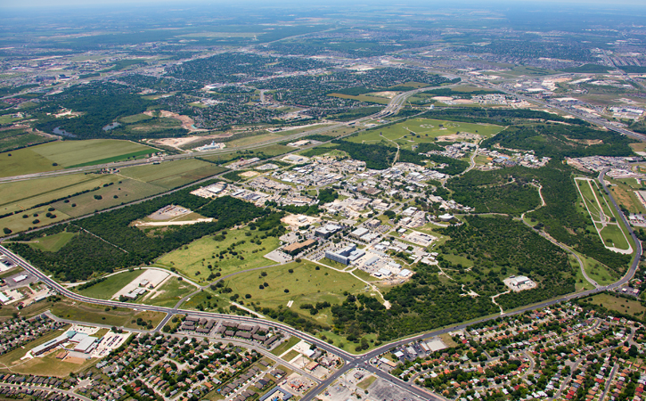

**Prepared for: In Collaboration with:**

**NASA University of Arizona**

**John Falker, PhD Dr. Christopher Walker**

**Space Technology Mission Directorate**

**Prepared by:**

**Southwest Research Institute®**

**6220 Culebra Road**

**San Antonio, Texas 78238-5166**

**Technical Point of Contact: Administrative Point of Contact:**

**Mr. Ira Steve Smith Mr. Jeffrey Kirchhoff**

**6220 Culebra Road 6220 Culebra Road**

**P.O. Drawer 28510 P.O. Drawer 28510**

**San Antonio, Texas 78228-0510 San Antonio, Texas 78228-0510**

**Telephone: 210-522-3587 Telephone: 210-522-2605**

**Fax: 210-522-4521 Fax: 210-522-3559**

**Electronic mail:** [**ssmith@swri.org**](mailto:ssmith@swri.org) **Electronic mail:** [**jeffrey.kirchhoff@swri.org**](mailto:jeffrey.kirchhoff@swri.org)

|  |
| --- |
| ***SwRI Proprietary Information****: This proposal includes data that shall not be disclosed outside the Government and shall not be duplicated, used, or disclosed--in whole or in part--for any purpose other than to evaluate this proposal. However, if a contract is awarded to this offeror as a result of--or in connection with--the submission of these data, the Government shall have the right to duplicate, use, or disclose the data to the extent provided in the resulting contract.* |

Approved by:

This data package contains technical data that is controlled by the International Traffic in Arms Regulations (22 CFR 120-130) and may not be provided, disclosed, or transferred in any manner to any person, whether in the U.S. or abroad, which is not 1) a citizen of the United States, 2) a lawful permanent resident of the United States, or 3) a protected individual as defined by 8 USC 1324b(a)(3), without the written permission of the United States Department of State.



__________________________________

James L. Burch, Vice President

Space Science and Engineering

** Southwest Research Institute®**

6220 Culebra Road • P.O. Drawer 28510 • San Antonio, Texas, USA 78228-0510 • (210) 684-5111 • TELEX 244846

**Project Summary**

This is a collaborative Co-I Institution proposal in support of the main proposal “10 meter Sub-Orbital Large Balloon Reflector (LBR)” being submitted by the University of Arizona with Christopher K. Walker as PI. We propose to develop and demonstrate the technology required to realize a suborbital, 10 meter class telescope suitable for operation from radio to THz frequencies. The telescope consists of an inflatable, half-aluminized spherical reflector deployed within a much larger carrier stratospheric balloon. Besides serving as a launch vehicle, the carrier balloon provides a stable mount for the enclosed telescope. Looking up, the LBR will serve as a telescope. Looking down, the LBR can be used for remote sensing or telecommunication activities. By combining successful suborbital balloon and ground-based telescope technologies, the dream of a 10 meter class telescope free of >95% of the Earth’s atmospheric absorption in the far-infrared can be realized. The same telescope can also be used to perform sensitive, high spectral and spatial resolution limb sounding studies of the Earth’s atmosphere in greenhouse gases and serve as a high flying hub for any number of telecommunications and surveillance activities. LBR is a multi-institution effort between the University of Arizona (the PI institution), SWRI, JPL, and APL.

LBR was selected in 2013 by the NASA Innovative Advanced Concepts (NIAC) program to proceed into the NIAC Step I Phase B program. This makes LBR eligible to propose for a 2014 Phase II award. The goal of our NIAC Phase II effort is to bring the new proposed concepts to a Technology Readiness Level of at least 2 in maturity, by addressing key unknowns, assumptions, risks, and paths forward remaining after the Phase I completion.

**TABLE OF CONTENTS**

Project Summary ii

1. Large Balloon Reflector (LBR) Design 1

1.1 Materials and Structure 1

1.2 Fabrication Methods 3

1.3 Gore Method 3

1.4 Polyhedron (Soccer Ball) 3

2. THREE Dimensional Fabrication (Sails) 4

3. LBR Deployment and Pressure Management 4

4. Tasks 5

5. Deliverables 6

6. PERIOD OF PERFORMANCE 6

7. References 6

lisT OF FIGURES

Figure 1. LBR Sphere Configuration 6

Figure 2. Typical "gore" pattern sections used in most scientific balloons 7

Figure 3. Example of a Goldberg Polyhedron 7

Figure 4. North Sail 3 Dimensional (3DL®) Fabrication Technology 8

Attachment 1: Detailed Cost

# Large Balloon Reflector (LBR) Design

## Materials and Structure

There are several materials that can be used for the fabrication of the LBR sphere. There are four (4) major factors which affect the surface figure of the LBR sphere: 1) differential pressure and therefore skin stress, 2) thermal loading, 3) any localized stiffening due to reinforcements or seams and 4) gravitational effects distorting the spherical shape. These effects encourages the use of relatively stiff (Young’s modulas) materials with balanced mechanical properties. Potential homogenous materials include such films as Nylon®, Mylar®, LaRC-CP1® Polyimide or tailored to adjust for these effects by the use of scrims or weaves mechanically bonded to a base film to tailor the mechanical stiffness orientation. This is exemplified by the NASA DP6611-0.25-0.25. This composite has been use for super-pressure balloons and stratospheric airships The LBR requires a conductive surface therefore metallization of one hemisphere is required. The metallization of Mylar® and other materials has been successfully accomplished for decades as demonstrated by the ECHO satellites as well as other long duration scientific super-pressure balloons such as the GHOST and CARRIER balloon flights conducted by NCAR in the 1960s and 1970s.

Fortunately the Antarctica flight environment is a fairly benign balloon environment. During the launch and flight windows for scientific balloon flights from McMurdo Station, the balloon is exposed to constant daylight, although at a low elevation angle. The surface albedo also increases the heat load and can vary between ~0.5-~0.8. The LBR thermal balance will end up being a subset of what the carrier balloon is seeing but attenuated. In Phase I, a very cursory thermal analysis was performed for determining the effect on sphere strain. A more detailed analysis will be performed with Thermal DeskTop® in Phase II to better predict the total, transient and localized heat loads on the LBR, especially the effect of the metalized hemisphere. Preliminary calculations were performed under Phase I to determine deformations due to skin stress (ie dP) as well as thermal deviations. In the case of Tables I & II, the numbers are based on the room temperature properties of Mylar®. This should be the worst case condition since the lowest strength and modulas occur at the warmer temperatures and should provide a conservative estimate for the deformations of the LBR. In reality the film temperature should be lower and as such, have higher stiffness, therefore lower deformations and thermal contractions.

|  |  |  |  |  |  |
| --- | --- | --- | --- | --- | --- |
| **Table I:** Change in LBR radius as a function of deviation in stress level | | | | | |
| **Change in Stress: psi** | **10000** | **8000** | **6000** | **4000** | **2000** |
| E (Modulas-RT): psi | 700000 | 700000 | 700000 | 700000 | 700000 |
| **Change in Radius (cm)** | **14.3** | **11.4** | **8.6** | **5.7** | **2.9** |

|  |  |
| --- | --- |
| **Table II:** Contraction in radius due to cooling | |
| **Change in Temp.** | **Change in Radius (cm)** |
| -10.0 | -0.18 |
| -20.0 | -0.36 |
| -30.0 | -0.55 |
| -40.0 | -0.73 |
| -50.0 | -0.91 |
| -60.0 | -1.09 |
| -70.0 | -1.27 |
| -80.0 | -1.45 |
| -90.0 | -1.64 |

The LBR sphere is made of two hemispherical hull sections (Figure 1), one that is transparent and one that is metalized to be reflective to the THZ signal. The distortion due the gravitational effects and the rotation in the elevation control of the LBR are minimized by the use of the 3 planes of the internal curtains. The internal curtains provide additional radial stiffening in the 3 axes in addition to the mountings for the receiver hardware. However, it will provide some localized stiffening due to their attachment to the skin. A cursory assessment was performed under Phase I (Chodimella, 2006; Thomas, 1984) but a more detailed thermal and finite element analysis will be performed in Phase II to quantify distortions due to the four (4) major factors that will influence the spherical LBR surface figure.

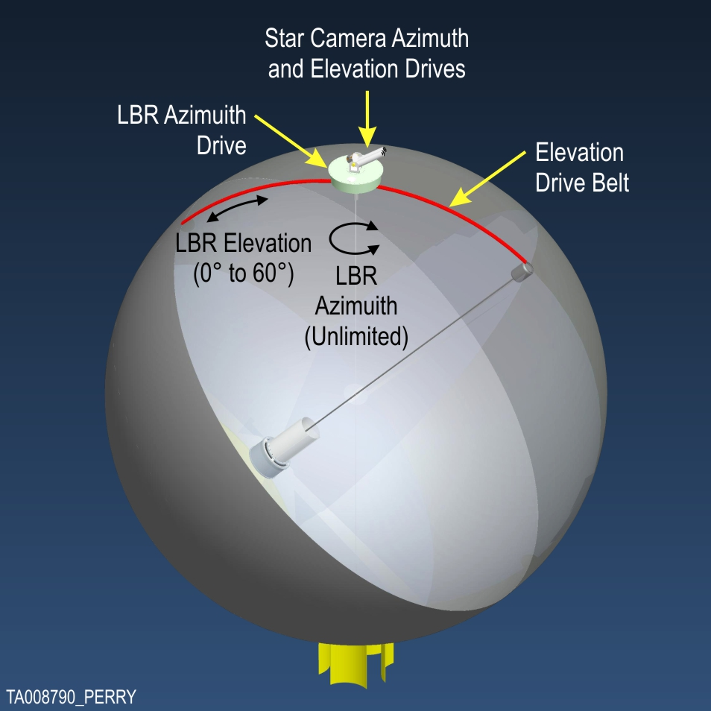

Figure . LBR Sphere Configuration

## Fabrication Methods

Many fabrication methods with a wide variety of materials have been investigated over the years. The ideal material would consist of a balanced film, where the mechanical properties are the same in all directions. Additionally, it would be preferable to have the antenna fabricated of a single 3 dimensional shaped membrane. The material would also have a coefficient of thermal expansion (CTE) equal to 0 such that it is stable under all temperatures. Unfortunately the real world does not cooperate that easily. Three identified methods of fabricating the sphere were preliminarily investigated under Phase I but will be investigated in greater detail under Phase II. One method will be chosen for the fabrication of the 10 m diameter test sphere.

## Gore Method

The first approach is the typical “gore” technique (Figure 2) (ie. banana peel) employed in the fabrication of large scientific balloons. The “gore” technique makes use of flat sheets of film cut into a pattern and then sealed together to create a 3 dimensional (3D) structure. For a small number of gore under low pressure the volume looks faceted. This then requires higher pressures to stretch or deform the material into the more spherical shape. If too few, it will exceed the structural limits of the material and fail, often catastrophically. This can be remedied by increasing the number of gores but this further creates an undesirable stiffening of the structure at the apex and nadir of the sphere due to converging seam tapes. The structure thus has a variable structural stiffness along its length which has to be accounted for in the structural analysis such that the final shape will be the desired spherical shape. More structural analysis and testing is required to define the influence on the LBR surface figure.

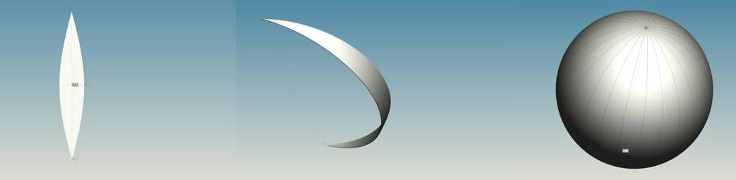

Figure . Typical "gore" pattern sections used in most scientific balloons

## Polyhedron (Soccer Ball)

Another method is similar to that employed in soccer balls where hexagonal and pentagonal sections are seamed together. This approach could provide more uniform loading over the “gore” approach but may be more costly to fabricate.

It is the [Goldberg polyhedron](http://en.wikipedia.org/wiki/Goldberg_polyhedron) (Figure 3.).  A Goldberg polyhedron is a convex [polyhedron](http://en.wikipedia.org/wiki/Polyhedron) made from hexagons and pentagons. [Geodesic domes](http://en.wikipedia.org/wiki/Geodesic_dome) and soccer balls are often based on this structure.



Figure . Example of a Goldberg Polyhedron

A sphere fabricated this way would offer a more uniform structural stiffness distribution. However, the fabrication of such a sphere may be more difficult from a production standpoint due to the size of the inflatable and possibly more costly. More structural analysis and fabrication investigation is required and will have to be conducted under Phase II.

# THREE Dimensional Fabrication (Sails)

The ideal way of fabricating the LBR would be to cast it in the correct spherical shape. Several methods were investigated such as blown extrusion, casting, etc. None of the approaches investigated appeared very feasible for our application based on complexity, required environmental controls and equipment availability. It was concluded that further pursuit of this approach would be fruitless or unaffordable if a method did exist. As such, we investigated other ways of obtaining a 3D shape rather than trying to deform plat panels into a 3D shape. A leader in 3D structures is the sail maker North Sails North America (Figure 4).

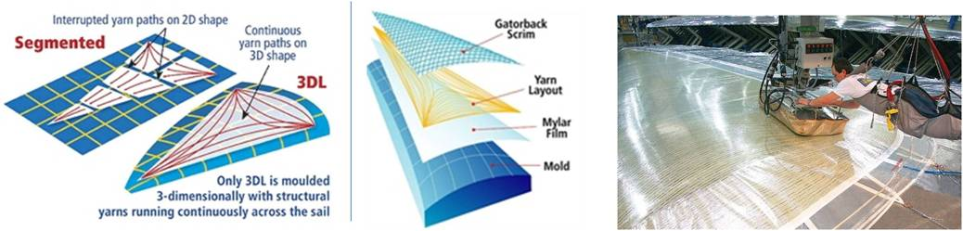

Figure . North Sail 3 Dimensional (3DL®) Fabrication Technology

Programmable molds are draped with Mylar film and then a computer-controlled system applies precisely tensioned yarn over the Mylar.  3DL® more efficiently utilizes each individual yarn because it is laid smooth and continuous - with no breaks or bending at seams - in the same shape that it is expected to take in its operating state. The molds can be adjusted to shape structures of widely varying cambers. Sewing or seaming is limited to the corners, edges or attachment points. This same process could be applied to the LBR fabrication. It uses many of the same materials that have been used in ballooning for decades. The process will have to be modified to minimize areal densities.

# LBR Deployment and Pressure Management

The packed LBR remains in this protective container during launch. During ascent the container, at approximately 60,000 when the carrier balloon volume has grown adequately (Smalley 1966), will be slowly lowered using an internal winch. Once the flaccid LBR is completely extended from the container, the blowers will pump helium from the carrier balloon in to the LBR sphere. The two blower assemblies will maintain the pressure at the selected differential pressure to provide the optimum shape and stability. The LBR hull and internal curtains will be made of very thin film and scrim that have been selected to almost completely transparent to the target signal.

Under Phase I we developed an operational plan for the LBR deployment. In Phase II we intend to build the LBR container and winch system and deploy the system several times in a large high bay building.

# Tasks

During Phase II, SwRI will design and have fabricated a ~10 m LBR sphere, perform ground structural testing and deployment testing. Tasks to be performed during this contract are listed below:

|  |  |
| --- | --- |
| 1 | **Project Management** |
| 2 | **Sphere Design** |
| 2.1 | Structural Analysis/Deformation |
| 2.2 | Thermal Analysis/Deformation |
| 2.3 | Dynamics Analysis |
| 2.4 | Deployment Bag |
| 2.5 | Manufacturing Specifications |
| 3 | **Fabrication** |
| 3.1 | Material Procurement |
| 3.2 | Sphere Fabrication |
| 3.3 | Deployment Bag Fabrication |
| 4 | **Ground Testing** |
| 4.1 | Test Plan Development |
| 4.2 | Fabrication of Mechanical Interfaces |
| 4.3 | Installation of Ancillary/Mock-up Hardware |
| 4.4 | Sphere Inflation |
| 4.5 | Mechanical & Electrical Testing |
| 5 | **Deployment/Dynamics Testing** |
| 5.1 | Sphere/Bag Installation |
| 5.2 | Deployment Tests |
| 5.3 | Modifications & Retesting |
| 6 | **University of Arizona Testing** |
| 6.1 | Ship To Test Site |
| 6.2 | Assist in Testing |

1.0 Management: Weekly telecoms with LBR Team Members. Monthly reports will be provided to the PI Chris Walker as well as a Final Report for reporting to NASA.

2.0 Sphere Design: Perform more detailed design and analyses to determine the structural response to differential pressure, gravitational, thermal and reinforced/stiffening loads and generation of fabrication specification.

3.0 Fabrication: Includes the procurement LBR sphere materials/ fabric, construction of the sphere and Quality Assurance

4.0 Ground Testing: Development of Test Plans, fabrication of ancillary test hardware, inflation of the sphere and initial structural performance testing.

5.0 Deployment/Dynamics Testing: The sphere will be installed in its deployment container and then multiple deployments of the system will be performed.

6.0 University of Arizona Testing: The LBR sphere will be shipped to the PI for instrument integration and ground testing with supporting SwRI test support

# Deliverables

The following Deliverables will be submitted to the PI for his reporting requirements:

1. Monthly Status Report
2. Midterm Review briefing package
3. Final Technical Report
4. Annual Key Enabling Technologies Report
5. NIAC Symposium briefing charts

# PERIOD OF PERFORMANCE

Twelve months from receipt of contract.

# References

Chodimella, Surya, et al., Design Evaluation of a Large Aperture Deployable Antenna, American Institute of Aeronautics and Astronautics, 2006

Thomas, M and Veal, G., Highly Accurate Inflatable Reflectors, AFRPL TR-84-021, 1984

Smalley NCAR-TN-25, “Balloon Shapes and Stresses Below the Design Altitude”, Dec. 1966

**ATTACHMENT 1**

**DETAILED COST PROPOSAL**