Reflight of the Stratospheric Terahertz Observatory: (STO-2)

An LDB Experiment to Investigate the Life Cycle of the Interstellar Medium

1 Executive Summary
The structure of the interstellar medium, the life cycle of interstellar clouds, and their relationship with star formation are processes crucial to deciphering the internal evolution of galaxies. High resolution spectral line imaging of key gas tracers not accessible from the ground is needed to fill in major missing pieces of Galactic structure and witness the formation and dissipation of interstellar clouds. The reflight of the Stratospheric Terahertz Observatory (STO-2), a balloon-borne 0.8-meter telescope with an 8-beam far-infrared heterodyne spectrometer, will address these issues and significantly advance NASA’s Strategic Goal of “discovering how the universe works” by exploring how structures in galaxies evolve and how global star formation proceeds.
In its long duration flight, STO-2 will survey part of the Galactic plane in [C II] line emission at 158 µm, the brightest spectral line in the Galaxy; and [N II] line emission at 205 µm, a tracer of the star formation rate. At ~1’ angular resolution and <1 km/s velocity resolution, STO-2 will detect every interstellar cloud with A_{V} ≥ 0.4 in the surveyed region (Figure 1), and, through excitation and kinematic diagnostics provided by [C II] and [N II] line emission, will study how atomic and molecular clouds are formed and dispersed in the Galaxy. STO-2 will make 3-dimensional maps of the structure, dynamics, turbulence, energy balance, and pressure of the Milky Way’s Interstellar Medium (ISM), as well as the star formation rate.
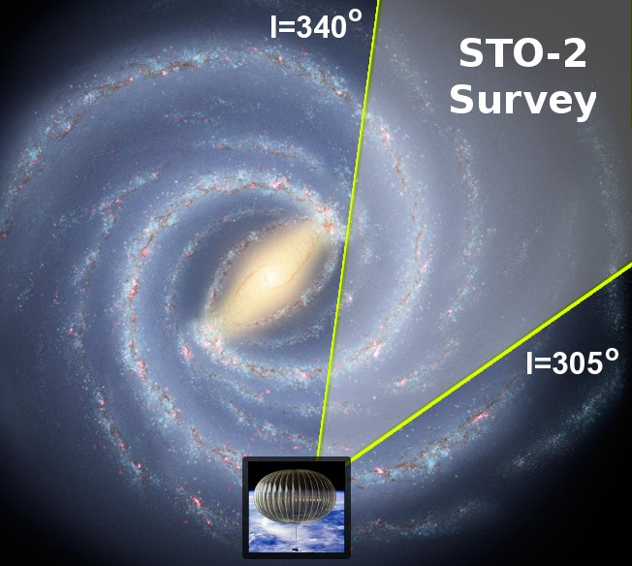
STO had its first science flight in January 2012. [CII], CO J=12-11, and [CI] observations began within ~12 hours of reaching float altitude. Several days into the flight a small vacuum leak developed in the instrument cryostat that caused the cryogenic [CII] and CO receivers to warm up prematurely. The efficacy of these observations was hindered by several technical issues (see Section 5.1). STO then entered its Warm Mission Phase, where it continued its observations using an uncooled 492 GHz [CI] receiver, until the end of its 14 day mission. With the recent return (24 February 2012) of the raw data from Antarctica reduction of STO-1 observations is now underway. Here we propose to re-fly STO with an upgraded, more robust cryogenic/receiver system that will allow THz observations to continue until stratospheric conditions or recovery constraints require terminating the mission.

1.1 Summary: Science Goals and Objectives
STO-2 will help provide a comprehensive understanding of the inner workings of our Galaxy by exploring the connection between star formation and the life cycle of interstellar clouds. We will study the formation of molecular clouds, the feedback of high mass star formation heating and disrupting clouds, and the effect of these processes upon the global structure and evolution of the Galaxy. The detailed understanding of star formation and evolution of stars and gas in the Galaxy is directly relevant to star formation in other galaxies. The nature of the feedback mechanism of massive star formation is pivotal to the evolution of galaxies. STO-2 thus addresses NASA’s goals and research objectives on galaxy evolution and star formation. STO-2 addresses the high priority goals:
Figure 1: Overview of the region to be surveyed by STO-2. This 35◦ longitudinal swath of the Galactic Plane reveals spiral and interarm regions of the Galactic ISM
  - Determine the life cycle of Galactic interstellar gas.
  - Study the creation and disruption of star-forming clouds in the Galaxy.
  - Determine the parameters that affect the star formation rate in a galaxy.
  - Provide templates for star formation and stellar/interstellar feedback in other galaxies.
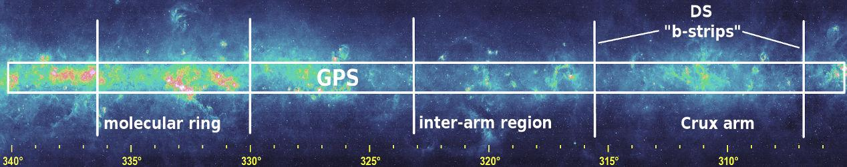
Figure 2: Midcourse Space Experiment (MSX) 8.3 µm map of the Galactic Plane from the Molecular Ring through the Scutum-Crux spiral arm. Annotations highlight regions to be explored by STO-2 in its Galactic Plane Survey (GPS).

- Summary: Mission Approach
To achieve these scientific goals, STO-2 will map the pivotal [C II] 158 µm and [N II] 205 µm lines. In particular, [C II] is extraordinarily versatile; it probes ionized gas (HII), atomic clouds (HI), and the photo-illuminated surfaces of molecular clouds. [C II] provides a unique measure of the interstellar medium that is not possible with HI or CO line emission alone: it directly distinguishes atomic clouds from diffuse intercloud HI gas (unlike HI which is not density sensitive), identifies “dark” molecular gas not associated with CO emission, and probes mass flows from CO cloud surfaces. Thus, in combination with CO, HI and [NII] observations, [C II] identifies and measures the formation and destruction of clouds in ways impossible with HI and CO maps. The [N II] line, in addition to providing an extinction-free probe of ionizing radiation and star formation rate in the Galaxy, can be used to isolate the fraction of [C II] line emission that comes from ionized gas, conclusively determining its origin and distribution.
To map the [C II] and [N II] lines over a large portion of the southern Galactic Plane, STO-2 will utilize two heterodyne receiver arrays to produce a total of eight beams in the focal plane, each with 1024 spectral channels. In the long duration (14-42 day) flight STO-2 will map a 35 square degree area including the Galactic molecular ring (Figures 1 & 2) as well as 5 deeper strips in Galactic latitude b=±2◦ in selected arm and interarm regions. STO-2 achieves 1 arcminute spatial resolution and 3σ intensity limits of 2.0×10⁻⁵ (t/1 sec)^{−1/2} and 8.0×10⁻⁶ (t/1 sec)^{−1/2} erg s⁻¹ cm⁻² sr⁻¹ in the [C II] and [N II] lines – sufficient to detect and resolve both spectrally and spatially all Giant Molecular Clouds (GMCs), all significant H II regions, and all cold neutral medium (CNM) clouds with A_{V} ≥ 0.4 mag (potential building blocks of GMCs) in the surveyed region. The STO-2 heterodyne receivers provide sub-km/s velocity resolution and sufficient bandwidth to detect and resolve line emission from all Galactic clouds along the line of sight. The deliverable data products include:

- A high fidelity database of spatially and velocity resolved far-infrared [C II] 158 µm and [N II] 205 µm fine-structure line emission in the Galaxy.
- A combination of STO-2’s data products with existing line and continuum surveys to characterize the structure and dynamics of interstellar clouds and their relation to star formation.

The data are produced in large scale (Galactic Plane Survey) and selective (Deep Survey) modes:
  - GPS: Galactic Plane Survey: 305◦ < l < 340◦; −0.5◦ < b < 0.5◦. The GPS contains more than 10⁵ spatial pixels and has 10⁴ times higher sensitivity than FIRAS/COBE when convolved to the same resolution. STO-2 will catalogue all neutral clouds with A_{V} ≥ 0.4 mag. and all ionized clouds with emission measure > 50 cm⁻⁶ pc.

  - DS: Deep Survey of arm and interarm regions defined by ancillary observations from AST/RO and Mopra telescopes: b = −2◦ to +2◦ strips at l = 315.97◦, 323.13◦, 330.00◦, 336.42◦ and 342.54◦, with Δl=0.05◦. Sensitivity will be 3-4 times higher than the Galactic Plane Survey.

1.3 Summary: Complementarity with Other Missions and Existing Data
STO-2 will provide the best interstellar cloud survey for enhancing the science return from the GLIMPSE and MIPSGAL Spitzer Legacy programs, the Herschel Infrared Galactic Plane Survey HIGAL, and H I and CO line surveys. STO-2 will enhance the interpretation of these data sets by providing essential observational links required to trace the cloud life cycle. Using Galactic rotation to place the clouds along the line of sight, STO-2’s high spectral resolution enables 3 dimensional maps of Galactic interstellar matter, from which many physical parameters in the Galaxy (e.g., pressure and star formation rate) can be extracted.
STO-2, being optimized for large-scale mapping of the weak extended emission of ISM clouds, complements the high angular resolution, but limited mapping capabilities of other far-IR platforms with heterodyne receivers. The larger Herschel Space Observatory (HSO) and the Stratospheric Observatory for Infrared Astronomy (SOFIA) have beam sizes of 12 to 15′′ at [CII], and mapping speeds that are 2-3 orders of magnitude slower than STO-2.
STO-2 builds on the technical lessons (see §5.1) and observational experience gained from the STO-1 flight. These observations are now in the process of being reduced. The experience gained in performing and analyzing these observations will serve as valuable stepping stones to the much more extensive [C II], [N II], and [CI] observations planned for STO-2.

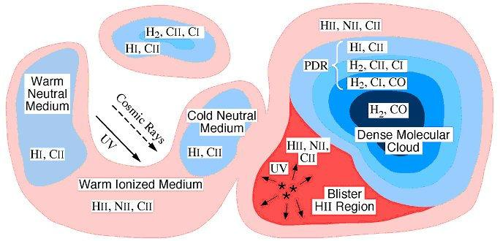
2 Science Goals & Objectives
Figure 3: Schematic representation of ISM com-ponents. STO-2 detects and maps in the Galaxy the higher column density CNM component, the H₂/C⁺ ”dark” component, the photodissociation region (PDR) surfaces of molecular clouds, the H II component, and (with H I) the WNM/CNM ratio.
2.1 Background
Via spatially and spectroscopically resolved [CII] and [NII] line emission, STO-2 probes the formative and disruptive stages in the life cycles of interstellar clouds. It reveals new insight into the relationship between interstellar clouds and the stars that form from them, a central component of galactic evolution.
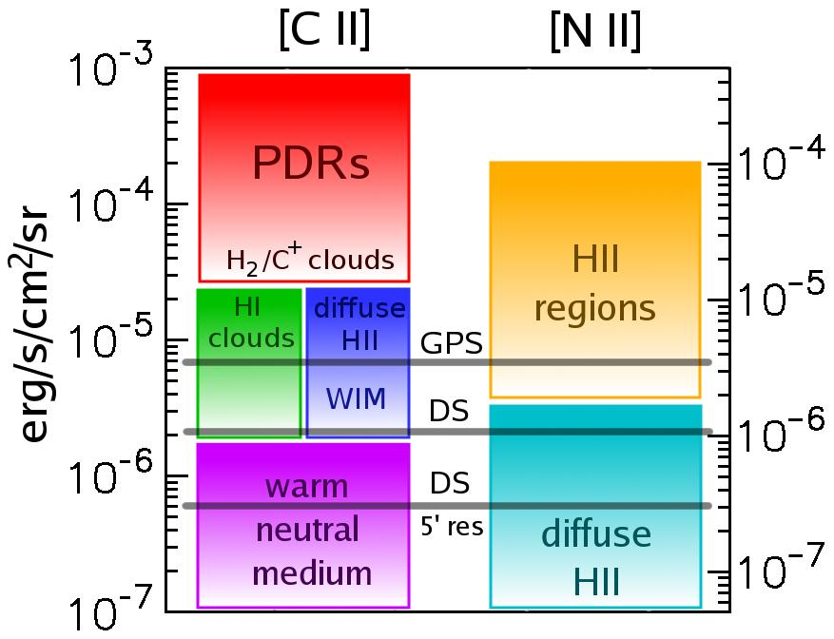
Neutral interstellar gas is the dominant mass component of the ISM, and tends to exist as two phases in rough thermal pressure equilibrium: a diffuse warm neutral medium (WNM) with hydrogen densities at the solar circle of n ∼ 0.3 cm⁻³ and T∼8000 K, and denser, colder “diffuse HI clouds” (CNM) with n∼40 cm⁻³ and T∼70 K (Heiles & Troland, 2003; Wolfire et al., 2003). Turbulence provides a broader spectrum of conditions (Mac Low et al., 2005; Gazol et al., 2005; Jenkins & Tripp, 2011), but thermal balance drives neutral gas toward these phases. With sufficient shielding column, N > 10²⁰ − 10²¹ cm⁻² of hydrogen nuclei, the CNM clouds begin to harbor molecular interiors. These H₂/C⁺ clouds are sometimes called “dark clouds” because they cannot be detected in HI, H₂, or CO emission. This component has been indirectly inferred by γ ray (e.g., Grenier et al. 2005), submillimeter dust emission (Planck Collaboration et al. 2011), and IR dust extinction maps, but direct emission from its gas in [CII] and accurate measurement of its contribution to the ISM and to the formation of GMCs can be done only by STO-2. Above N~3 × 10²¹ cm⁻² the clouds become detectable in CO, and above N~10²² cm⁻² they become gravitationally bound and stars may form in their interiors (McKee, 1989). The largest condensations take the form of GMCs with masses 10⁵ − 10⁶ M⊙ and are responsible for most of the star formation in the Galaxy. These ISM components are shown schematically in Figure 3.
Figure 4: Comparison of STO-2’s sensitivity with [C II] and [N II] integrated intensity for various ISM components. HI and H₂/C⁺ clouds (dark gas) constitute the building blocks for molecular clouds. HII regions and bright PDRs often constitute pho-toevaporating gas from molecular clouds, or cloud destruction. The corresponding sensitivities (3σ rms noise) of STO-2’s two survey modes (see §1.2 for definitions) are indicated by horizontal lines.
WNM is converted into CNM clouds via thermal instability either if the ultraviolet radiation field (heating) diminishes (Parravano et al., 2003) or if the pressure increases because of the passage of a (e.g., super-nova) shock wave (McKee & Ostriker, 1977). GMCs presumably form from a large assemblage of CNM clouds; the leading theoretical models invoke gravitational instabilities in huge regions 0.5-1 kpc in size along spiral arms (Ostriker & Kim, 2004). This assemblage process has never been directly observed and other mechanisms have been invoked such as the convergence of flows in a turbulent medium (Hennebelle & Perault, 2000; Heitsch et al., 2006).
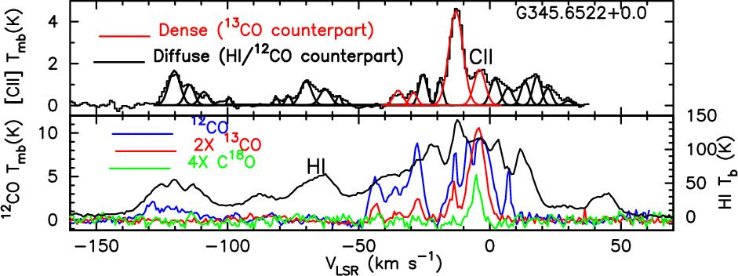
The ultraviolet radiation from massive stars not only heats the CNM and WNM and determines the relative portions of these phases, but it also ionizes gas and heats it to 10⁴ K, producing H II (low density=WIM) regions. [N II] line emission provides an extinction-free measure of ionizing radiation from young, massive stars (a direct measure of star formation rates), and [C II] and [N II] together measure the disruptive impact of UV radiation on the surfaces of neighboring clouds; a key part of the stellar/interstellar feedback that governs galactic evolution. GMCs are primarily destroyed by the ultraviolet radiation from OB stars which form inside and lie relatively close to their natal GMCs (Williams & McKee, 1997). CNM clouds are destroyed by the interstellar UV field produced by the global (many hundreds of pc) OB stellar population. A high global star formation rate produces a more intense interstellar radiation field, thereby lowering the CNM population and converting these regions to ionized or WNM gas. This conversion then lowers the rate of GMC formation, and thus the global star formation rate. These stellar feedback effects could regulate star formation rates in galaxies.
Figure 5: [C II] spectra obtained with Herschel/HIFI for the GOTC+ program (Langer et al. 2010), along with CO and HI data, show diffuse atomic clouds ([CII] and HI), molecular cloud surfaces ([CII] and CO, and dark clouds ([CII]) observed along a single line of sight in the Galaxy.
Figure 4 shows the [C II] and [N II] intensities of these cloud components with the nominal STO-2 survey mode sensitivities, while Figure 5 shows a Herschel/GOTC+ [C II] observation (see also §4.2) with complementary CO and H I spectra along a line of sight through the Galaxy. This pointed observation shows that many kinds of clouds are detectable with modern heterodyne receivers at THz frequencies. Diffuse clouds appear with [C II] and HI emission, whereas illuminated surfaces of molecular clouds are visible in [C II] and CO. A significant WNM component is observed in the H I (only). This single-pointing with Herschel foreshadows the large-scale mapping of these lines that will be possible with STO-2.

2.2 Goal 1: Map the Entire Life Cycle of Interstellar Gas
STO-2 will (1) map and catalog as a function of Galactic position the size, mass distribution and internal velocity dispersion of atomic, molecular and ionized clouds in the Galaxy. It will (2) identify the physical origin of [C II] emission, (3) allow construction of the first large-scale thermal pressure map of the ISM, (4) the first map of the gas heating rate, and (5) a more sensitive, detailed map (using [N II]) of the star formation rate.
(1) Interstellar gas cycles from molecular gas, to atomic and ionized gas, and back to molecular gas. STO-2’s unique blend of sensitivity, angular resolution and spectral resolving power allows it to map and diagnose all components of the warm and cold interstellar medium. STO-2 will survey spiral arm, interarm regions and a large portion of the molecular ring, where much of the star formation occurs in the Galaxy. Galactic rotation causes a distance-dependent velocity separation of the clouds along the line of sight, and STO-2’s high spectral resolution allows us to then determine the distance to the clouds using standard methods. Therefore, STO-2 will provide an unprecedented 3D global map of the distribution of clouds of ionized gas, atomic gas, and molecular clouds (via their [C II]-emitting surfaces) as a function of Galactocentric radius (R) and height (z) in the Galaxy. We can compute the density of clouds (i.e., the number of clouds per kpc³) and their size distribution as functions of R and z, and see how clouds are clumped together in spiral arms or supershells. In regions of cloud clustering, the superb velocity resolution of STO-2 will measure the random motions of clouds, and diagnose large scale turbulence.
  - Because [C II] line emission can come from ionized, atomic, and dark clouds and from GMC surfaces, its origin can be difficult to disentangle toward complicated lines of sight, particularly in the Inner Galaxy. For example, COBE FIRAS observations show that the ionized component of the ISM radiates strongly in both [C II] 158 µm and [N II] 205 µm (Wright et al., 1991). To distinguish the origin(s) of [C II] emission, velocity-resolved measurements of the distribution of the ionized gas must be made in [N II] and compared to the [C II] distribution, along with comparisons with H I and CO. STO-2 will conclusively determine the origin of the [C II] emission, by measuring the portion of the [C II] emission coming from each component.
(3) The ratio of CNM [C II] to H I intensity (which determines their column and mass) provides a measure of the [C II] emissivity per H atom which rises monotonically with gas density and thermal gas pressure. The STO-2 survey over a large portion of the Galactic Plane thereby enables the construction of the first barometric maps of the Galactic disk, determining the ambient thermal pressure in different environments (e.g., the spiral arms versus interarm regions, turbulent versus quiescent regions). The STO-2 team’s theoretical models are vital to determining the density, temperatures, and thermal pressures in the clouds. These can then be correlated with star formation rates to understand stellar/interstellar feedback mechanisms.
(4) The [C II] line dominates the cooling of CNM clouds. From its intensity we directly obtain the gas heating rate of clouds as a function of radius throughout the Galaxy. Besides the fundamental interest in tracing the energy flow in the Galaxy, the observations also can test our theoretical hypothesis that the heating is provided by the grain photoelectric heating mechanism in diffuse clouds.

2.3 Goal 2: Reveal the Formation & Destruction of Clouds
By observing the [C II] line, STO-2 will reveal clouds clustering and forming in spiral arms, super-shells, and filaments, and follow the growth of clouds to shield molecules and eventually to become gravitationally-bound GMCs. STO-2 will observe “dark” clouds that cannot be seen in H I or CO emission, and estimate their contribution to GMC formation. STO-2 will also directly measure the subsequent dissolution of molecular clouds into diffuse gas via stellar feedback.
Formation of diffuse H I clouds (CNM). Turbulence may play an important role in the formation and evolution of interstellar clouds. In a standard scenario where CNM clouds are formed from WNM gas by thermal instability, we can picture the role of turbulence in two ways: large scale instabilities, density waves and supernovae drive compressional motions that increase the thermal pressure and trigger the thermal instability (de Avillez & Breitschwerdt, 2005). Alternatively, regions undergoing thermal instability may generate turbulence, and convert the CNM into a complex network of pancakes and filaments (Kritsuk & Norman, 2002). Because of this dynamic nature of both the triggering and evolution of the thermal instability, departures from thermal pressure equilibrium may be widespread in the ISM (Heiles & Troland, 2003), and the notion of a dynamic multiphase ISM has been proposed. Only a careful study of both the spatial structure and kinematics of diffuse gas in transition between phases can tell us the role of turbulence and dynamic pressure in the life-cycle of the ISM.
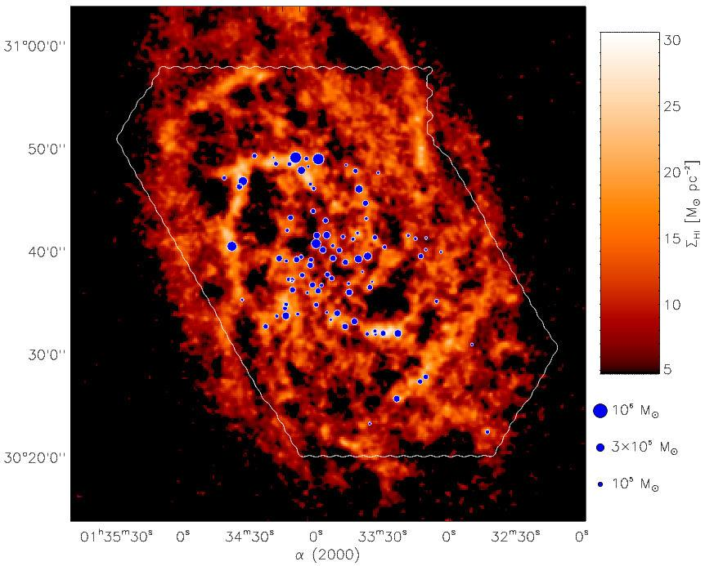
Formation of GMCs. The formation of GMCs is a prerequisite for massive star formation, yet the process has not yet been directly observed! STO-2 is designed with the unique combination of sensitivity and resolution needed to observe cold atomic and dark clouds assembling GMCs (Figure 6). Four mechanisms have been proposed to consolidate gas into GMC complexes (Elmegreen 1996): (1) self-gravitating instabilities within the diffuse gas component (often in a spiral arm where density is highest and the Jeans time is shortest), (2) random collisional agglomeration of clouds, (3) accumulation of material within high pressure environments such as shells and rings generated by OB associations, and (4) compression in the randomly converging parts of a turbulent medium. STO-2 can distinguish these processes from each other and consider new cloud formation schemes by:
Figure 6: GMCs locations (blue dots) in the nearby spiral galaxy M33 are overlaid upon an integrated intensity map of the HI 21 cm line (Engargiola et al., 2003). These observations show that GMCs in M33 are formed from large structures of atomic gas, and foreshadow the detailed study that STO-2 will provide of GMC formation in the Milky Way.
- Accounting for all the molecular hydrogen mass (the H₂/C⁺ dark clouds as well as the H₂/CO clouds) when computing global measures of the interstellar medium.
- Clearly identifying CNM clouds via the density sensitivity of [CII] compared to HI 21 cm.
- Constructing spatial and kinematic comparisons with sufficient resolution, spatial coverage and dynamic range to discriminate the above 4 scenarios.
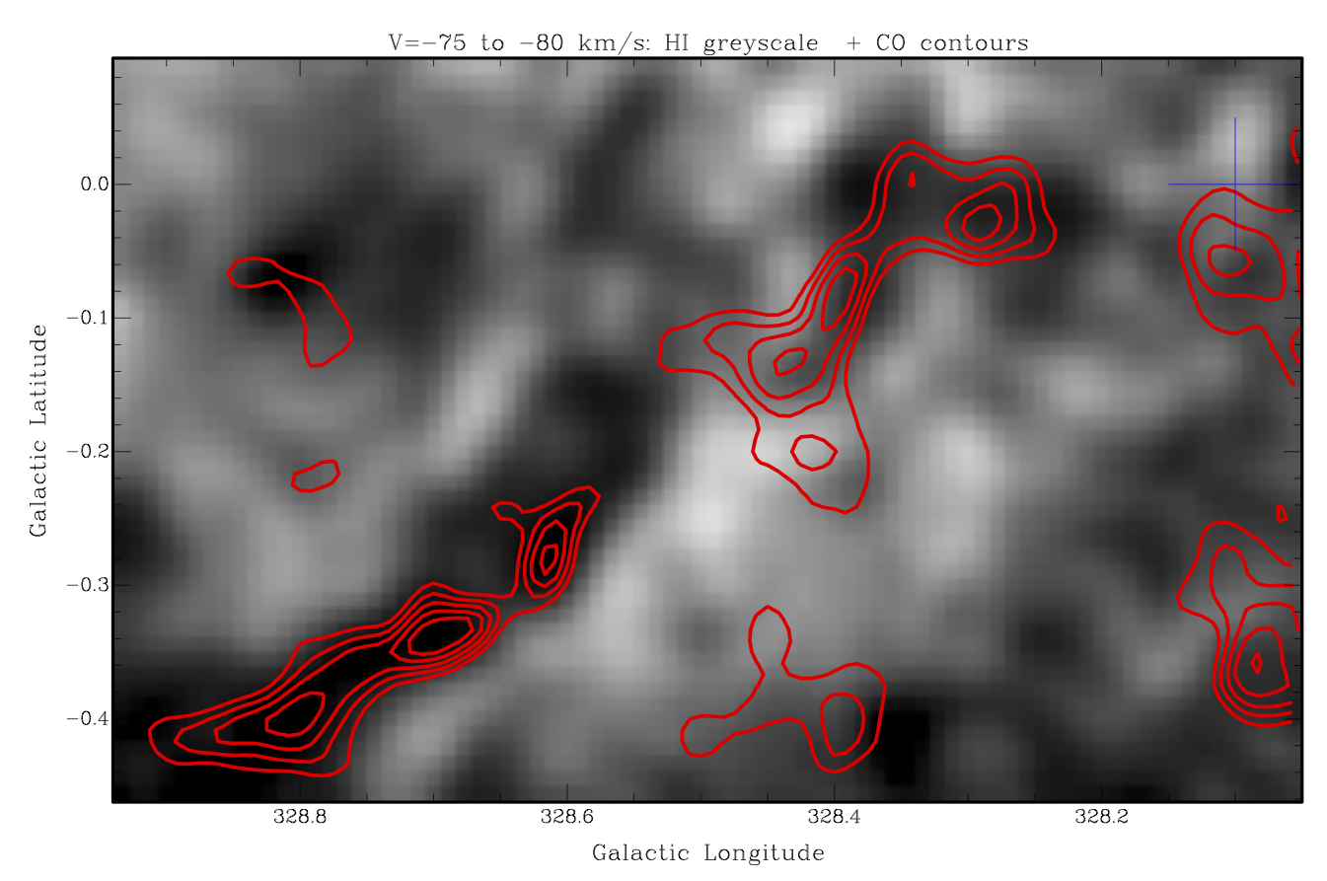
Currently, associating diffuse gas (H I) with molecular gas (CO) is difficult owing to the density-insensitivity of the HI 21cm line. Unlike [C II], a significant fraction of the H I emission can come from low density WNM gas. Because the [C II] emissivity is 10 times higher for H I clouds than WNM gas, it barometrically picks out clouds of atomic CNM gas. It directly detects the dark gas, and reveals its motion. Regions of GMC formation may therefore be tracked by higher than average H I and H₂/C⁺ cloud densities (number of clouds per kpc³), or regions with individual clouds with higher than average columns or pressures. With STO-2’s velocity resolution, these regions can be identified with superrings or spiral arms or convergent parts of a turbulent medium. STO-2 will identify the sequence of phase transitions as the gas transits through the spiral potential, and will witness the process of cloud formation directly from H I or dark gas clouds. One example of such a candidate cloud-forming region is shown in Figure 7, where high-resolution CO J=1-0 observations from Mopra (§4.1) are overlaid upon a HI map from SGPS (McClure-Griffiths et al., 2005). A 50 pc GMC filament of CO emission is shown over a narrow (5 km/s) velocity interval along with the same velocity H I; the region also shows an absence of bright infrared continuum features. While these observations are generally consistent with a natal GMC that has not yet evolved to form dense cores or young stars, imaging spectroscopy of [C II] from STO-2 would provide conclusive evidence for GMC formation. Unlike H I observations alone, [C II] emission can easily distinguish dense clouds of H I from diffuse gas, and can reveal dark clouds. Furthermore, with high spectral resolution, the atomic and molecular kinematics of GMC assembly can be directly measured with high fidelity from the [C II], H I, and CO line profiles.
Figure 7: An example of a young GMC filament (50 pc long at a distance of ~4.5 kpc with mass ~5×10⁵ M⊙. Mopra CO J=1-0 contours (red) are overlaid on an H I 21 cm image. A blue cross marks the line of sight of a single Herschel GOT C⁺ (see §4.2) observation, which uncovered bright [C II]. An STO-2 [C II] map of this region will much more clearly show the kinematics and the location of the atomic and “dark” clouds that may be coalescing to form this GMC.
The high spectral resolution of STO-2 enables crucial kinematic studies of the Galaxy to be made. The expansion of stellar outflows and supernova remnants create supershells that sweep up surrounding ISM and overrun surviving molecular clouds and cloud fragments. STO-2 will determine the kinematics and thermal pressures of most supershells, fossil superrings, and molecular clouds just condensing via gravitational instability of old superrings. STO-2 will detect many of the CNM clouds formed out of WNM in the shells, and the larger column density clouds, which may harbor H₂. With these detections STO-2 will determine the role of OB association-driven supershells and superrings in the production of molecular clouds and the cycling of gas between the various phases of the ISM.
STO-2 witnesses the disruption of clouds. [C II] and [N II] measure the photoevaporating atomic or ionized gas driven from molecular clouds with UV-illuminated surfaces, thereby converting the clouds to WNM, CNM, or to diffuse H II regions. Thus, STO-2 can directly determine the rate of mass loss from catalogued clouds, and their destruction timescales.

2.4 Goal 3: Map the Star Formation Rate in the Galaxy

STO-2 will probe the relation between the gas surface density on kpc scales and the [N II]-derived star formation rate, so that we might be able to better understand the empirical Schmidt-Kennicutt Law used to estimate the star forming properties of external galaxies.
Star formation within galaxies is commonly described by two empirical relationships: the variation of the star formation rate per unit area with the gas surface density (atomic + molecular), Σ_{SFR} (Schmidt, 1959) and a surface density threshold below which star formation is suppressed (Kennicutt, 1989; Martin & Kennicutt, 2001). This empirical relationship is used in most models of galaxy evolution with surprising success given its simplicity. In practice, the relationship is derived by comparing a tracer of star formation to a tracer of interstellar gas; it has been evaluated from the radial profiles of Hα, H I, and molecular emission for tens of galaxies. The mean value of the Schmidt index, n, varies from 2 (Schmidt, 1959) for star formation vs. H I, to ∼1 when star formation is compared to tracers of high-density molecular gas (Onodera et al. 2010). Sufficiently-dense molecular cores decouple from the galactic environment and form stars at a rate that depends only on their internal physics and is essentially uniform across all galaxies. The Schmidt-Kennicutt Law for star formation rate vs. low-density gas is therefore a manifestation of the processes that form dense cores, processes whose nature is explored by STO-2.
STO-2 will help us understand the origin of the Schmidt Law. The [N II] line is a potentially excellent tracer of the star formation rate, measuring ionizing luminosity with high sensitivity, angular and spectral resolution, unaffected by extinction. The [C II] line, in conjunction with H I 21-cm and CO line emissions, provide the first coherent map of the neutral interstellar gas surface density and its variation with radius. STO data will correlate the thermal pressures on the surfaces of GMCs (which may relate to the formation of cores inside) with surface densities of H I and CO. It may uncover regions around OB associations devoid of GMC-forming CNM clouds. The current high rate of star formation in associations may impoverish large regions of the clouds needed to start the star formation cycle in the future. Such measurements are pivotal to models of star formation feedback & global galactic evolution.

2.5 Goal 4: Construct a Milky Way Template
[C II] 158 µm, the strongest Galactic cooling line, will be the premier diagnostic tool for studying external galaxies with far-infrared (FIR) observatories (SOFIA, Herschel) and in the submillimeter for galaxies with large redshifts (Atacama Large Millimeter Array). To interpret the measurement of extragalactic [C II] one must turn to the Milky Way for the spatial resolution needed to disentangle the various contributors to the total [C II] emission. At present, there is debate on the dominant origin of the [C II] emission in the Galaxy: diffuse H II regions, CNM clouds, or the surfaces of GMCs. STO-2 will solve this mystery. The [C II] and [N II] intensities, combined with ancillary CO and HI observations, identify each component of [C II] emission. The STO-2 mission covers a broad range of density and UV intensity, thus establishing the relationship between physical properties, [C II], [N II], CO, H I, FIR emission, and star formation. This study will provide a “Rosetta Stone” for translating the global properties of distant galaxies into reliable estimators of star formation rate and state of the ISM.

3 Science Requirements
The science goals outlined in Section 2 define a clear set of measurement requirements which the instrument and mission must be able to perform. Table 1 portrays this flow of requirements, setting the requirements for the instrument and mission implementations that are described in the sections to follow.
These requirements define the scope of the STO-2 Galactic Plane Survey, which will span a maximum of 35 square degrees at moderate sensitivity: 3σ detectability of 7 × 10⁻⁶ erg s⁻¹ cm⁻² sr⁻¹ in [C II], adequate to detect the assembly of GMCs from diffuse CNM clouds with hydrogen columns of a few times 10²⁰ cm⁻². In [N II], sensitivity will be better than 2 × 10⁻⁶ erg s⁻¹ cm⁻² sr⁻¹ with modest spectral and spatial smoothing, since diffuse HII regions will span many arcminutes on the sky even at a distance of 10 kpc. Such diffuse H II regions tend to dominate [N II] and [C II] emission from ionized gas (McKee & Williams, 1997) and are a substantial component of the ionized gas in the Galaxy. Previous surveys of [N II] and [C II] were limited to very small regions (KAO, ISO, Herschel) or had low angular resolution (COBE, BICE) (Bennett et al., 1994; Nakagawa et al., 1998). STO-2 will fully sample both species over large regions of sky to its diffraction limited angular resolution of 1′.
Table 1: Flow of Requirements, from Science goals to Instrument Implementation
Pertinent Science Goal(s) | Measurement Requirement | Instrument requirement
Life cycles (1), Formation of clouds (2) | Angular resolution to resolve ~3 pc clouds at the Molecular Ring (5 kpc). | 1 arcminute resolution requires 0.8m aperture at 1-2 THz.
Life Cycles (1), Formation of clouds (2), Galactic SFR (3), Milky Way template(4) | Spectral resolution to resolve spectral lines and measure cloud, shell and superbubble dynamics (km/s scale). | High resolution heterodyne spectroscopy with 1 km/s spectral channels.
Life Cycles (1), Galactic SFR (3), Milky Way template (4) | Spectral bandwidth to encompass the Galactic rotation curve from l=305º to 340º . | V_{LSR} = -140 to +20 km/s  requires max 1 GHz bandwidth at [CII] frequency.
Life Cycles (1), Galactic SFR (3), Milky Way template (4) | Mapping coverage to sample the inner Molecular Ring, interarm regions, and at least one major spiral arm. | Mapping longitudes from l=305º to 340º and coverage of the molecular scale height (-0.5º to 0.5º) in latitude.
Life cycles (1), Formation of clouds (2) | Sensitivity to sense CNM clouds aggregating into molecular clouds (limiting A_{V} = 0.4 mag). | 3σ detectability of 1 K km/s = 7.1x10⁻⁶ erg/s/cm²/sr in [CII].
Life cycles (1), Galactic SFR (3), Milky Way template (4) | Sensitivity to sense HII regions with emission measure of 50 cm⁻⁶ pc. | 3σ detectability of 0.3 K km/s = 1.0x10⁻⁶ erg/s/cm²/sr in [NII] with spectral & spatial smoothing.
Life Cycles (1), Formation of clouds (2), Galactic SFR (3) | Sensitivity and mapping coverage to cover the full [CII] and [NII] scale heights to A_{V} = 0.1 mag. | Deep survey spanning -2º to +2º in latitude, with 3σ detectability of 0.3 K km/s = 2x10⁻⁶ erg/s/cm²/sr in [CII].
Life Cycles (1), Formation of clouds (2), Galactic SFR (3), Milky Way template(4) | From prev. requirements, sufficient mapping speed to span 35 square degrees of mapping within one LDB flight (~14 days) from Antarctica. | >1 sq.deg/day requires THz arrays of ~4 pixels per frequency band at current sensitivities (Trec=~1000K DSB).
Deeper coverage reaching truly diffuse cloud column densities corresponding to A_{V} = 0.1 mag and spanning the full emission scale height requires the STO-2 Deep Survey (DS). The Deep Survey is comprised of a series of 4-degree linear strips in Galactic latitude, spaced equally in Galactocentric radius, which include slices of the Molecular Ring, Scutum-Crux spiral arm, and inter-arm regions. These strips are chosen to match b-strips made both by AST/RO (in [C I] and mid-J CO lines) and Mopra (in CO J=1-0). Deep surveys allow us to detect faint [C II] and [N II] from diffuse ionized clouds, probe the formation of small molecular clouds, and will help determine the origin of most of the [C II] emission in the Galaxy.

4 Complementarity with Existing Data Sets and Other Missions
STO-2 will provide the community with a totally unique [C II] and [N II] survey, enabling quantitative extraction of many physical parameters of the interstellar medium in a 3D data cube. Its spatial resolution is comparable to Mopra surveys of CO emission in the southern hemisphere (see below) and also to the Southern Galactic Plane HI Survey (McClure-Griffiths, 2005), allowing placement of the [C II] 158 µm and [N II] 205 µm emission along the line of sight with respect to the CO and H I emission.

4.1 Relationship to Existing Data Sets
CO: The Mopra telescope in Australia (see UNSW letter of Support) has been upgraded for the STO project to make rapid CO surveys of the southern sky in all isotopologues of CO J=1-0. In 2011 we obtained maps in each isotopologue from b = ±0.5◦ and l = 323◦ to 330◦, at subarcminute spatial resolution and 0.1 km/s spectral resolution. We plan to map the region b = ±0.5◦ and l = 330◦ to 340◦ in 2012 with time recently awarded. A sample of our Mopra CO survey is shown in Figure 7. The CO J=1-0 surveys will complement the STO-2 survey by helping to identify molecular clouds whose surfaces STO-2 detects and whose ionized gas seen in [N II] and warm neutral gas seen in [C II] may be expanding into the ISM (Onishi et al., 2005). In addition, the STO team will obtain complementary CO J=4-3 and 7-6 maps at comparable resolution with NANTEN2 (see below, [C I] discussion).
H I: The STO-2 surveys enhance substantially the interpretation of existing H I surveys. The H I emission maps are sensitive only to column, whereas [C II] is sensitive to density times column. [C II] therefore picks out the cloud regions with density > 30 cm⁻³, whereas the H I is often dominated by the WNM emission (see Figure 5). In fact, H I clouds can appear in absorption, in emission or undetected against the confused background and foreground WNM. When H I and [C II] are both seen in emission, their ratio provides the gas density and pressure in the cloud. When extended and broad H I emission is seen without a [C II] counterpart, WNM or thermally unstable gas is identified.
[C I]: Moving from the CNM through the surfaces of molecular clouds to their cores, the predominant form of carbon transitions from C⁺ to CO, with high abundances of atomic C in the transition region. The STO team has access to guaranteed observing time at the NANTEN2 telescope in Chile to obtain complementary data for the regions covered by STO in the [C I] 370 µm and 609 µm lines with angular resolutions of 25 and 45 arcsec, respectively. In addition, a southern Galactic Plane survey of the 370 micron [C I] line (at 2’ angular and 0.8 km/s spectral resolution) is currently being performed by the High Elevation Antarctic Terahertz (HEAT) telescope now in operation at ‘Ridge A’, the summit of the high Antarctic plateau (Kulesa et al. 2011). These data are in the public domain with no proprietary period. Maps from STO-2 coupled with CO and [C I] data, will follow carbon in all its forms in position, velocity, cooling rate, temperature and pressure as the interstellar gas evolves.
Infrared Continuum Surveys: MSX, Infrared Astronomical Satellite (IRAS), and Spitzer GLIMPSE and MIPSGAL Galactic plane surveys permit locating dark clouds, supershells, and star forming regions using the IR continuum.
4.2 Complementarity to Other Missions
STO-2 builds upon the heritage of three pioneering surveys which provided coarse pictures of [C II] and [N II] emission in the Galaxy. COBE (spatial resolution 7◦, velocity resolution >1000 km/s), BICE (spatial resolution 15′, velocity resolution 175 km/s), and the Infrared Telescope in Space (IRTS, spatial resolution 10′, velocity resolution 750 km/s). STO-2 has about the same sensitivity to surface brightness as these missions, but adds orders of magnitude in spatial and spectral resolution. None of these missions had sufficient spectral or spatial resolution to locate clouds, or separate one cloud from another along a given line of sight, and thus could not draw specific conclusions about cloud properties or distributions, or even the origin of the [C II] or [N II] emission (Hollenbach & Tielens, 1999). Besides COBE, BICE and IRTS, other platforms include the former Kuiper Astronomical Observatory and Infrared Space Observatory, which did not survey the Galaxy in [C II] and [N II], but made pointed observations, albeit without sufficient spectral resolution to resolve the velocity structure of the lines. The Spitzer Space Telescope has no spectroscopic capability at these wavelengths.
The Herschel Space Observatory (HSO) is in its last year of operation and the observing program has been finalized. The high spectral resolution HIFI instrument on HSO has made a number of small maps of [C II] (and partly [N II]) emission from active star-forming cores and their adjacent cloud interfaces. The Herschel Galactic Observations of Terahertz C+ (GOT C+) project surveyed the Galactic disk in the [C II] line with HIFI’s sub km/s resolution. GOT C+ measured 500 lines-of-sight (with a narrow 15 arcsec beam) separated typically by 0.5 to 1 degree. GOT C+ demonstrated the utility of velocity-resolved [C II] observations (together with complementary H I and CO surveys) to trace the different phases of the ISM. In particular, the GOT C+ survey found a significant number of dark gas components (Langer et al. 2010, Velusamy et al. 2010). STO-2 will map and measure the motions of these dark clouds. Due to its coarse sampling, the GOT C+ survey lacks a picture of the surroundings of individual lines-of-sight, and STO-2 will provide the full picture of clouds that are forming and dissipating.
SOFIA with its present heterodyne instrument GREAT, and in particular with its future array heterodyne receiver upgrades, will be very efficient at mapping the detailed distribution and structure of ISM clouds at high spatial resolution and over small areas, but will not have sufficient observing time to conduct large scale mapping. The STO-2 survey in the [C II] and [N II] lines will provide guidance to SOFIA follow-up studies of small scale structure in confined areas of interest. STO-2 will be unique in providing maps of large areas at moderate spatial but full spectral resolution, thus obtaining an unbiased sample of ISM clouds and their motions across the Milky Way.
5 Science Implementation
5.1 The 2012 STO-1 Campaign
STO-2 benefits tremendously from the experience gained on STO-1 and recent breakthroughs in THz local oscillator (LO) technology by Co-I’s at JPL. The STO-2 instrument package will be more sensitive, simple, and robust than on STO-1. The addition of a small, efficient, cryocooler will extend the mission’s cryogenic lifetime to ~60 days. Except for the new LO’s and cryocooler, all components are re-used from STO-1. The entire instrument package will pass through a thermal-vac test before flight.
STO was successfully launched on Jan. 15, 2012 (see Figure 12). Science observations commenced within ~12 hours of reaching float altitude (Figure 1b). They continued until an hour before mission termination on Jan. 29th. During the mission the performance of all flight systems was fully characterized and adjustments made to the software as needed. After ~5 days a small vacuum leak developed in the flight cryostat that caused the cryogenic receivers to warm up prematurely. STO then entered its Warm Mission Phase, where it continued its observations using an uncooled [CI] receiver until termination.

Lessons Learned
STO-2 we will achieve its Baseline Science Goals by benefiting from the following lessons–learned.
- Carry back-ups of as many mission critical components as possible. Within a few days of our first launch attempt one of the instrument’s three local oscillators (LO’s) died, making it necessary to use a back-up unit with a smaller tuning range and making [N II] observations untenable.
- Thermal-vac test all flight systems for an extended period. The STO dewar performed as expected until several days into the flight when what appears to have been a small vacuum leak occurred. This caused the cryogenic receivers to warm-up prematurely, ending [C II] and CO observations. We then began the STO Warm Mission, observing with the ambient temperature [C I] receiver for the rest of the flight. The STO-2 cryostat will undergo extensive thermal-vac testing and be packed in a well-padded, reinforced shipping container. The original dewar container was struck and damaged on the trip to Antarctica. One vacuum seal was compromised and had to be repaired on-site. We do not know if the leak experienced in flight is related to the leak that occurred on the ground.
- Design flight hardware to be as simple and modular as possible. This is especially true for balloon payloads that are assembled and disassembled in the field. For STO-1, the complexity of instrument assembly was driven by the tight mechanical tolerances required by the THz optics. These tolerances also impacted instrument performance, reducing available mapping speed. Fortunately, for STO-2, new high-power LO’s have been developed that greatly reduce these tolerances, making the assembly and performance optimization much easier.
- Verify that target telemetry rates can be achieved regardless of gondola orientation. During the STO-1 flight it was only possible to achieve the desired high data rates if the gondola orientation was optimized for TDRSS.
- System level testing cannot be overdone. During flight several software anomalies arose that were not detected during ground testing. One of these impacted pointing early in the mission. Fortunately, we were able to resolve these issues in flight. For STO-2 we have scheduled a longer I&T period to assure optimum acquisition of science data.
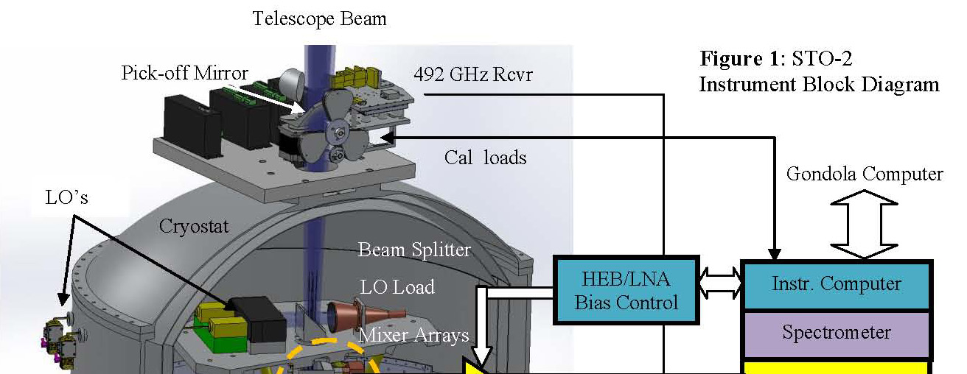
Figure 8: STO-2 Instrument Block Diagram

5.2 Instrument Summary
The observational goal of STO is to make high spectral (<1 km/s) and angular resolution (50") maps of the Galactic plane in [C II] (1.9 THz) and [N II] (1.46 THz). During the flight complementary maps in [C I] (492 GHz) will also be made. To achieve the angular resolution requirement STO utilizes a telescope with an 80cm aperture. To achieve the target spectral resolution and sensitivity, STO utilizes a leading-edge, THz heterodyne receiver system. The instrument portion of STO consists of (1) the telescope, (2) two- 4 pixel cryogenic receivers and one ambient temperature receiver (3) FFT spectrometers, (4) the instrument control electronics, and (5) the cryostat. The STO gondola is fully flight tested and contains (1) the solar arrays and power regulation system, (2) the attitude control system (ACS), (3) the gondola computer, (4) the solid-state memory for data storage, and (5) the transponder (provided by CSBF). Our observing strategy for the main survey is to make adjacent On-the-Fly (OTF) strip maps of the Galactic plane. An ambient load/cold-sky calibration (CAL) is used at the beginning and end of each strip map. During each strip map (lasting as long as ~20 minutes) the calibration load will be regularly observed. With this mode of operation, secondary chopping is not required.

5.2.1 System Description
Table 2: STO-2 Instrument Properties
Property | Description
Telescope | 0.8m Cassegrain
Target Frequencies | [CI]: 1.9THz  [NII]: 1.46THz  [CI]: 0.49THz
Angular Resolution | 50" @ [CII]
Receiver Type | 2x2 HEB Mixer Arrays
System Noise Temp | ~3000K (SSB)
Spectrometer | FFT
Bandwidths | 1 GHz - Corresponds to  158 km/s for [CII]
Spectral Resolution | 2 channel resolution =  0.3 km/s at [CII]
Cryogenic System | Hybrid He-4 Cryostat
LHe Hold-time | ~60 days
A block diagram of the STO-2 instrument is shown in Figure 8. The STO-2 optical system consists of an f/20 Cassegrain telescope, Calibration (Cal) Box, Local Oscillator (LO) Box, and simple reimaging optics. The converging light from the telescope’s secondary enters the Cal Box from above. Just inside the box is a flip mirror. When in the beam path the mirror redirects the light to a room temperature, Schottky receiver tuned to the 492 GHz [CI] line (the same unit that was flown in STO-1). While on the ground this receiver is used to perform end-to-end testing of STO’s electronics. It also provides ancillary science data while in flight. Once the on-board liquid helium supply is exhausted, the 492 GHz receiver continues to operate, allowing the possibility of a warm mission. While the pick-off mirror is in the beam path the mirror’s back-side directs the light from a blackbody calibration load down into the cryostat. The calibration load can be heated or kept at ambient temperature. With the flip mirror out of the way, the telescope beam proceeds into the cryostat where it passes through a 10% reflective dielectric beam splitter used to inject the THz LO beams. STO-2 utilizes recently developed LO sources with ~10 times the power of those available at the time of the STO-1 flight. The ability to use a simple beamsplitter in STO-2 instead of the Fabry-Perot ring diplexer required by STO-1 dramatically reduces the complexity of the system, making assembly and optical alignment far simpler. The new 1.9THz LO source was designed and built by our Co-I’s at JPL specifically for STO-2. The beamsplitter and final multiplier stages are mounted to a plate maintained at 70K by a low-power cryocooler. This cryocooler is also used to help cool the outer radiation shield of the cryostat, tripling the helium lifetime over what was achieved previously. Once through the beamsplitter the combined sky and LO beams are split into horizontal and vertical components by a polarizing grid. One polarization reflects off the grid into reimaging optics that match the f/20 beams of the telescope to the beams needed to efficiently couple into the 1.45 THz mixer array. Similarly, the other polarization passes through the grid to reimaging optics that efficiently illuminate the orthogonally polarized 1.9 THz array. Each array has four Hot Electron Bolometer (HEB) mixers that are thermally strapped to the ~4K helium tank. These will be the same mixer arrays that flew in STO-1 and are the same type of mixers that are being flown in the high fre-
quency band of the Herschel HIFI instrument. The HEB mixers downconvert the high frequency sky signals to much lower, microwave frequencies. From the mixer output coax conveys the downconverted sky signal to a series of low-noise cryogenic and room temperature microwave amplifiers. The amplifiers boost signal levels to where they can be digitized. The first stage IF low-noise amplifiers (LNAs) will utilize the same high-performance, low-power technology developed for STO-1. The IF signal will have a center frequency of 1.65 GHz and a 1 GHz bandwidth. At our highest observing frequency (1.9 THz, the [CII] line) a 1 GHz IF bandwidth will provide 160 km/s of velocity coverage. Each GUSSTO pixel will have its own 1024 channel FFT spectrometer to produce a power spectrum of the input signal. The power spectra from all 9 pixels are read by the instrument computer and passes on to the gondola via an ethernet link. All instrument electronics and subsystems flew on STO-1.

5.2.2 Expected Sensitivity.
Recent lab measurements on waveguide and quasi-optical HEBs operating between 1 and 2 THz have yielded double side band (DSB) receiver noise temperatures of ~1000K. For our sensitivity calculations we have assumed an end-to-end DSB receiver noise temperature of 1500K and single-sideband (SSB) system noise temperature, T_{sys} = 3000K. With the 13 second integration time per Nyquist-sampled resolution element characteristic of the unbiased, Galactic Plane survey (GPS) mode, we will be able to achieve rms noise levels of 0.33 K at a 1 km/s velocity resolution. The STO instrument properties are summarized in Table 2.

5.2.3 Component Selection
STO-2 will utilize the same HEB mixers and low-noise amplifiers (LNAs) flown on STO-1. These mixers have been shown to have the sensitivity required for the STO-2 science investigations. The 2x2, 1.46 THz array was developed by JPL and the 2x2, 1.9 THz array by the University of Cologne (See University of Cologne letter of Support). The LNAs were developed specifically for STO by Sander Weinreb at Caltech/JPL.
JPL has developed and delivered flight-qualified solid state local oscillator (LO) chains for HIFI that cover the 1400-1600 and 1600-1900 GHz bands. These LO chains consist of GaAs MMIC power amplifier modules and JPL designed and fabricated waveguide GaAs planar multiplier Schottky diode circuits. Since the development of HIFI, a number of improvements, including the output power capability, have been demonstrated by JPL and will be used for STO-2. A representative power curve for a 1.9 THz LO chains is shown in Figure 9. Both LO chains employ a x2x3x3 architecture. The first stage doubler in each chain utilizes a quad-chip configuration that allows it to handle input power levels in excess of 600 mW. The second stage is a dual-chip tripler. The final waveguide block contains a single tripler chip. A Potter horn will be used at the output. Even with a 10% beamsplitter being used for LO injection, each HEB pixel will receive ~1 microwatt of LO power, an ample amount for efficient mixing. A lower power version of these LO chains was successfully flown on STO-1. The output beams from the 1.5 THz and 1.9 THz LO chains are orthogonally polarized. Each beam is transformed into four separate beams by a reflective phase grating and power at the two bands combined on a wire grid polarizer. These phase gratings and grids are the same types flown on STO-1. After the grid, the LO and signal beams for each mixer are combined using a beam splitter and travel to the feedhorns, and finally to the mixers.
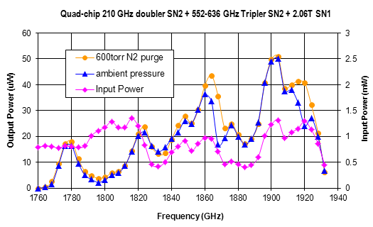
Figure 9: 1.9 THz LO output power vs. frequency
STO-2 will utilize the same spectrometer system successfully flown on STO-1. Developed originally for the PI's 64-beam 345~GHz heterodyne array (“SuperCam”) project by Omnisys, each spectrometer board has four 1 Gs, 8-bit digitizers and a Xilinx Virtex4 FPGA which together perform a real time programmable digital FFT of the IF signal. Four Omnisys boards are used in the flight system, providing 8 IF inputs with 1 GHz of bandwidth each. One additional spectrometer board will be mounted in the spectrometer pressure vessel for use with the Schottky receiver.

5.2.4 Cryostat
Gray Text is Subject to Export Control Restrictions
STO-2 will use the same high efficiency, liquid helium cryostat from Ball Aerospace flown on STO-1, with the following enhancements:
- A small, robust cryocooler will be added to extend the helium hold time to ~61 days.
- A new vacuum collar and lid will be machined to reduce the number of vacuum seals and simplify the integration of the instrument with the cryostat, afforded by the use of new, high-power LO’s.
Figure 10 shows the STO cryostat mounted to its telescope. It has a 90 liter helium tank and an outer and inner vapor cooled radiation shield (OVCS and IVCS, respectively). Figure 8 shows a cutaway view of the STO-2 cryostat. The STO mixer arrays and associated optics are mounted on the lower insert stage which is bolted to the top of the helium tank. The mixers dissipate approximately one milliwatt of heat and operate at < 4.5 K. The IF output of each mixer is connected to an LNA via a short (~6 cm) length of stainless steel coax. The first stage of each LNA dissipates ~2 mW. The LNAs and IVCS operate at 16 and 30 K, respectively, and are cooled primarily by the helium tank vent gas. A low-loss, AR-coated silicon window passes the desired signals from the telescope through the vacuum shell. There is a THz low-pass filter in the signal path through the OVCS. The ~100 GHz LO tones required to drive the frequency multipliers on the 70K LO plate enter the cryostat through two waveguide vacuum windows in the side collar. Stainless steel waveguide and G-10 standoffs are used to thermally isolate the LO’s.

Figure 10: STO Cryostat mounted to telescope (Payload #1, Willy Field, Dec. 2011)

Figure 10: STO Dewar attached to telescope (Willy Field, Dec. 2011)
Export Controlled
A cryocooler will be mounted on the side collar to provide additional cooling of the OVCS and LO plate. The cryocooler chosen is the Sunpower Cryotel CT, a low cost, commercial, linear Stirling cycle cooler. This cryocooler has 4.7 watts of capacity at 65 Kelvin, which is a margin of 50%. With all instrumentation on, the cryostat thermal model predicts the flight dewar will have a hold-time of ~60 days
On day 5 of the STO-1 flight a vacuum leak developed in the cryostat. The leak led to the premature warm-up of the HEB mixers. Damage to the cryostat’s shipping crate upon arrival at Willy Field suggests rough handling during transport to Antarctica may have contributed to the leak. To reduce risk, the STO-2 cryostat will undergo extensive thermal-vac testing before its hang-test. After the hang-test it will be packed in a padded, reinforced shipping container for the trip to Antarctica.
5.3 Gondola & Telescope

Figure 12: The STO-1 gondola ready for its first scientific flight from Antarctica in January 2012.
Telescope
Mass slider for CG adjustment
Dewar: keeps detectors at 4K for 45+ days
CSBF SIP
SIP solar arrays
Azimuth reaction wheel
High-gain TDRSS antenna
Low-gain TDRSS antenna
Mezzanine: holds pressure vessels with computers
Star cameras
5.3.1 STO Telescope
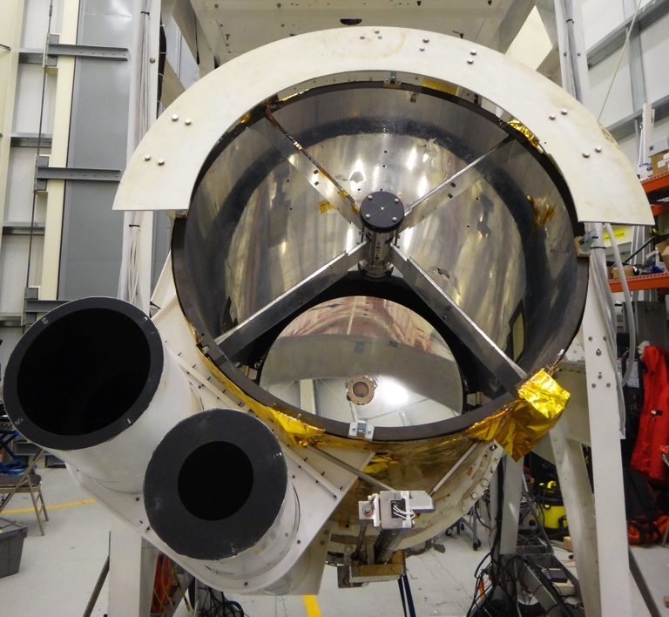
Figure 11: STO’s 80-cm aperture telescope successfully flown in January 2012 from Antarctica. The two tubes on the lower left are the baffles of the two star cameras.
We will reuse the same telescope that was previously used for the first Antarctic flight of STO (Walker et al. 2010), shown in Figure 11, with only minor modifications. The primary mirror is an 80 cm diameter, f/1.5 hyperboloid made of honeycombed Ultra Low Expansion titanium silicate glass and weighing just 50 Kg. Its surface is polished to optical quality, and is thus esssentially perfect for operation in the 100-200 μm range. Its support and spider arms are made of graphite-epoxy, which is light weight and has high thermal stability. For STO-2 the secondary mirror will be redesigned to provide a F/20 beam at the focal plane. We will also recoat the surface of the primary mirror.
5.3.2 STO Gondola Structure
The STO gondola will be the same one previously used for STO-1. Figure 12 shows the STO gondola in full flight configuration. The gondola carries and protects the telescope and attached Dewar and detectors and houses the command and control systems for both STO and NASA-CSBF. Its basic dimensions (without solar arrays) are: 2 x 1.5 x 4.5 m (WxDxH). The frame is made of standard aluminum angles bolted together and painted with a white thermal coating. The structure is strong enough to support up to 2000 Kg even under the 10 g shock experienced at the end of the flight when the parachute inflates
The total mass of the STO payload, shown in Table 3, is well below the design structural limit. Additionally it is rigid enough to allow the required telescope pointing stability of < 15". The gondola can be separated into lighter components for easy post-flight retrieval in the field. NASA-CSBF balloon control electronics (the Support Instrument Package, SIP) is attached on the bottom of the gondola , inside a protective aluminum cage.
For STO-2 we will repair/replace the gondola structural components that were damaged during the STO-1 landing and recovery. Subsequently we will perform thorough system & subsystems testing with a suspension system at APL's high-bay Balloon Payload Integration Facility, which is comparable to the balloon train. Thermally all STO-1 subsystems behaved as predicted, no major changes in the thermal design will be done for STO-2. We already have detailed thermal and structural analysis of the current gondola configuration. The models will be modified to take into account any small mechanical and electronics changes we plan for the STO-2 program.

5.3.3 Command and Control System
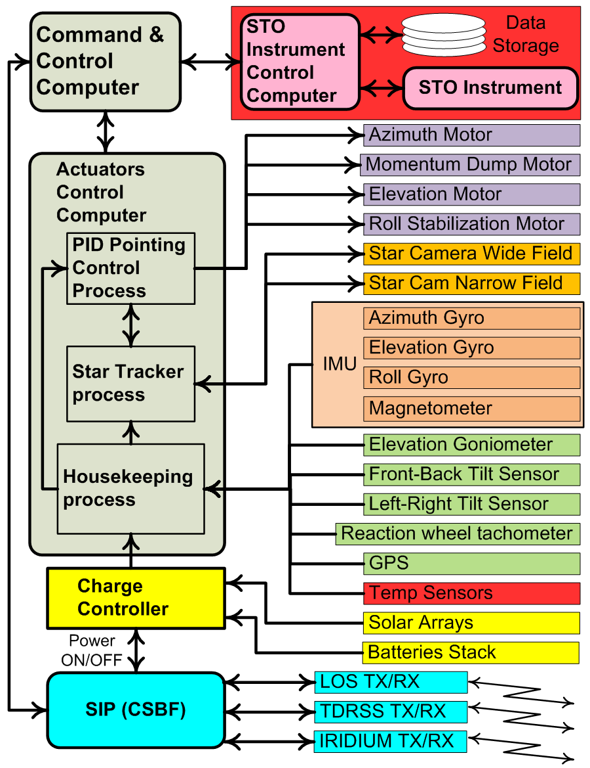
Figure 13: STO Command & Control System
Figure 13 gives an overview of STO-2 command and control system. It is virtually the same used for STO-1. We do not plan any modifications since it performed flawlessly during STO-1 flight. There are two main computers on-board: the Command and Control Computer (CCC) and the Actuators Control Computer (ACC). Both computers use a commercial ATX motherboard with a Pentium-based CPU, solid state hard drives, and Linux as the operating system. They are housed in two vessels that maintain 1 atm pressure throughout the flight, allowing the use of off-the-shelf commercial grade electronic components. The CCC is responsible to schedule all the operations performed by the gondola and handles the communications between the gondola subsystems and the ground. It also communicates to the science computer via an Ethernet socket. It can operate fully autonomously or execute commands received from the ground. The ACC acts as interface between the CCC computer and all the other gondola subsystems. It gathers all the housekeeping data (temperatures, pressures, voltages …) and sends them to the CCC for delivery to the ground. The ACC also handles the attitude control system described further below.
Table 3: STO-2 Weights
Item | Weight
Item | lbs | kg
Gondola frame & command & control | 2100 | 953
Telescope: | 490 | 222
Heterodyne spectrometer/He dewar: | 360 | 163
CSBF equipment: | 570 | 259
Total: | 3520 | 1597

5.3.4 Telecommunications
The telecommunications system for STO-2 will be the same as that used for STO-1. We will rely entirely on the NASA-CSBF provided Support Instrument Package (SIP) for remote link between the gondola and the ground. The SIP has three available channels to/from the ground. For the first ~24 hours the gondola will be in Line-of-Sight (LOS) to the launch station in Antarctica and will use a UHF radio link at a data rate of 1 Mb/s. During LOS operations ample amounts of housekeeping data will be available for analysis of both science and gondola performance. After loss of the LOS radio link, communications will be maintained via a 92-Kb/s TDRSS satellite relay and a lower rate IRIDIUM relay (one 255 byte packet every 15 minutes). A 6-Kb/s TDRSS link is also available and is used as backup. TDRSS and IRIDIUM signals will be received at CSBF's Operations Control Center (OCC) in Palestine (TX) and sent to a local STO ground support computer that will redistribute the data packets to other STO ground stations at APL, the University of Arizona and to the team in Antarctica. All the STO ground stations will be able to display and store the same telemetry information received at the OCC, and commands can be sent to the gondola computers from any station. About 90% of the science data acquired during the flight will be downlinked using the TDRSS link and will be sufficient to meet the scientific goals in the case of payload loss. The ground support computers will use the same software package GSEOS, by GSE Software, Inc., that was previously used for STO-1. During the STO-1 flight the 92-Kb/s TDRSS link would sometimes drop out during observations when the gondola moved in azimuth. Our team will work closely with CSBF to reduce or (hopefully) eliminate these occurrences.

5.3.5 Pointing System
The pointing system will be virtually the same as that used for STO-1, with the addition of a roll compensation system. The science pointing requirements are: pointing range of 360° and 0 to 57° in elevation less a half cone of 20° in the direction of the Sun; stability < 15"; knowledge < 15"; source acquisition accuracy < 20". During the STO-1 Antarctic flight we have demonstrated that the current design can exceed those requirements. To aim the telescope at the desired target in the sky we use an elevation/azimuth mount. The telescope is attached to the gondola on its elevation axis and a torque motor attached to it rotates the telescope in elevation by pushing against the gondola frame. It is also equipped with a goniometer that measures the angle with respect to the gondola with a resolution of ~ 10 arc minutes. To point in azimuth the entire gondola rotates on the vertical axis via Momentum Transfer Unit (MTU) which is same as the one flown in STO-1.
During the STO-1 flight we detected a side-to-side pendulation (roll) of the gondola with a fast frequency of about 0.5 Hz and amplitude between 30 and 150 arc seconds. This roll results in an azimuth pointing error of the telescope in the sky given by the formula: Roll_amplitude * sin(Telescope_elevation), which becomes significant for high telescope elevations. In STO-1 the only way to compensate for the roll induced error was to rapidly dither the gondola in azimuth. However, due to the large gondola inertia and the high roll frequency, it was extremely difficult to completely eliminate this pointing error source. For STO-2 we will implement an active roll stabilization system that will remove the fast components of the gondola roll.
The fine gondola attitude is determined by an Inertial Measuring Unit (IMU) and two APL built star trackers. It is composed of three high-precision, low-drift fiber optic gyroscopes, the Optolink SRS-2000. These gyroscopes have a bias drift of less than 3 arcmin/hr over a wide temperature range and less than 18 arcsecs/hr at a fixed temperature. Initialization of azimuth and elevation for the IMU is done on the ground before launch. From the STO-1 flight experience, when the gondola reaches float altitude, the initial error in estimating telescope orientation will be < 30 arc minutes.
For precision attitude knowledge to < 5 arcseconds, STO-2 flies the same two star cameras developed and built by APL for the STO-1 program, and successfully used on STO-1 Antarctic flight (see Figure 14). They are also attached to the telescope metering structure. They are commercial Stardot Netcam SC-5 with APL modified hardware to allow them to operate at float altitude environment. One star camera is configured with a 50mm focal length f/2.4 lens and red filter. It has a ~7° FOV and is capable of detecting magnitude 6.5 (and dimmer for red stars) stars at altitude during daylight conditions. STO’s second star camera is identicall to the first except that the input optical system is a 500mm mirror lens. It has a ~0.5° FOV and is capable of imaging bright stars (< magnitude 2), and planets during daylight from the ground.
The pointing performance achieved during STO-1 flight (see Figure 14) demonstrates that the combination of gyroscopes, star trackers and PID controller can deliver a pointing knowledge of about 2 arc-seconds and a pointing stability of < 2 arc-seconds in both elevation and azimuth, meeting the requirements for STO-2.

Figure 14: Azimuth and Elevation Pointing errors achieved in flight.
Active AZ pointing changes

5.3.6 Power System
The STO-2 power system will be the same used for STO-1 with no modifications planned since it performed flawlessly during the Antarctic flight. It consists of the solar arrays, the charge controller, and the battery stack. The solar arrays are composed of 480 cells model A300 from SunPower Corp. The maximum power delivered by the arrays is about 1100 W, while the estimated total STO-2 power requirement will be only about 450 W. This gives a margin of 650 W. We estimate that during landing and recovery of STO-1 we lost about 50% of the arrays. For STO-2 we plan to replace only the damaged arrays. The new arrays are assembled by SunCat Solar of Arizona who also built the ones for STO-1. The charge controller distributes the load across the panels, ensures that the system's battery stacks are maintained at near full charge, sunlight permitting, and provides on/off power switching capability from ground commands. It will be the same used for STO-1 and will require no modifications.
The battery stack is composed of 2 sealed lead-acid ODYSSEY PC1700 rechargeable batteries connected in series. The stack has a capacity of 65 amp-hours with a nominal bus voltage of 24 V. During the STO-1 flight the battery charge level never dipped below 60%.

5.4 Data Analysis and Archiving
STO-2 data analysis will make use of the data reduction techniques developed for STO-1. Both missions benefit from the many man-years of effort put into reducing Herschel/HIFI HEB receiver data. Indeed, several of our team members are experts in this area and are now applying their skills to the STO-1 data set. Once the raw data has been accurately tagged and a baseline removed, a wide range of standard data reduction packages and techniques can be employed. The most demanding storage requirement for a 35 sq. degree spectral map is 10 GB. In flight this data volume can be readily handled by embedded computers with nonvolatile Flash memory. The spatially & spectrally re-gridded final data product data volume is <500 MB. There will be two data product releases in the proposal performance period: (1) a preliminary, first light, release after the Antarctic mission in March 2015, and (2) a final release of all data in December 2015. The final release will be fully calibrated and include all science products. All science tools, packaged reduction software, data products and catalog products will be made available from the STO survey web page.
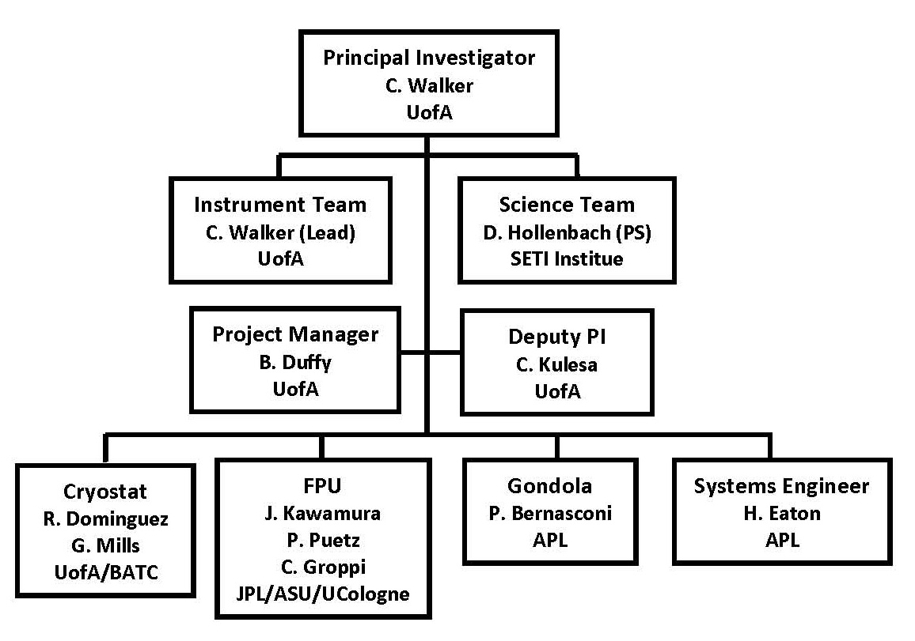
Figure 15: STO-2 Organization Chart
6 Management
The organizational structure of STO-2 is shown in Figure 15 and closely follows that of STO-1. Dr. Walker (PI) is responsible for all aspects of the success and scientific integrity of STO-2. He will be assisted at the University of Arizona by Dr. Craig Kulesa, who will serve as Deputy PI and Brian Duffy, Project Manager (PM). The STO science team will be led by Dr. David Hollenbach (SETI Institute) who will be STO Project Scientist (PS). The Instrument Team will be led by the PI (Walker). Dr. Bernasconi (APL Institutional PI) will oversee the STO gondola efforts at APL. Dr. Jonathan Kawamura will oversee the FPU integration and testing at JPL The master schedule shown in Figure 16 identifies the project's major milestones and development activities. We are fortunate in that all flight critical systems were recovered from STO-1 in excellent condition. Indeed, a careful inspection of flight hardware in the hangar after recovery revealed no significant damage; only a few gondola structural members and cables cut during recovery operations need be replaced. The flight cryostat, optics, and critical electronic systems (including the spectrometer and telescope control computer) were flown back by commercial air and have undergone evaluation in the lab. The cryostat, except for the vacuum leak that occurred in flight, appears to be in excellent shape and the electronics ran when powered-up. This successful recovery of STO-1 allows STO-2 to get off to a running start in January 2014.
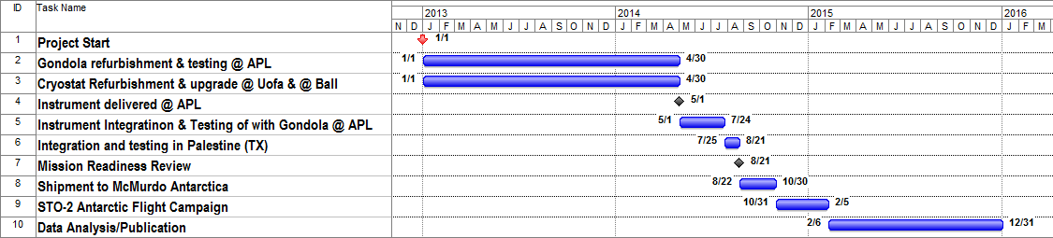
Figure 16: STO-2 Project Schedule

