D OVERVIEW
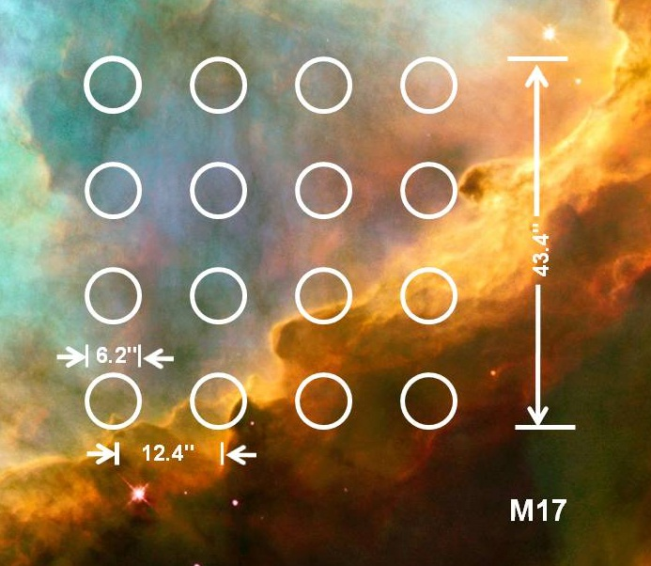
The Oxygen Heterodyne Camera (OCAM) is a technology demonstration, 4 x 4, `Super’-THz heterodyne array instrument for SOFIA. It is optimized to observe the 63 µm [OI] fine-structure line (see Fig. D-1.0). OCAM will be a new, powerful probe of the interaction of stars with their environment and serve as a pathfinder for future, large format, heterodyne arrays.

The 63 µm (4.7 THz) [OI] fine-structure line is the dominant cooling line of warm, dense, neutral atomic gas. Because of its far greater intensity in high UV photodissociation regions (PDRs) and shocks, the [OI] 63 µm line is superior to the [CII] 158 μm line in probing regions of massive star formation and the centers of galaxies. It is a unique probe of PDRs, shock waves from stellar winds/jets, supernova explosions, and cloud-cloud collisions. These radiative and mechanical interactions shape the interstellar medium of galaxies and drives galactic evolution. The size scale of the interactions can excite [OI] emission over many parsecs. Moreover, the emission regions are often complex, with multiple energetic sources processing the environment. Spectrally resolved observations of the [OI] line with OCAM will allow users to disentangle this convoluted interaction and permit the study of the energy balance, physical conditions, morphology and dynamics of these extended regions. In this way, OCAM will provide new, unique, insights into the interrelationship of stars and gas in a wide range of galactic and extragalactic environments. The OCAM focal plane will contain 16, low-noise, hot electron bolometer (HEB) mixers each producing a 6.2" diffraction limited beam on the sky, with a total field of view (FOV) of 43.4". For a line width of δv = 0.4km s⁻¹, OCAM will achieve a 1σ antenna temperature [OI] detection limit of 0.30 K in 100 seconds. These limits vary as δv^{-0.5}. The 1σ intensity detection limit is 6x10⁻⁵ erg s⁻¹ cm⁻² sr⁻¹ in [OI]. This limit varies as δv^{+0.5}.
Fig. D-1.0: OCAM’s beam footprint on M17.

  - Primary Goals
OCAM directly addresses the NASA Strategic Plan (2011) Goal 2.4: Discover how the universe works, explore how it began and evolved, and search for Earth-like planets.

The primary goals of the Science Demonstration flights are to use [OI] emission to:
Goal 1: Investigate the radiative interaction of massive stars with their natal clouds.
Goal 2: Investigate the interaction of protostellar winds and jets with their natal clouds.
Goal 3: Investigate the interaction of massive stars with their environment in the Galactic Center.
Goal 4: Uniquely probe conditions in the nuclei of nearby, face-on, normal & starburst galaxies.

0.2 Mission Approach
During its 3 science demonstration flights on SOFIA, OCAM will image a number of regions in the Galactic Center at 6.2" spatial and 0.4 km/sec velocity resolution. Maps will also be made toward star forming regions (e.g. Orion, W3A, M17, Cepheus) and towards a spiral arm region of the nearby, face-on galaxy, M33. The proposed observations will provide powerful, new insights into the evolution of the ISM both in the Milky Way and beyond.

0.3 Data Products
1. Fully sampled, velocity-resolved, large area surveys of [OI] 63µm line emission and/or absorption toward the Galactic Center, Orion, Cepheus, W3A, M17, and M33 (see Fold-Out 1, Science, Fig. 1.1-1.4).
2. A database of existing complementary line and continuum surveys.
The data products from OCAM will be data cubes of spectral line maps, a standard radio astronomy product.
0.4 Complementarity to Other Missions
OCAM surveys directly complement the spatially limited (single pixel) [OI] observations planned with the GREAT heterodyne receiver on SOFIA; increasing the volume of science data gathered on any given flight by more than an order of magnitude. The OCAM data set will serve as a Rosetta Stone for interpreting the lower spectral resolution [OI] data being collected on Herschel and, in the future, with FIFI-LS on SOFIA.

D- 1 Science GOALS & OBJECTIVES
The radiative and mechanical interaction of stars with their environment drives turbulence and the dispersal of molecular clouds, an essential part of the life cycle of the ISM, breaks and reforms molecules, resetting the organic inventory of space, and, in partnership with gravity, sculpts the Universe in which we live. High spectral resolution observations of the 63 µm (4.7 THz) line of [OI] with OCAM on SOFIA will provide a new, powerful probe of this interaction, previously unattainable on extended size scales. High spectral resolving power is essential for disentangling the complex, violent interactions of stars and gas.
OCAM exploits dramatic developments in THz technology and digital signal processing to fly a multi-pixel, 4.7 THz heterodyne camera. Due to severe atmospheric attenuation at ground and mountain-top altitudes, observations of this line can only be conducted from suborbital or space-based platforms. At SOFIA altitudes (~41,000 ft) the atmosphere has ~75% transmission. Obtaining extended, velocity-resolved images of [OI] will (for the first time) offer the possibility of disentangling the complex interaction of protostars with their natal clouds and fully understanding the effects of stellar feedback.
D- 1.1 Overview of OCAM Capability
The main capabilities of OCAM are:
- High spectral (<1 km/s with 300km/s instantaneous bandwidth) and high spatial (6.2") resolution.
- High speed mapping capabilities (collect more than ~1,000, high quality (T_{rms}< 1K), [OI] spectra per flight).
- High sensitivity (detect [OI] emission from the gas around every B star in the galaxy and detect [OI] in absorption in clouds with A_{v} > 0.5-1 in surveyed regions).

D-1.2 Specific Goals and Objectives
D-1.2.1 Goal 1: Radiative interaction of massive stars with their natal clouds

The [OI] 63 μm line is the dominant cooling line of dense PDRs and provides a unique probe of the physical conditions and dynamics of photo-evaporating clumps and cloud surfaces illuminated by strong UV radiation fields. We propose to study the [OI] emission from a small sample of PDRs surrounding HII regions, spanning the full evolutionary range from deeply embedded ultracompact HII regions to highly evolved regions in their champagne phase to study the dispersal of molecular clouds due to FUV radiation from OB stars.
Most stars form in cold Giant Molecular Clouds (GMC) with sizes of tens of parsecs, average gas densities of order 50 H₂ molecules cm^{-3.}, and masses of order 10⁵ M. The clouds, however, are very clumpy and the typical density of the clumps well exceeds 10³ cm⁻³. The massive O and B stars, with luminosities of 10⁴ to 10⁶ L, radiate mainly FUV (6-13.6 eV) and EUV (> 13.6 eV) photons that ionize, photodissociate, and heat their surroundings. Once an OB star is formed, the EUV creates 10⁴ K HII regions of extremely high thermal pressures. These HII regions expand into the GMC and eventually breakout, creating ionized flows that disperse the GMC (see Figure D-1.1). The FUV radiation photodissociates and heats (T~ 100-3000 K) a neutral layer of hydrogen column (N ~ 10²¹ to 10²² cm⁻²) that surrounds the HII region until breakout, after which it forms a surface layer on the GMC. This layer is called a photodissociation region or PDR (Hollenbach & Tielens 1999). Clumps in the PDR will be photoevaporated by the FUV heating of their surfaces. The warm neutral gas in the PDR can partake in the dispersion of the GMC and, because FUV photons penetrate more gas column than EUV photons, the FUV may actually dominate this process.
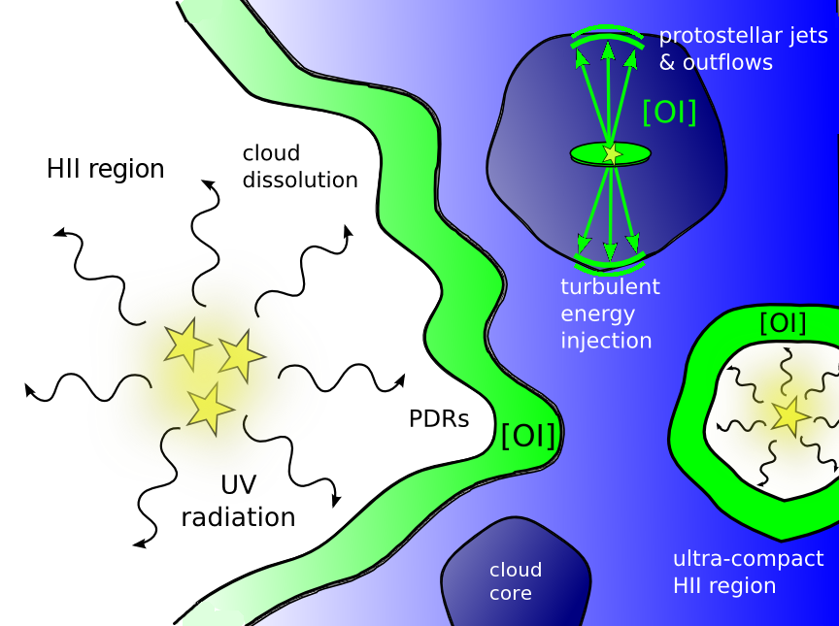Figure D-1.1 Different stages in the evolution of the interaction of newly formed stars with their natal clouds. Protostellar jets and winds drive strong shocks in their surroundings, injecting turbulent energy. EUV and FUV radiation create (ultra)compact HII regions surrounded by PDRs that will expand into the cloud until they break out as a ‘champagne’ flow. In this way, molecular clouds are stirred up, dispersed, and their star formation is stopped. OCAM is uniquely suited to trace this dynamic and energetic interaction between stars and their natal clouds.

The evolution of the HII region begins with the early ultracompact stage, where the electron densities are n_{e}~ 10⁵ cm⁻³, the sizes ~ 0.01 pc, and the surrounding PDRs have hydrogen densities of n~10⁶ cm⁻³ and FUV fluxes given by G₀ ~ 10⁶, where G₀ is the FUV flux in units of the local interstellar field, or 1.6x10⁻³ erg cm⁻² s⁻¹. This stage may last ~ 10⁵ years. As the HII region and surrounding PDR expand, the electron and surrounding neutral hydrogen densities decrease, and the FUV flux on the PDR declines. In this way, the dynamics of the expanding HII region adds turbulence and supersonic internal motions in the GMC. By the time the HII region breaks out of the cloud, which typically occurs in ~ 3x10⁵ years when n_{e} ~ 100 cm⁻³, the PDR density n~10⁴ cm⁻³, and the FUV flux is G₀~1000. The HII region size is typically~ 3 pc. After breakout, the EUV and FUV photons erode the surface of the GMC, and push it away from the OB association. This is the period of GMC dispersal. Here, the PDR densities and G₀ drop further. This “blister” period lasts the life of the OB stars, or the life of the GMC, whichever is shorter, but in any case is of order 10⁶ to 10⁷ years. During both the embedded period and the blister period the typical flow velocities of the neutral gas traced by [OI] is of order ~ 1-10 km/s. Clumpiness inside the GMC means that the HII region is by no means spherical, and the PDRs that are formed trace the clumpy structure of the cloud. This interaction between massive stars and their natal cloud controls the star formation process by compressing gas clumps through shocks – triggering subsequent star formation – photo-ionizing and photoevaporating envelopes around low mass protostars in the cluster – creating prominent globules, fingers, and proplyds – and dispersing gas in ionized and neutral gas flows. As illustrated in Figure D-1.1, the formation and evolution of stars in GMC’s drives turbulence, photo-evaporation, and cloud dispersal, which are key parts of the Life Cycle of the ISM. The primary goal of OCAM is to better understand how the intense radiation fields and jets and winds from newly formed stars drive these processes. Besides the fundamental interest in tracing the energy flow in the Galaxy, the proposed observations coupled with theoretical models (Fig. D-1.2) will provide the gas physical conditions (temperature, density, and incident UV fields on clouds).
[OI] 63 μm emission mapped at high spatial and spectral resolution is an ideal probe for the radiative interaction of massive stars with GMCs. This line dominates the cooling of PDRs for G₀ > 100 and n>100 cm⁻³, see Figure D-1.2. Typically, the [OI] luminosity is 10⁻³ -10⁻² of the luminosity of the OB star or stars which power the HII region and PDR.
Figure D-1.2: Diagnostic diagram for the [OI] & [CII] emission from PDRs in terms of the density, n_{H}, and incident UV field, G₀ (Kaufman et al 2006). [OI] is brighter than [CII] in all regions with G₀>10³. Comparison of line intensities and dust continuum levels directly probes the density and incident FUV field of a PDR. Observations of a few prototypical PDRs are indicated.
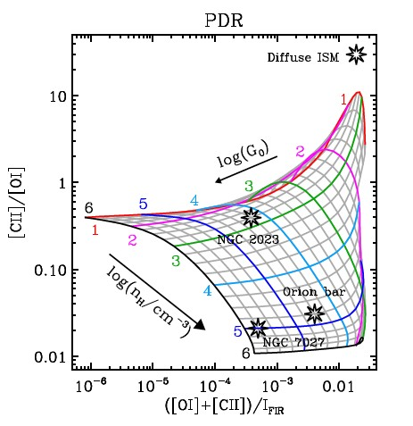
OB associations range in luminosity from ~10⁴ L (a single B star) to 10⁷ L (superstar clusters with hundreds of OB stars). Therefore, we anticipate [OI] luminosities of ~ 10²- 10⁵ L from the surrounding PDRs. In the later stages of evolution, this luminosity arises from an extended region (e.g., 3 pc at 1 kpc is ~ 10') so that only a small fraction of the luminosity lies in an individual SOFIA pixel. Nevertheless, in massive star formations regions like Orion, the [OI] surface brightness is expected to be ~2x10⁻³ erg cm⁻² s⁻¹ sr⁻¹ on a size scale of 10'. At this brightness, OCAM can directly trace the evolution of the gas and follow the dispersion of clouds.
At high gas densities, the [OI] 63 μm line dominates the cooling, with the [OI]/[CII] ratio reaching ~100 at n ~10⁶ cm⁻³. [CII] dominates the cooling at lower densities (n <1000 cm⁻³). The [OI]/[CII] line ratio at n >1000cm⁻³ is mainly sensitive to density, while at lower density the [OI]/[CII] ratio is mainly sensitive to gas temperature or incident UV radiation field. Figure D-1.2 demonstrates how the [OI] line, in combination with the [CII] line and the bolometric IR continuum, can be used to diagnose gas density, FUV flux, and thereby gas temperature. In addition, the ([CII]+[OI]) /FIR (far infrared) continuum from GLIMPSE, MIPSGAL, and HiGAL) provides an observational measure of the grain photoelectric heating efficiency. This procedure is well established and has been used to analyze previous KAO, ISO, and Herschel observations (Kaufman et al 2006; Steiman-Cameron et al 1997).
We propose to investigate the energetics and dynamics of the radiative interaction of massive stars with their parental clouds using OCAM. We have selected a sample of sources which span the full evolutionary sequence of this interaction; from the earliest phase as a deeply embedded ultracompact HII region (e.g., W3A), through the compact HII region phase where a champagne flow has just broken out of the cloud (M42-Orion), to more fully developed flows (e.g., M17). The sample also probes the embedded cluster size, ranging from HII regions powered by single or a few O stars (W3A, Orion; See Fold-Out 1, Science, Fig. 1.1), to those powered by 10-50 O stars (M17), to regions powered by 100’s of O stars (Arches, Quintuplet clusters, see section D-1.2.3). In each of these types of objects, we have selected a region with a size of 4'x4' centered on regions we expect to be dynamically representative for the star-cloud interaction – such as prominent ionization bars, evaporating globules, fingers or other dynamically evolving structures – which we will fully sample with OCAM. Supporting dust continuum and [CII] observations of all these regions exist through Spitzer and Herschel programs but only OCAM can provide the required spectral resolution to disentangle PDR and shock contributions in these dynamically confused regions and measure the photo-evaporation of molecular clouds due to OB stars.

D-1.2.2 Goal 2: Protostellar winds and jets interacting with their natal clouds

The [OI] 63 μm line is one of the strongest shock emission lines of the galaxy and provides an excellent diagnostic of mass loss from protostellar winds and jets. We propose to measure the [OI] associated with the outflows in the Cepheus cloud and study the global input of turbulent energy into molecular clouds by winds and jets of embedded low mass protostars.

Both forming and dying stars produce spectacular jets and outflows. Protostellar jets and wider-angle winds drive shocks into the surrounding cloud and entrain swept-up shells whose influence can reach up to 10 pc or more from the driving sources (See Fold-Out 1, Science, Fig. 1.2).
As accelerated gas interacts with its environment, it can generate turbulence, sputter grains, dissociate molecules, ionize atoms, and even disrupt the parent cloud, stopping further accretion and star formation. Outflows dominate feedback in regions forming only low-to intermediate-mass stars and may therefore contribute to the shaping of the IMF. Some massive star-forming regions such as Orion OMC-1 produce poorly collimated explosive outflows. Dying stars produce expanding envelopes. Their collapsing cores propel jets and fast winds into these envelopes during the proto-planetary nebula phase, often producing outflow structures resembling those powered by forming stars.
Radio, mm, near-IR, and visual tracers provide measurements of the velocities and masses in various flow components. Since each is a highly selective tracer of specific shock velocities, densities, and states, they provide an incomplete picture of the outflow. For example, species such as CO are calorimeters of the mass and momentum of swept-up, molecular gas; visual and near IR lines of H, [SII], [FeII], and H₂ trace the locations and velocities of fast (> 20 km/s shocks). However, because of its low-excitation (excited state only 228 K above ground) and the high abundance of elemental O, the 63 μm [OI] line is one of the strongest and most ubiquitous shock emission lines in galaxies. In fast (> 50 km/s) shocks where the cooling is dominated by optical and UV lines, the [OI] line is an excellent diagnostic of the mass loss in the wind or jet being shocked as it impacts the environment around young stars (Hollenbach 1985).
High extinction in embedded and distant regions renders near IR and optical tracers useless. For example, while the 2 μm lines of H₂ can be used to probe outflows in nearby, low-opacity regions, attempts to observe this tracer in clouds more than a few kpc from the Sun have mostly failed due to high extinction. In contrast, the long wavelength [OI] line can be observed nearly anywhere in the Galaxy.
A heterodyne focal plane-array is needed because mapping of the velocity and line-width is essential for discriminating between source models. [OI] associated with outflow lobes will closely follow the jets and cavity walls traced by reflection nebulae, heated PAH layers detected by Spitzer, or traced by molecular emission lines. Photo-excited emission from PDRs and from slow-shocks associated with D-type ionization fronts are expected to follow the warm-dust traced by Herschel/PACS 70μm and Spitzer 8 and 24 μm emission. In addition, the resolved line profiles can discriminate the broader emission from shocks from the narrow emission from PDRs. Low mass protostars often form in clusters, and in nearby star-forming clouds the extent of these clusters is of order arcminutes. The mapping capability of OCAM, with its 16 pixels, will enable a quick census of the mass and momentum input of the winds and jets of these outflows, and their contribution to the observed turbulence in molecular clouds.
OCAM will extend the investigation of outflows in the distant, highly obscured regions of the Galactic plane and Central Molecular Zone (CMZ) where the most massive stars and star clusters in our Galaxy are forming. Examples of such regions include: the Sgr B2 complex, the most massive and luminous star forming complex in the Milky Way, W43, W49, and W51 – three `mini-starbursts’ which are the closest analogs to the super-star-cluster (SSC) forming regions in nearby galaxies such as M82 and the Antennae. The 6.2" angular resolution of SOFIA, combined with the sub-km/s spectral resolution and several hundred km/s bandwidth of OCAM, will enable the detection of outflow such as Orion OMC-1 in these distant complexes without the line-of-sight confusion seen in CO or HCO⁺ towards the inner-galaxy or the CMZ.
D-1.2.3 Goal 3: The interaction of massive stars with their environment in the galactic center.

OCAM is well suited to probe the unique star forming environment of the galactic center and measure the energetics, physical characteristics, and kinematics of the warm, dense gas in the PDRs associated with the super star clusters in this environment. This will be a key stepping stone for our detailed understanding of the interaction of massive stars and their environment on the scale of galactic nuclei.
At a distance of only 8 kpc, the center of the Galaxy provides a unique opportunity for studies of the physical and chemical conditions of the interstellar medium and the star formation process in the nuclei of galaxies. Molecular clouds in the Galactic Center are unique because they have higher temperatures and densities, and stronger turbulent velocity fields (e.g., Guesten & Philipp 2004). Magnetic fields with mG field strength have been reported, that – at least locally – control the dynamics of some clouds. The heating is manifold with OB stars near the center creating diffuse ionized regions surrounded by PDRs at the edges of the cavities. Clouds compressed at the edges of the expanding bubbles are shock heated (e.g., Martin- Pintado et al. 1999). The dense gas phase in shielded cloud cores is heated by dissipation of small-scale turbulence (Wilson et al. 1982) and/or magnetic viscous heating (Guesten et al. 1987). It is therefore not surprising that the galactic center is a unique star forming environment. Several dense clusters containing thousands of OB stars are interacting vigorously with the surroundings through strong radiation fields and intense shock waves. Velocity and spatially resolved [OI] studies will provide a new view of the interaction of massive stars with their natal clouds in this unique setting.
Figure D-1.3: Large-scale VLA image of the galactic center, showing the mix of prominent HII regions, supernova remnants, and non-thermal filaments (Kassim et al. 1999).

Most of the ~4 x 10⁷ M of gas within the central 300 pc of our Galaxy resides in relatively dense molecular clouds, although an atomic component globally comprising a few percent of the total mass is evident in HI (Lang et al. 2010, & references therein). The atomic component resides largely in PDRs around prominent HII regions created by massive stellar clusters, such as the Arches, Quintuplet, and Central Parsec clusters, and around embedded, compact HII regions around massive clusters in formation, such as Sgr B2 and Sgr C (see Figure D-1.3). One of the most spectacular HII complexes in the Galaxy surrounds the Arches and Quintuplet clusters, which produce the large-scale “Radio Arc Bubble” (Foldout 1, Science, Figure 1.3), a strong shock colliding with its immediate environment (e.g., Simpson et al. 2007). Extended [OI] and [CII] have been observed with ISO toward the Sickle and Arches Filament molecular clouds lying at the upper rim of this Bubble (Cotera et al 2005; Poglitsch et al. 1991) but the limited spatial resolution and possible absorption by foreground material hamper interpretation in terms of the PDR density, temperature, and FUV field as well as the energy and momentum of the extensive shocks surrounding the Radio Arc Bubble.
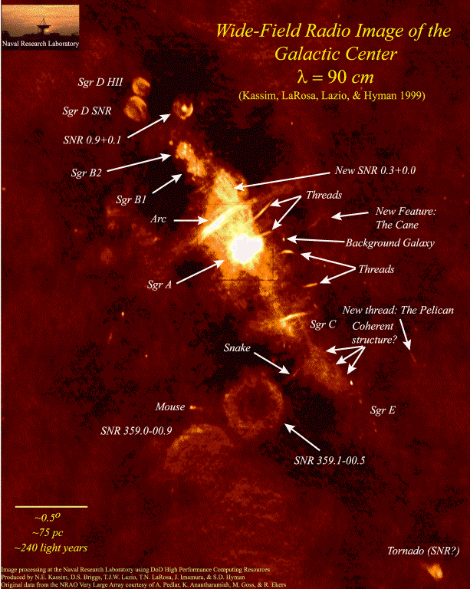
The Circumnuclear Disk (CND) – the presumed reservoir for future episodes of accretion on to the central black hole – surrounds the central stellar cluster of young, massive stars, and has been regarded by theorists as a rather porous PDR. In a previous study with the KAO, Jackson et al. (1993) measured strong [OI] emission from the ionized interior of the CND – Sgr A West – and pointed out that the atomic component of the central CND cavity carries an order of magnitude more mass than the ionized gas. Their [OI] mapping indicated that the inside edge of the CND itself may have some emission, but their resolution and sensitivity were not adequate to characterize the CND in any detail. Both the porous structure and the large atomic-to-ionized gas mass set this interaction zone between the central cluster and its surroundings apart from other regions of star formation in the galaxy. The CND is therefore an ideal target for OCAM on SOFIA.
Our strategy for observing the GC with OCAM is to map the 63µm line in four extended regions in the GC, as shown in Foldout 1, Science, Figure 1.3. The first, and largest – 14'x8' – is centered on the CND, and includes the compressed rim of the supernova remnant Sgr A East, which surrounds the CND in projection and possibly in 3D and the prominent 20 and 50 km s⁻¹ molecular clouds. With OTF mapping to a sensitivity of 7x10⁻⁵ erg cm⁻² s⁻¹ sr⁻¹ at 1 km/s resolution, and regridding to 12" spatial resolution, the CND-centered region can be observed in one 3-hour observing leg, allowing for overhead. The high spectral resolution is important for the characterization of foreground absorbing clouds (discussed below), but better sensitivity is achievable on the broad-lined GC clouds by smoothing the emission lines to a resolution of ~5 - 10 km/s.
The other three regions – all 6'x6' in extent – are centered on the Sickle and Arches HII regions and on Sgr B2 – a dramatic massive cluster in formation (Figure D-1.3). OTF mapping to a sensitivity of 2x10⁻⁵ erg cm⁻² s⁻¹ sr⁻¹ would require about two hours per region, with overhead, so these three regions could be mapped in two 3-hour flight legs. As outlined in section D-1.2.2 and D-1.2.3, at the regridded resolution, the observed [OI] 63 µm emission can be analyzed together with existing dust continuum and (spectrally unresolved) [CII] 158 µm maps from Spitzer and Herschel to provide the density, temperature, UV field in the PDRs and the mass loss and kinetic energy input by massive stellar winds.
An important secondary benefit of the proposed observations is that they will probe foreground gas. The CMZ is a strong continuum source at 63µm (e.g., Molinari et al. 2011), so gas in cold foreground clouds in the 3 kpc, Scutum, and Sagitarius-Carina arms should be visible in absorption. The narrow lines from these clouds – seen in absorption in many molecular lines – make them relatively easy to distinguish from the CMZ emission. In this way we can probe the oxygen abundance in different regions in the galaxy (see D-1.2.5.2). Most importantly, we are likely to see in absorption gas that is orbiting the GC in the innermost X1 orbits (sometimes referred to as the expanding molecular ring, or EMR). According to the prevailing paradigm (Binney et al. 1991), this gas has recently undergone the transition from atomic to molecular, as it migrates inwards via interactions with the Galactic bar. This gas has a relatively low density, so [OI] in the near side of the EMR would be seen in absorption against the bright continuum from warm dust in the CMZ, much as molecules such as OH and H₂CO in the near side of the EMR are seen in absorption against the radio synchrotron background. The EMR features are usually separable from the CMZ emission features because of large velocity offsets.

D-1.2.4 Goal 4: [OI] in Nearby Galaxies

OCAM allows the study of the interaction of massive stars on the global scale of OB associations in local group galaxies. Here, we propose to measure the [OI] emission in the nucleus of M33 and several prominent HII region complexes in order to measure the energetics, physical characteristics, and kinematics of the warm, dense gas in the PDRs as the massive stars destroy their natal clouds.
For a comprehensive view of the processes that drive star formation and the evolution of the interstellar medium, the conditions affecting star formation locally must be considered in the context of the overall dynamics of the galaxy. As gas is compressed in spiral arms, molecular cloud complexes are formed and star formation is triggered (Elmegreen 2011), resulting in rich star clusters and OB associations. The combined radiative and mechanical action of these stars will in turn shred the clouds stopping further star formation. The interstellar medium changes state as it flows through the stellar spiral density wave. This interaction is difficult to follow in our own galaxy because of the vast scales involved and the line-of-sight confusion but yet it is at the core of the life cycle of the interstellar medium. [OI] 63 µm observations of extragalactic HII region complexes provide an excellent tool for the study of the relevant processes on a global scale.
Existing observations and detection of the [OI] 63µm line in galaxies demonstrate the value of OCAM for extragalactic sources. The [OI] 63µm line was detected in emission from M82 (Watson et al. 1984), NGC 253, and NGC3256 (Carral et al. 1994) using the Kuiper Airborne Observatory. Subsequent studies have used ISO/LWS (Malhotra et al. 2001, Higdon et al. 2003, Kramer et al. 2005), and Herschel/PACS (Mookerjea et al. 2011). The observations fall into two categories: (1) single spectra, with arcminute spatial resolution and ∼ 100 km s⁻¹ spectral resolution, of a galaxy’s central region, and (2) small maps (2′×2′), with 7″ resolution and ∼100 km s⁻¹ spectral resolution, of star-forming regions in spiral arms. OCAM data will have substantially higher spectral resolution, providing valuable insight to the physical processes involved. The flux of the [OI] 63µm line is comparable to or greater than that of the [C II] 158µm line in luminous regions and is a significant fraction (~0.2%) of the total power emitted by spiral and irregular galaxies. The [OI] line flux, in combination with the [CII] 158 µm line flux and the far-infrared continuum flux provide the physical conditions in the emitting gas; e.g., the comparison of [OI] to [CII] and ([OI] + [CII]) to the IR continuum measure the gas density and strength of the illuminating UV field (Fig. D-1.2). Malhotra et al. (2001) were able to determine these values over broad regions in the centers of galaxies. OCAM maps of these galaxies will have 100 spatial resolution elements and 100 velocity resolution elements for each ISO/LWS beam. The value of improved spatial resolution is exemplified by Herschel/PACS maps of the HII region BCLMP302 in M33 (Mookerjea et al. 2011, Figure D-1.4). The [OI] emission varies strongly over a 2′ region and its distribution provides substantially new information, and new insight into the spiral arm phenomenon. The observed extent and variability of the [OI] emission underscores the need for large format heterodyne arrays on SOFIA.
OCAM will dramatically improve [OI] observations over the current state of the art, having both higher spatial resolution and orders-of-magnitude better velocity resolution. A region in a spiral galaxy like that shown in Figure D-1.4 will typically have an overall linewidth of 20 km/s comprised of multiple components. OCAM will, for the first time, resolve those components and show their dynamical interactions. Spiral density wave phenomena that create and destroy molecular clouds result in dynamical effects having velocities that are typically a few kilometers per second, velocities that can, for the first time, be resolved and measured by OCAM. 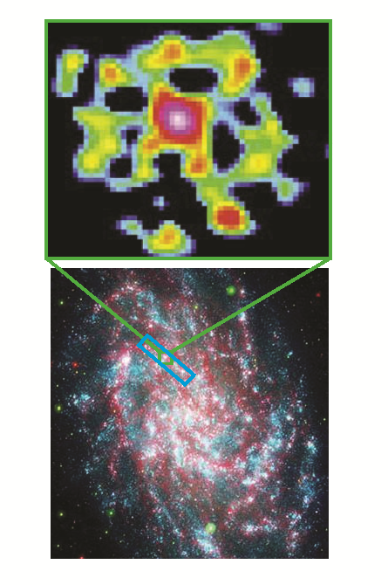
Figure D-1.4: (lower) False color image of the nearby galaxy M33 obtained by GALEX and Spitzer. Far-ultraviolet light from young stars glimmers blue, near-ultraviolet light from intermediate age stars glows green, while the red traces the photodissociation regions through the fluorescent emission of PAH molecules pumped by these ultraviolet photons. (upper) intensity of the [OI] line with 12″ resolution in the small region shown in green in the lower map, from Mookerjea et al. (2011). High spectral resolution [OI] mapping of M33 with OCAM (cyan box in lower frame) will trace the energetics and dynamics of the UV photons from the young massive stars with their environment.
The local group, late-type spiral galaxy, M33, is an ideal target for studying the global aspects of the interaction of massive stars with their natal clouds. With its fairly face-on view (inclination is 56 degrees) and loose SA(s)cd structure, the open spiral arms resolve into a multitude of individual stellar clusters and HII regions. At a distance of 840 kpc, OCAM’s pixels correspond to 25 pc and are well matched to the size scale of well-developed OB associations and their associated giant HII region complexes. M33 is also a regular, relatively unperturbed disk galaxy and has been well studied at X-ray, UV, optical, far-infrared, submm and radio wavelengths. Of key importance to this proposal, dust continuum observations and (spectrally) unresolved [CII] observations have been obtained with Herschel. With OCAM we will target the nucleus of M33 and the prominent HII regions, NGC604, NGC 595, IC142, BCLMP302, and BCLMP691.

D-1.2.5 Enabled science
The development of a sensitive heterodyne array at the [OI] frequency will enable a broad range of science questions to be addressed. These include the inner winds of Asymptotic-Giants Branch (AGB) stars, the interaction of the superwind with previous ejecta in post-AGB objects and planetary nebulae, the effect of the reverse shock on ejecta in young supernova remnants such as Cas A, the inner winds of red supergiants such as alpha Ori, the [OI] emission from nearby protoplanetary disks, the [OI] emission from X-ray excited gas, and the oxygen elemental abundance in the ISM. Extended absorption line studies with OCAM will be particularly powerful, as they provide the only measure of cold oxygen gas in the neutral ISM.

D-1.3 OCAM Complements Past Work
D-1.3.1 Relationship to Existing Data Sets
The data from the proposed OCAM science investigation will be highly complementary to existing observations performed in other atomic and molecular species, as well as continuum surveys. These include observations carried out by Herschel and other space missions.
CO: The CO surveys in the Galaxy^{41,42,43} and LMC^{44,45} will complement the OCAM survey by identifying molecular clouds whose surfaces OCAM detects and in which embedded young stars drive [OI]-producing shocks.
H I: OCAM observations enhance substantially the interpretation of existing H I surveys, allowing the PDR region where these two neutral atomic species coexist to be explored.
[CII] & [C I]: The velocity resolved [OI] 63 μm OCAM data will greatly enhanced the spectrally unresolved [CII] 158 and [CI] 609 and 370 μm studies obtained with PACS and SPIRE on Herschel. Coupled with CO data, this will provide a powerful probe of PDR chemistry, dynamics, and physical conditions.
Infrared Continuum Surveys: MSX, Infrared Astronomical Satellite (IRAS), Infrared Space Observatory (ISO), Spitzer GLIMPSE and MIPSGAL, and Herschel HIGAL Galactic plane surveys, and Spitzer SAGE and Herschel HERITAGE LMC surveys permit locating dark clouds, supershells, filaments and star forming regions using the IR continuum. The proposed OCAM Galactic Center survey provides the best corresponding interstellar cloud survey in [OI] that will place these 2D imaged structures in a broader context by identifying them with different phases of the ISM, providing a 3-dimensional location in the Galaxy via their Doppler shift, and measuring their internal velocities and velocity dispersions.

D-1.3.2 Complementarity to Other Missions/Instruments
SOFIA is the only existing platform for conducting high spectral resolution [OI] 63 µm observations (the KAO having been the only other). OCAM observations will complement the ongoing lower spectral resolution [OI] observations being conducted on Herschel by PACS and soon on SOFIA by FIFI-LS. The spectral resolving power (λ/∆λ) of OCAM is ~1000x greater than these instruments. The GREAT instrument on SOFIA can provide similar high spectral resolution, but OCAM will have several times the instantaneous bandwidth and far greater mapping speed.

D-2 INVESTIGATION REQUIREMENTS
D-2.1 Spectral Resolution
The flow motions of the neutral gas heated by energetic radiation are typically of order 1–10 km/s. The thermal and/or microturbulent velocities are of order 1 km/s. Therefore, we require spectral resolution of somewhat less than 1 km/s.
D-2.2 Spatial Resolution and Mapping Capability
An expanding HII region with a PDR shell surrounding it starts with a size of order 0.01 pc and expands to sizes of order many pc. At 1 kpc these sizes correspond to angular sizes from 2" to > 200". Therefore, to observe numerous expanding HII regions at various epochs (and therefore sizes) requires a single pixel beam size of order a few arc seconds, but at the same time the ability to map regions of size ~ several arcminutes, or a region perhaps 1 to 10% of the area of a GMC. Typically, the angular size of young, low mass clusters is of order arcminutes in nearby molecular clouds. The typical separation of individual low mass stars is of order 5-10". Thus, a single pixel beam size of 5-10" and a mapping capability of a few arcminutes is required.

D-2.3 Sensitivity
For the sensitivity estimate, we consider an OB association at a distance of 10 kpc with FUV luminosity of ~ 10⁴ L (i.e., single B star) and assume that this source is smaller than the 6" diffraction limit of SOFIA at 63 μm, and that the [OI] luminosity is 100 L (see section D-1.2.1) and the line width is 10 km/. Also, assume a velocity resolution of 1 km/s. The flux on a single pixel and in a single velocity channel is then 3x10⁻¹² erg cm⁻² s⁻¹. Thus, we require a single velocity channel line flux sensitivity of ~ 10⁻¹² erg cm⁻² s⁻¹.
OCAM instrument requirements are summarized in the Science Traceability Matrix (see Fold-Out 1). Proposed survey regions in Orion, Cepheus A, the Galactic Center, and M33 are indicated with white boxes in Fold-Out 1, Figs. 1.1 – 1.4.

D-3.0 OCAM Data Products
The OCAM data products will be comprised of a set of FITS (Flexible Image Transport System) files that contain a cube of data corresponding to line intensity as a function of the 2 angular coordinates and spectroscopic axis. The data cubes are generated in a pipeline that consolidates the raw, On-the-Fly Mapping data into a grid of Nyquist-sampled spectra. There will be a separate FITS cube for each measured spectral line observation. Each data cube will be fully calibrated with subtracted spectral baselines. For each FITS cube, the OCAM team will also deliver a set of two dimensional images that includes a statistical error image of intensity values and a masked moment image equivalent to integrating over the full spectral bandpass.

D-4.0 Minimum Science/Technology Mission
OCAM’s goals are twofold; demonstrate the path forward to achieving large-format, high frequency, THz heterodyne focal plane arrays on SOFIA and to conduct groundbreaking science with a building-block prototype, 4.7THz array. These goals could potentially be achieved using one of OCAM’s 1x4, [OI] subarrays and two flights on SOFIA. The principal science goals would be achieved by making 10'x10' maps of the Galactic Center, M33, and Orion. The minimum mission would eliminate a full year from the project budget, resulting in a savings of ~$2M.

D-5.0 Science Implementation
OCAM benefits tremendously from hot electron bolometer (HEB) mixer and low-noise amplifier (LNA) technology developments for Herschel and STO, as well as NASA’s investment in Quantum Cascade Laser (QCL) LO technology. OCAM will utilize digital autocorrelator spectrometers with heritage from ESA (Odin) and NASA (MLS & STO) missions.

D-5.1.0 Instrument Summary

The instrumental goal of OCAM is to demonstrate the technology required to make high spectral (<1 km/s) and angular resolution (6.2") maps of the Galactic Center, star forming regions, jets/shocks, and nearby galaxies in [OI]. SOFIA’s operational altitude and telescope aperture make it an ideal observational platform for such an array. To achieve the target spectral resolution, OCAM will utilize heterodyne receivers. OCAM consists of: (1) a 16-pixel heterodyne receiver tuned to the 4.7 THz (63 µm) [OI] line; (2) autocorrelator spectrometers; (3) instrument control electronics; and (4) a closed-cycle cryostat (see Fold-Out 2, Instrument). Much of the OCAM instrument architecture and hardware is based on the experience gained in developing the 64 pixel, 345 GHz, Superheterodyne Camera (SuperCam) array and the instrument package for the Stratospheric THz Observatory (STO).
A Block Diagram of the OCAM instrument is shown in Fold-Out 2, Instrument, Figure 2.1. Key instrument parameters are listed in Fold-Out 2, Instrument, Table 2.0. OCAM’s optics are simple, low-loss and designed to provide a 6.2" full-width-half-maximum (FWHM) beam size on the sky with a 44" x 44" field of view. Our observing strategy is to make adjacent On-the-Fly (OTF) strip maps of survey regions. An ambient load/cold-sky calibration (CAL) will be performed at the beginning and end of each strip map. During each strip map (lasting as long as ~10 minutes) a calibration load will be regularly observed. This mode of operation reduces the reliance on secondary chopping.

D-5.1.1 System Description
The OCAM instrument has a simple, modular design (see Fold-Out 2, Instrument, Fig. 2.1). The instrument optics, local oscillator, mixer arrays, and first-stage, low-noise amplifiers reside in a removable cryostat insert (Figure D- 1.5a, below). The insert consists of 300K (ambient) vacuum plate, a 45K plate, and a 4K plate, all rigidly held together with low thermal conductivity, G-10 struts. The f/19.5 beam from the SOFIA telescope enters the insert through a resonant, low-loss, polyethylene, pressure window. It then passes through a metal mesh 4.7 THz bandpass filter mounted to a 45K radiation shield (not shown). The filter prevents bolometric heating of the hot electron bolometer (HEB) mixer array. The beam then passes through the location of a solenoid activated pick-off mirror. With the mirror ‘in’ (as shown) the back-side of the mirror directs light from a precision, temperature regulated, blackbody load down into the 16 pixel, [OI] 4.7 THz HEB array. With the pick-off mirror out of the way, the telescope beam passes through a 10% reflective dielectric beam splitter that combines the sky and 4.7 THz local oscillator (LO) beam. The 4.7 THz LO beam (shown in blue) is generated by a solid-state, quantum cascade laser (QCL) mounted to the 45K plate. A beam splitter directs a few percent of the LO beam to a 10-cm long absorption tube containing methanol gas. A methanol absorption line is used to frequency lock the QCL as demonstrated by Richter et. al. (2010) and Ren et. al. (2011). The LO beam is then reflected off a phase grating designed to illuminate each pixel in the focal plane array with the proper amount of LO power. Once through the sky beam splitter/combiner, the combined signal and LO beams are divided into horizontal and vertical components by a polarizing grid (see Figure 1.5b). Each polarization component encounters a roof mirror which spatially separates and reflects it into two, 1x4 arrays of AR coated, elliptical lenses. Each lens is designed to efficiently couple an f/19.5 SOFIA beam to a 2x2 mm HEB mixer chip mounted on its base. To achieve the designated beam spacing on the sky, the center to center separation of lenses is 3.1mm. Just above each lens the roof mirror is machined to correct for any measured squint that occurs due to mounting errors between the lens and the mixer chip. Each 1x4 subarray of HEB mixers is integrated into a common mount.
Polarizer
Figure D-1.5: OCAM Cryostat Insert. a) Sky (yellow) and local oscillator (blue) signal paths through the insert. b) Combined sky and LO beams is divided into vertical and horizontal polarization components, each of which is split between two, 1x4 mixer arrays by a roof mirror.
SOFIA Beam
Pick-Off Mirror
SkyBeam Splitter
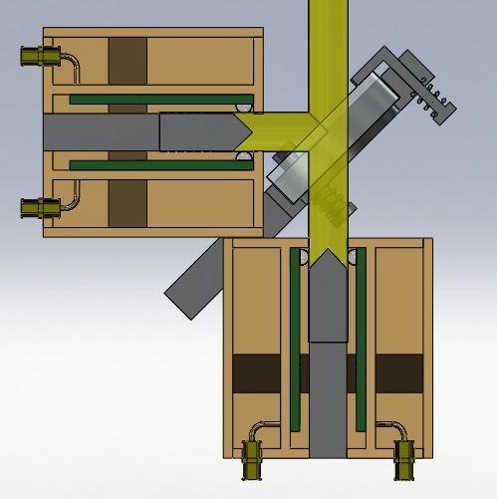
The HEB mixers downconvert the high frequency sky signals to microwave frequencies by multiplying the incident sky and LO beams together across a resistive nonlinearity in the HEB’s micron-size Niobium Nitride (NbN) bridge. The product of the multiplication contains sum and difference frequencies. Filtering permits only the difference or intermediate frequency (IF) signal to appear at the mixer output. From there, coax conveys the downconverted sky signal to a series of low-noise cryogenic and room temperature microwave amplifiers, which boost signal levels to ~0.1 uW, suitable for digitization.
QCL
Cal Load
Polarizer
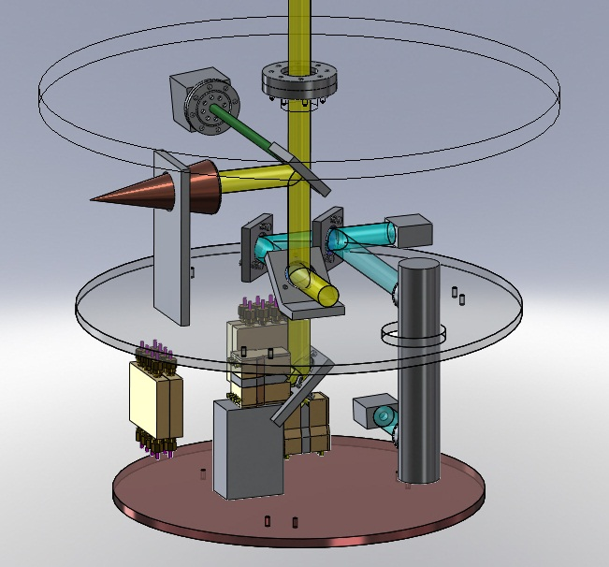
SOFIA Beam
Pick-Off Mirror
QCL
Absorption Tube
IF Amps
SkyBeam Splitter
Cal Load
a)
1x4 Mixer Arrays
b)
The critical, first stage IF low-noise amplifiers (LNAs) will utilize the same high-performance, low-power technology developed for STO. The IF signals will have a center frequency between 1 and 3GHz and an instantaneous bandwidth of 2 to 5 GHz. At our observing frequency (4.7 THz, the [OI] line) a 5 GHz IF bandwidth will deliver 319 km/s of velocity coverage. Velocity coverage of this order is needed to accommodate the wide velocity dispersion expected in the data toward the inner parts of the Galaxy.
Polarizer
Each OCAM pixel will have its own 1024-lag, autocorrelator spectrometer to produce a power spectrum of the input signal (see discussion below). The power spectra from all 16 pixels are read by the instrument computer and passed on to SOFIA’s data acquisition system via an ethernet link. All OCAM electronics including (1) the IF/correlator boards, (2) the HEB/LNA bias board, (3) the QCL frequency lock box, (4) the pick-off mirror controller board, and (5) the instrument computer will be mounted in the `counter-balance’ equipment rack attached to the elevation flange (see Fold-Out 2, Instrument, Figure 2.2).

D-5.1.2 Expected Sensitivity
Recent lab measurements by OCAM SRON team members on quasi-optical HEBs at ~5 THz have yielded double side band (DSB) receiver noise temperatures of <1000 K (see Fold-Out 2, Instrument, Fig. 2.6). At SOFIA altitudes the noise added by the atmosphere is usually less than the receiver noise. For our sensitivity calculations we have assumed a receiver noise temperature of 1000K and single-sideband (SSB) system temperature (including atmospheric and optical losses) of T_{sys} = 4000K. For a 1 km/s line width (δv), we will achieve a 1σ, T_{rms}~0.3K in integration time (δτ) of 100sec. This limit varies as (δvτ)^{-0.5}. The OCAM instrument characteristics are summarized in Fold-Out 2, Instrument, Table 2.0.

D-5.1.3 Component Selection

D-5.1.3.1 Mixers
OCAM will utilize HEB mixer technology originally developed for Herschel by SRON and Technical University Delft. At the `super’ THz frequency of OCAM, quasi-optical mixers are the proven technology and have been shown to provide the sensitivity needed for the proposed OCAM science investigations. A plot of the noise temperature of HEB receivers as a function of frequency is provided in Fold-Out 2, Instrument, Figure 2.6. Transitioning these HEB mixers to the 4x4 array for OCAM is a straightforward repackaging of proven technology. Additional concept drawings of the mixer arrays are provided in the Fold-Out 2, Instrument, Fig. 2.5. OCAM’s 4.7 THz HEB devices will be fabricated by SRON/TU Delft. The UofA will use the devices in the assembly of the 1x4 mixer subarrays.
Figure D-1.6: Left: Schematic block diagram to illustrate the frequency locking by using a gas cell. Right: Absorption lines of methanol near the [OI] line at 4.744 THz (Ren et. al. 2011).
Poor Allan times have been a major issue for HEB mixers. However, recently our SRON Co-Is have demonstrated a method to stabilize a hot electron bolometer (HEB) mixer at 2.5THz (Hayton et al. 2011). The technique utilizes PID feedback control of the local oscillator (LO) laser intensity by means of a voice-coil based actuator placed in the beam path, effectively acting as an LO AGC loop. They show that a factor of ~50 improvement in the measured total power Allan variance is possible with this technique in addition to the factor ~10 improvement gained in spectroscopic mode. In this stabilized mode of operation the HEB bias current becomes the set point for the PID loop and is maintained through rapid correction of the LO intensity. This has the effect of significantly reducing multiple instability sources including: LO amplitude noise, LO mechanical instability, and even signal direct detection in the event that large changes in signal are present. Spectroscopic Allan times of >30sec in a 16MHz bandwidth were measured. We will use this LO stabilization approach in OCAM. Such long Allan times will dramatically reduce the required number of calibrations and dramatically increase the data quality and mapping speed.

D-5.1.3.2 LO’s
At the frequency of the [OI] line (4.744THz), the only viable option for a compact local oscillator is a THz Quantum-Cascade laser (QCL) (Kohler et al. 2002). LO’s based on multipliers have not been demonstrated above ~2.7 THz. A gas laser was built as an LO for the satellite, EOS MLS, launched by NASA. However, it made use of a line at 2.5 THz, which is very strong. At 4.7 THz, there is only a relatively weak line available. This line is roughly 8 GHz from the [OI] line. A frequency difference of 8 GHz is too great for HEB mixers because of their limited IF noise bandwidth (6 GHz).
Co-I Hu’s group at MIT has demonstrated a 4.7 THz source that can be used as an LO (see Fold-out 2, Instrument, Fig 2.4. To build the 4.7 THz LO sub-system for OCAM, the UofA, MIT, and SRON/TU-Delft will work as a team. The MIT-SRON team has pioneered QCL/HEB technology (Ren et al. 2010) and will utilize this experience for OCAM. MIT is responsible for delivering the required QCLs. SRON/TU Delft is responsible for frequency locking the QCL and testing it with HEB mixers. Figure D-1.6 illustrates the frequency locking approach. UofA will build the flight LO system per the SRON/MIT design.

D-5.1.3.3 Spectrometers
The OCAM spectrometer system will be an Omnisys Instruments autocorrelator unit capable of processing 16 x 5.5 GHz receiver inputs at 6.45 MHz resolution. The OCAM spectrometer architecture is based upon a proven ASIC design (HIFAS) and has been operated up to a 14 GHz clock rate (Fold-Out 2, Instrument, Fig. 2.7). The preliminary OCAM design is based on using four of the pictured blocks. The total spectrometer volume is just 8 x 16 x 16cm.

D-5.1.4 Cryostat
A 3-D rendition of the OCAM cryostat is shown in Fold-Out 2, Instrument, Figure 2.3. The cryostat is a cylinder 50cm long and 30 cm in diameter. Light from the telescope enters the cryostat through a resonant, 25mm diameter low density polyethylene window and passes through an IR blocking filter mounted on the 45 K radiation shield. OCAM will use a CryoMech PT410 cryocooler. The cooler has 1.0 W of thermal load capacity at 4.0 K and 35W at 45K with orientation-independent operation for elevation swings < ±30˚. The operating temperature of the cryocooler is stabilized by the addition of a helium gas pot on the 2nd stage. Once the 2nd stage cools to 4 K, the helium gas liquifies. The OCAM HEB array is heatsunk to this pot via low-loss, vibration-damping copper straps. Calculations indicate the PT410 load capacity is sufficient to cool the mixers and amplifiers to the proper operating temperatures. The PT410 cold head will be driven by a gymbaled, water-cooled compressor mounted to the aircraft at the location of the SI equipment racks. CryoMech has given us an estimated cost for the custom refrigerator/compressor and Universal Cryogenics of Tucson, Arizona has provided a quote for the cryostat and compressor mount fabrication.

D-5.2 Mission Design
The OCAM baseline mission is to have 3 SOFIA science demonstration flights, with the goal of mapping ~0.25 square degrees of the Galactic Center, star forming regions, and nearby galaxies. An efficient On-The-Fly (OTF) mapping algorithm will be utilized to achieve maximum science throughput. Further discussion may be found in Sections E-1 and E-4.
D- 5.3 Data Analysis and Archiving
OCAM has 16 heterodyne pixels, each with 1024 spectroscopic channels. The diffraction limited beam size is 6.2" with a FOV of order 1 arcminute. The beams will be scanned at about 10”/sec. This implies a readout rate of 1/4 second or faster, in order to avoid beam smearing. For 12 bit numbers the data rate is of order ~1Mbit/sec. The real time data stream will be used to optimize observing strategies when required. The primary data pipeline task is to regrid the irregularly sampled On-the-Fly data onto a regular grid. The science team has extensive experience in this area. Because the OCAM surveys will provide new insights into the role [OI] emission line plays in several different types of astrophysical environments and are expected to be of value to the broader astronomical community, the science team is favors waiving a normal data proprietary period in favor of direct data releases to the community. The OCAM data products will be in the form of FITS data cubes distributed from the University of Arizona and registered to the National Virtual Observatory (NVO). The data will be released as soon as calibration and formatting is complete.
Science Team Member | Role and Responsibility | Relevant Capabilities and Experience
Chris Walker (UA) | Principal Investigator | Sub-mm Instruments, Star Formation, PI- STO
Alexander Tielens (U Leiden) | Project Scientist: PDR Co-Lead | ISM Physics, Star Formation, Herschel/HIFI Project Scientist
John Bally (U. Colorado) | Jets/Shock Lead | IR/Submm Observations of Jets/Shocks
Chris Groppi (ASU) | Deputy Instrument Scientist | Sub-mm Instruments, Star Formation
Frank Helmich (SRON) | [OI] Survey Lead: SRON | ISM Physics, Star Formation
David Hollenbach (SETI) | PDR & Jet/Shock Co-Lead | ISM Physics, Star Formation
Craig Kulesa (UA) | DPI: Instrument Scientist | Sub-mm Instruments, ISM Physics, D-PI STO
Chris Martin (Oberlin) | Synergy with Herschel Programs | Herschel HIGGS program PI, Submm Instruments
Gary Melnick (SAO) | Absorption Line Studies Co-Lead | SWAS PI, ISM Physics and Chemistry
Mark Morris (UCLA) | Galactic Center Lead | Galactic Center Optical, IR, Radio Observations
David Neufeld (JHU) | Absorption Line Studies Co-Lead | Physics and Chemistry of the ISM
Antony Stark (SAO) | Nearby Galaxy Lead | CO Surveys, Physics of Galactic Center

Table D-2 Science Team Roles, Responsibilities, Capabilities and Experience
D- 5.4 OCAM Team
The OCAM mission is supported by an outstanding team of scientists with extensive experience in observations, modeling, theory, and interpretation of the interstellar medium, star formation, and galactic nuclei (including ours). The roles, responsibilities, and experience of each Science Team member are summarized in Table D-2. Instrument Team members include leading experts in HEB mixers (J.R. Gao of SRON) and QCL local oscillator technology (Qing Hu of MIT and John Reno of Sandia National Laboratories). Chris Walker (PI), Craig Kulesa (Co-PI), Tony Stark, Chris Groppi, and Chris Martin all have extensive experience designing, building, and deploying THz receiver systems.

