A 4-6 K Cryocooler for ULDB Astronomy

Summary

We propose to develop, test, and demonstrate an efficient, low-power, low-mass, 4-6K mechanical refrigerator (i.e. cryocooler) for balloon-borne experiments. The cooler will be initially flown on the Stratospheric TeraHertz Observatory (STO). The upper limit for flight times of LDB experiments with detector arrays requiring cooling in this temperature range has been limited by the liquid cryogens they must carry. Even with a large (120-200 liter), well engineered dewar (e.g. for BOOMERanG¹) flight times of only ~14 days have been possible. For these types of experiments to reach flight times of ~40 days for zero pressure and ultimately 50+ days for super pressure balloons, cryogenic systems are needed that can keep detectors at their required operating temperatures for comparable periods. Ultra long hold time liquid helium cryostats capable of such lifetimes are too heavy to meet the ~1 ton payload target for ULDB missions. In ground-based astronomy where detector systems routinely run for >100 days at a time, the community has been using commercially available cryocoolers to meet experimental requirements for many years. These coolers require an initial investment which is often more than a liquid cryogen based system, but their reliability, lifetime, and low operating cost more than pay for the extra investment. However, the power and weight requirements of a present off-the-shelf system capable of cooling even a modest size detector array to 4-6 K make them impractical for LDB and ULDB flights. Fortunately, light weight cryocoolers have been under development by NASA in support of space-based telescopes for some time. One such cryocooler developed by Ball Aerospace as a prototype for the MIRI instrument on JWST more than meets the cooling requirements for STO. By upgrading the STO cryostat from a liquid helium based system to one utilizing the Ball cryocooler, the STO flight time can be extended to match that of the balloon, potentially tripling the science return for each flight. The potential savings in logistics costs and man years of effort to achieve the same science return is, in itself, significantly more than the cost of the proposed effort. The cooler will be designed so that similar units can be reconfigured to meet the needs of other potential users. The demonstration of the cooler on STO will help pave the way for the ~100 day flights of ULDB missions in the future. Additionally, the successful development of the 4-6 K ULDB Cryocooler will be transitional to space flight and improve the Technology Readiness Level (TRL) for future low temperature space astronomy missions.

- Scientific Justification
The proposed cryocooler development and implementation is an enabling technology that will help provide a paradigm shift in what is possible on extended balloon flights in a variety of leading-edge astrophysics research areas.

Throughout much of NASA’s history of high altitude balloon flights cryogenically cooled detectors have been used to gain new insights into the origins and evolution of stars, planets, and the Universe itself. Many of these instruments served as pathfinders to test both the scientific theories and technologies for space based observatories. One principal advantage of space based platforms has been the ability to conduct observations over much larger periods of time than has been available from balloons. However, with the new capability of ~40 day LDB flights from the Antarctic and, in the future, even longer (~100 day) flights through the ULDB program, the science that has traditionally been only achievable on SMEX and/or MIDEX class missions can now be realized at < 1/10 the cost. This cost savings means that a larger number and variety of science and technology path finding missions can be performed and a new generation of students and future PI’s trained.

One key to realizing the full potential of these longer flights for astrophysics is the availability of cryogenic systems that can meet both instrument and mission related requirements. The amount of helium (and subsequent tank size and weight) required to cool even modest sized focal planes to 4-6 K makes the realization of a dewar capable of >20 day hold times extremely difficult and/or impracticable for extended LDB and ULDB flights. Mechanical cryocoolers are an attractive alternative to liquid cryogen systems and have been employed at ground based observatories for decades. However, the power requirements for these systems (> 1.3 kW) makes them problematic for balloon payloads.

Here we propose to adapt an efficient, low-power, low-mass, Ball Aerospace cryocooler originally designed, built, and tested as a prototype for the MIRI instrument on JWST for use on LDB and ULDB flights. Once fully characterized in the lab, the cryocooler will be employed on the Stratospheric TeraHertz Observatory (STO). In its first Antarctic flight scheduled for 2010, STO will use a 200 liter liquid helium dewar to cool its 8, hot electron bolometer (HEB) focal plane mixers. By using a small cryocooler to cool a radiation shield to ~77K, the lifetime of the dewar is expected to be ~16 days. The Ball 4-6K cryocooler will replace the helium tank for the next expected science flight in 2012. With the implementation of the cryocooler the STO mission lifetime is, in principle, set only by the maximum time the balloon can remain aloft, ~40 days. The increased flight time dramatically increases the science return of the project with a significant reduction in cost in manpower and other resources compared to achieving the same science goals with multiple flights. As is, the Ball cooler meets all the STO technical requirements. The same basic cooler design will be capable of being readily modified to achieve either lower temperatures or greater cooling capacity as maybe required by other LDB/ULDB efforts. The cooler will have vibration levels comparable to or better than a more power hungry pulse tube cooler, making it suitable as a pre-cooler for bolometric detector arrays requiring sub-Kelvin temperatures. This type of detector is most commonly used for cosmic background and interstellar dust observations in the far-infrared.

The implementation of the cooler on STO directly addresses NASA Research Objective 3D.3. Through the cooler’s potential use on future LDB/ULDB projects where cooling of bolometric detectors is required for long periods, the proposed effort also addresses NASA Research Objectives 3D.1 and 3D.2. In its most recent report (20 December 2008) the Scientific Balloon Assessment Group identified three high priority needs over the next decade; 1) Fund an increased number of more sophisticated balloon payloads suitable for multiple missions and exploiting the new balloon capabilities, 2) Complete the development of super pressure balloons to enable operational programs at mid latitudes, and 3) Build capability for 100-day flights. The proposed cryocooler development and implementation is an enabling technology that will help provide a paradigm shift in what is possible on extended balloon flights in a variety of leading-edge astrophysics research areas and, in doing so, help meet these critical needs.

1.1 The Stratospheric TeraHertz Observatory: Overview

The Stratospheric TeraHertz Observatory (STO)² is a Long Duration Balloon (LDB) experiment designed to address a key problem in modern astrophysics: understanding the Life Cycle of the Interstellar Medium (ISM). In its first science flight in December 2010 STO will survey a section of the Galactic plane in the dominant interstellar cooling line [C II] (158 μm) and the important star formation tracer [N II] (205 μm) at ~1 arc minute angular resolution, sufficient to spatially resolve atomic, ionic and molecular clouds at 10 kpc. Our mission goals for this survey are to:

- Determine the life cycle of Galactic interstellar gas.
- Study the creation and disruption of star-forming clouds in the Galaxy.
- Determine the parameters that affect the star formation rate in the galaxy.
- Provide templates for star formation and stellar/interstellar feedback in other galaxies.

STO will be using the telescope and gondola originally used in APL’s Flare Genesis Experiment (see Figure 1). With the 80 cm telescope aperture, STO will have an angular resolution ~1’ and be able to discriminate clouds in a given beam and determine their distance from Galactic rotation. STO will utilize a heterodyne receiver system with a resolving power, R > 10⁶ . The first flight receiver will consist of eight, phonon-cooled HEB mixers; four optimized for the [CII] line and four for the [NII] line. The STO spectrometer will have sufficient bandwidth to detect all clouds participating in Galactic rotation in each of the 8 pixels. STO is capable of detecting every giant molecular cloud in the Galaxy, every HII region of significance, and every diffuse HI cloud with A_{V} > 0.3.

Figure 1. STO Telescope and Gondola: waiting to be reconfigured from APL’s Flare Genesis Experiment

1.2 Science Return from a ULDB STO

The realization of the proposed cryocooler effort will revolutionize the scientific grasp of astronomical LDB and ULDB missions, and increase the per-mission impact of the suborbital program without the additional logistical cost (i.e. by increasing the number of launches). Here, we illustrate what the impact would be for a second flight of STO, nominally proposed for December 2012. STO's first LDB science flight will map approximately 30 square degrees of the Southern Galactic Plane in the pivotal fine structure lines of [C II] and [N II], with a corresponding “Deep Survey” covering up to one square degree at increased sensitivity. Not including the expected improvements in terahertz heterodyne focal plane technology for the second LDB flight, a 40 day mission would allow an additional 80 square degrees of coverage in both the Inner and Outer Galaxy; a truly definitive Galactic Plane survey (Figure 2). Because conditions in the interstellar gas are sensitive to environment, and vary dramatically as a function of Galactocentric radius³, we must sample the entire Galactic Plane to construct a comprehensive map of the interstellar gas and star formation in the Galaxy. In addition to the Galactic Plane survey, the corresponding “Second Deep Survey” would encompass significant portions of the two nearest bright satellite galaxies of the Milky Way: the Large and Small Magellanic Clouds (the LMC and SMC respectively). Understanding the life cycle of interstellar clouds and star formation in these low-metallicity environments is a necessary step toward constructing a template for the galactic interstellar gas, to be ultimately applied to more distant galaxies⁴. STO would be able to map large portions of these galaxies with high sensitivity (10^{-6.5} erg/s/cm²/sr), an unachievable feat with the limited amount of time available on larger missions such as SOFIA and Herschel.

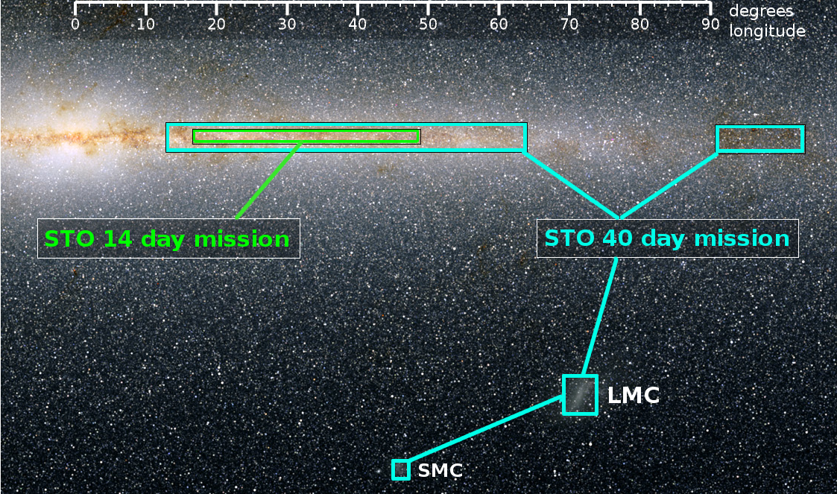
Figure 2. The scientific return from an extended duration (~40 day) balloon flight of STO, made possible by the cryocooler development proposed here would otherwise take three separate flights and at least 6 years to complete!

The resulting science return would take STO from the realm of the Milky Way interstellar medium to studies with direct extragalactic application! The proposed cryocooler could also be used with the newest generation of incoherent detectors such as BIB photoconductor arrays⁵ in the mid infrared and TES bolometers and MKID arrays in the far infrared⁶. As with heterodyne arrays, the scientific applications would span from comets to cosmology. In particular, high resolution spectroscopy (both with coherent and incoherent detectors) in the mid- and far- infrared will be a regime whose surface will only be scratched by Herschel during its lifetime, and represents a fraction of the scientific scope of SOFIA. Astrochemical studies of circumstellar disks, atmospheric studies of transiting extrasolar planets, and serendipitous spectral imaging and monitoring of active galactic nuclei and galactic black hole candidates would all be tractable scientific campaigns. LDB experiments will be able to make significant scientific progress on these and many other fronts in the next decade(s), but only if the capability of flying long, productive missions can be realized on the cryogenic front.

- Choice of Cryocooler Technology
The proposed ULDB cryocooler leverages off NASA space cryocooler development to provide a compact, low-power (< 400 W), low-weight (< 40 kg), low-vibration, 4-6 K cryogenic system for extended (> 100 day) operation.

The purpose of the STO cryogenic system is to hold the instrument at its required operating temperatures. Superconducting mixer elements require temperatures of 6 Kelvin or below, and the low noise amplifiers are optimally held below 18 K. The simplest and most common way to provide this environment is with expendable liquid helium, such as on the BOOMERanG program¹. That will be the initial method used for the STO science flight scheduled for 2010.

The essential cryogenic components in the STO cryocooler system are shown in Figure 3. The cryogen is the ultimate source of cooling for the mixers, LNA's and LO multipliers. Besides the usual MLI insulation and low conductivity structural support, the dewar has a thermal shield surrounding the helium tank for blocking parasitics. On BOOMERanG, the shield was cooled by vapor escaping the dewar and an additional nitrogen dewar. On STO, the shield is actively cooled by a single stage mechanical cooler.
Sunpower
Cryotel GT Cooler
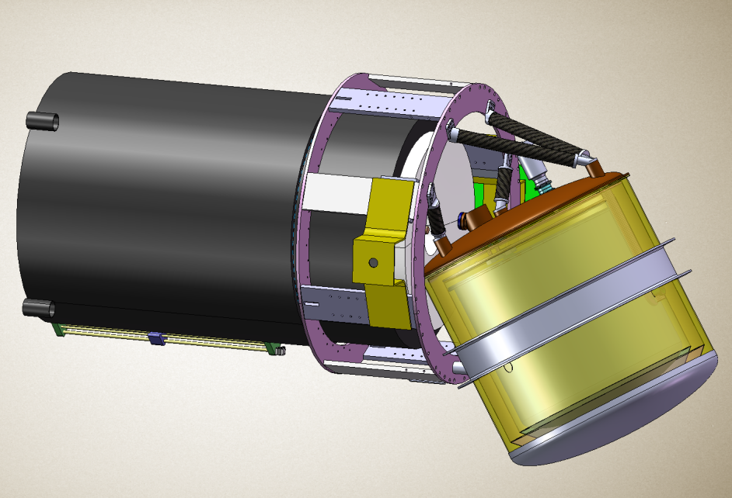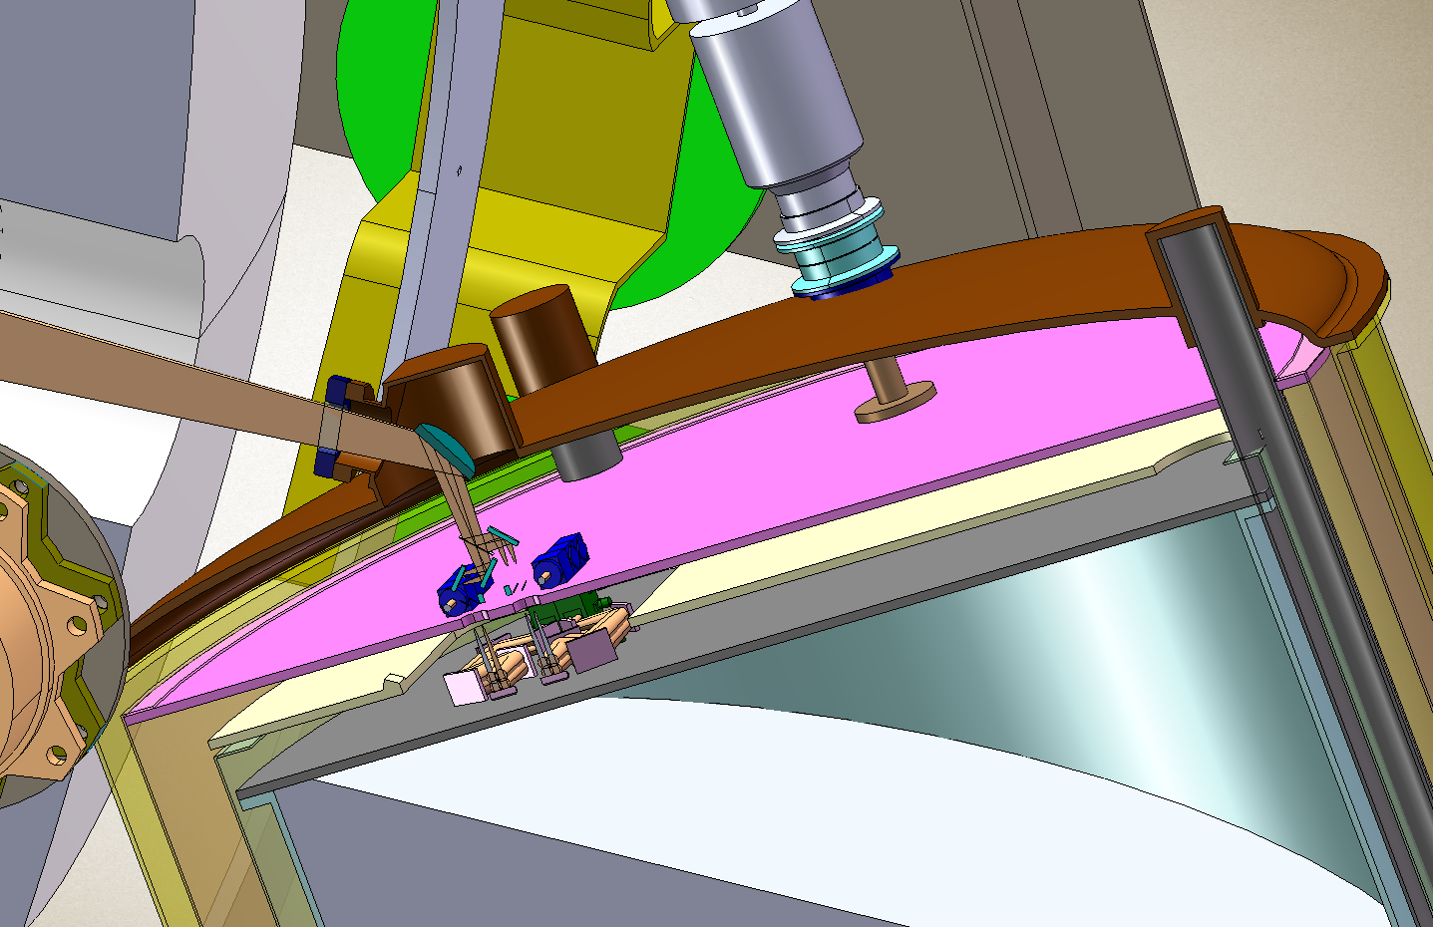
a
b
77 K
25 K
4 K
200 liters
Liquid Helium
Telescope
Dewar

Figure 3. The essential elements of the existing STO cryogenic system. a) Telescope and dewar assembly. b) The detector focal plane is cooled to ~4K by ~200 liters of ⁴He. A cryogenic lifetime of ~14 days is achieved by using a small, low-power cryocooler to hold the radiation shield at ~77K.

However, a liquid helium cryogenic system imposes inherent limitations on the mission. The most significant limitation is the limited helium lifetime. Other mission impacts from an expendable liquid cryogen system include large cooling system volume, relatively high mass, limited cooling capacity, and significant thermal shielding complexity. For the BOOMERanG program, a state of the art liquid helium system, has a lifetime limit of less than 17 days, required an additional nitrogen cryostat to reduce heat loads, had a cryostat volume of 140 liters (1.6 m height by 0.8 m diameter), and a cryostat mass of about 250 kg.

The current proposal is to upgrade the STO expendable cryogen system to a mechanical refrigerator, or cryocooler. Compared to an expendable cryogen system, cryocoolers inherently have long unattended lifetimes (10 years or more for space systems, a year or more for terrestrial systems), small volumes and system mass, and large cooling capacities. The enhanced lifetime is especially important for the STO mission and would enable both Ultra-Long Duration Balloon flights (over 100 days) and apply to future space missions in excess of 5 years in duration.

Providing cooling to 6 K or below, there are commonly two cryocooler options for the STO Mission: existing laboratory grade cryocoolers, such as the Sumitomo Gifford-McMahon (GM) or the CryoMech G-M Pulse Tube (P-T) coolers, or emerging, medium TRL (Technology Readiness Level) space coolers such as the Ball 4-6 K Hybrid Cooler. The lab coolers have the advantage of lower cost and higher maturity, while the space coolers have the advantages of lower power, lower induced vibration and jitter, and smaller size. Ball proposes to utilize the advantages of both lab and space coolers by developing a custom version of our space cryocooler using commercial cooler components that will meet the program requirements and enable the longer duration missions, at a much lower cost. The STO Cooler will be a long lifetime (over a year), low power (under 400 W), low mass (less than 40 kg), high capacity (over 80 mW at 4 to 6 K) system with a recurring cost 10 times lower than a space cryocooler. This will not only enable ULDB type missions, but also translate to higher TRL levels and lower costs for future space Terahertz and Infrared Astronomy missions.

2.1 STO Cryocooler System and Requirements

The ULDB cryocooler will be a ``drop-in’’ replacement to the conventional liquid helium system to be used in the first STO Antarctic flight, extending mission lifetime to match that possible with the balloon.

The STO Cryocooler System is shown in Figure 4.The mixers are mounted on a much lighter instrument cooling plate that replaces the helium dewar, leaving most of the former dewar volume empty. The STO cryocooler system consists of a compressor assembly driving two cold heads. The G-M precooler cold head is mounted on the shell alongside the existing single stage cooler and produces cooling to 15 K. A passive J-T (Joule-Thomson) remote cold head is mounted on the instrument cooling plate and provides the final stage of cooling, from 15 to 4-6 K. This remote cold head provides the refrigeration necessary for the mixers. A cryogenic thermal model was developed and generated the cryogenic cooling requirements (with margin) shown in Table I. A list of key requirements for the mechanical cryocooler is given in Table II.

Figure 4. STO cryogenic system retrofit with an active cryocooler. Helium cooling gas circulates through small tubes between the Compressors and the Cold Heads (tubes not shown).

Table I. STO Cryocooler cooling capacity requirements and performance.

Table II. STO Cryocooler Key Requirements
Requirement | Specification
Detector Cooling | >60 mW at <6 K
LNA and Shield Cooling | >85 mW at <20 K
Detector Temperature Stability | ±0.01 K
Lifetime | >100 days continuous
Input Power | <500 W
Mass | <50 kg
Induced Vibration | <100 mN at any frequency
Shock Environment | 10 g
Ambient Temperature | -40 ºC to 30 ºC survival  -5 ºC to 20 ºC operating

These requirements would be beyond the capabilities of typical laboratory cryocooler systems. The power efficiency has to be high because of the limited amount of power available on a balloon flight. The low operating environment temperature is a challenge to conventional oil lubricated machines. The low noise requirements of the scientific instruments place serious induced vibration constraints on a cooler. Microphonics, EMI, and temperature variations must be minimized. Finally, operating times in excess of 100 days are necessary, and reusability is mandatory. The following section outlines how these requirements are met by the proposed STO cooler in comparison to commercially available coolers.

2.2 STO Cryocooler Options and Selection

A list of candidate cryocoolers for STO is shown in Table III. There are several sources for coolers in the 4 K temperature range that would meet the cryogenic needs of the program. The ones in the table were selected as the most attractive options available. Examples of the hardware are shown in Figure 5.

Table III. A list of cryocoolers that meet the STO heat lift and lifetime requirements.

Requirement | Candidate Cooler
Requirement | GM  Sumitomo | GM-PT  CryoMech | STO Hybrid  GM-JT Cooler
Model | SRDK-101D | PT405 | Commercial version of Ball 4-6 K hybrid space cooler
Heat lift | 100 mW at 4 K | 570 mW at 4.2 K | 80 mW at 4-6K
Power | 1.3 kW | 4.7 kW | <0.4 kW
Mass | 50 kg | 143 kg | 40 kg
Lifetime | >10,000 hr | >10,000 hr | >10,000 hr
Vibe Export | Moderate | Low | Low
Environmental  Specification | 0-40ºC  >600 mbar | 0-40ºC  >600 mbar | Space qualifiable
Cost | Low | Low-Moderate | Moderate

Figure 5. Candidate cooler options for STO.

The key discriminating attribute in the table is the required input power (highlighted in yellow). The custom STO ULDB Hybrid (combination of GM and J-T) cooler is much lower in power than the other candidates. Its input power is 1/3 that of the GM and 1/10 that of the power inefficient Pulse Tube. The low power requirement makes the mechanical cooler option feasible for the STO Balloon flight and also translatable to space missions, where power is even in shorter supply. Increasing the power available on the gondola is not an adequate solution for existing GM-type coolers. Because extended solar panels act like wind sails even in the greatly reduced atmospheric pressure (1-5 mbar) at float altitude, tripling the surface area of existing panels would lead to much poorer pointing, slewing and tracking performance. This is unsatisfactory even for the far-infrared observations that STO will perform; for thermal infrared applications, this problem is even more severe.

Another key attribute is the exported vibration (highlighted in blue). Pulse tubes are attractive because their cold head vibrations are an order of magnitude less than those of GMs. However, the STO Hybrid cryocooler has exported vibration levels equal to or lower than the Pulse Tubes. This low exported Hybrid vibration is the result of the isolation provided by the remoteness of the cold head. Simple mechanical precoolers will use an "S-link" a few inches long, which can provide some amount of isolation. But the completely passive, no moving parts Hybrid remote J-T cold head can be separated from the active compressors by several feet of small diameter (<2 mm) capillary tubing for exceptionally good isolation. Additionally, the Hybrid cooler uses a small, balanced, linear compressor with significant lower vibration than the large oil lubricated Pulse Tube compressors, which are themselves not rated for the high-elevation, (potentially) low temperature LDB environment. Thus, the transmitted vibration from the remote Hybrid compressor will be lower than for the Pulse Tube compressor, and it is already rated for the environmental conditions present at float altitude.

2.3 STO ULDB Cryocooler System
The STO ULDB cryogenic system will use components developed for space where needed to meet design specifications and off-the-shelf components where possible to provide optimum performance at ~1/10th the cost of a comparable space borne system.

A schematic of the STO ULDB Hybrid Cooler shown in Figure 6. The hybrid cryocooler consists of two coolers, each used in its optimum range. The central precooler is a regenerative cooler, which cools the system from ambient to about 15 K. A second cooler provides J-T cooling from 15 to 6 K, where it is particularly efficient. Regenerative coolers, which includes pulse tubes, GM's, and Stirlings, are cyclic engines that repetitively expand gas at their cold end. They all use a metal matrix as a regenerator to store the gas heat as it shifts into the cold end. Regenerators rapidly lose their ability to store heat below 15 K, which makes them become increasingly inefficient. This leads to very high input power when regenerative coolers are forced down to 4-6 K. The Hybrid cooler only uses the precooler where it is efficient to do so and then takes advantage of the recuperative J-T cycle to provide the last stage of cooling from 15 to 4-6 K.

The recuperative J-T uses the regenerative precooler as a starting point. The precooler absorbs the loads associated with cooling its gas to 15 K. The gas leaves the precooler at a high pressure, travels down a counterflow heat exchanger where it exchanges heat with incoming gas and expands through the valve (a porous plug) to 6 K. The expanded gas returns via the heat exchanger and is available to be routed to other components to pick up heat as it makes its way back to the precooler. Even though the separate J-T compressor requires extra power, the combination is so efficient that the total power is far less than that taken to drive a regenerative cooler to 6 or especially 4 K.

Figure 6. Schematic of a STO ULDB-Type hybrid cryocooler.

Ball built and characterized a 4-6 K hybrid cooler with NASA JPL during the latter’s ACTDP (Advanced Cryocooler Technology Development Program). The cooler in test is shown in Figure 7 and the performance is shown in Figure 8. It easily met the STO cooling requirements with ~320 W of total input power.

Compressor

Figure 7. Ball Hybrid ACTDP cooler in test. J-T Compressor is on outside of vacuum test chamber and is same unit to be used for STO Cooler.

Figure 8. Performance data from ACTDP shows that it will meet the STO requirements for an input power of under than 400 Watts.

The cooler proposed for STO will essentially be the Ball ACTDP cooler built using a blend of space and commercial equipment to keep down costs. The J-T system will be the same as the one tested in Figure 7. All passive components will built from the same prints, and will be driven by the identical high performance J-T compressor, which has been transferred to the existing STO program. However, the ACTDP Stirling Precooler will be replaced with a "GM type" regenerative cooler assembled from commercial components. It will consist of a standard GM Coldhead, but the GM compressor will be replaced with an oil free, reed valve equipped, linear commercial compressor similar to the one used to drive the Stirling and built by CFIC. The pressure in the GM type cooler will be lowered to match the precooling required, accounting for the reduced power and extended life. The drive electronics will be a modified version of the electronics used in the ACTDP test. It will include two custom cooler control boards and commercial power equipment (power supplies and H-bridge amplifiers) for driving the compressors.

The system is expected to last at least 2 years without maintenance. The J-T system should be good for more than 10 years. Eliminating the oil filled GM compressor reduces the contamination that is the usual life-limiting aspect of the GM, and reducing the pressure should reduce any internal wear. If longer operating times are needed in the future, the precooler can be replaced with a space based type long life Stirling without much difficulty, given the “plug-in” component nature of the system.

As configured, the system will operate efficiently down to 6.0 K. The limit is due to the use of ⁴He in the J-T system. At lower temperatures, the condensation of ⁴He forces the system to lower pressures, which limits the mass flow that can be produced by the existing pump. However, as verified in test on the ACTDP Program, by substituting ³He for ⁴He, the existing system can be used to produce cooling down to 4 K, if required.

3.0 Implementation on STO

The 4-6 K cryocooler will be designed as a drop-in replacement for the liquid helium reservoir in the STO dewar. Therefore, the dewar mounting and instrument relay optics will remain unchanged. The instrument cold plate and outer vacuum shell, which are presently in detail design, will incorporate mechanical mounting details to accommodate the Ball cryocooler system in anticipation of its availability. The total weight of the cryocooler, compressor, and drive electronics (~40kg), is (to within a few kg) equal to the weight it is replacing. However, the majority of the weight is in the compressor and electronics which will be located off the telescope itself. The reduction in weight on the elevation axis will reduce the burden on the telescope drive system. In fact, the dewar drive system will be considerably simplified by the elimination of an existing moving mass required to counterbalance the loss of liquid helium at one end of the telescope over the duration of a mission. The <400W of power required by the 4-6 K cooler is within the power handling capability of the gondola design (1600W). To increase margin, additional solar cells will be added.

4.0 Management

This project inherits a diverse, focused, and experience management team already working together to complete the goals of STO. The PI, Chris Walker, the Project Manager, Tom McMahon, and the Deputy PM, Brian Duffy have worked together successfully on several large scale projects over the last 10 years. Along with the management at Johns Hopkins Applied Physics Laboratory (APL) and Ball Aerospace, all necessary infra-structure exists to track and manage the proposed effort.

The development, integration and operation of the balloon-borne, 4-6 K ULDB cryocooler is a collaborative effort between the University of Arizona, Ball Aerospace, and the Johns Hopkins APL. The majority of the effort and cost within this proposal lies in the subcontract with Ball Aerospace. It is therefore necessary to implement the subcontract with the lowest risk possible. To accomplish this we will develop a well defined Statement of Work, Tasks Management, Task Metrics with which to gauge progress, “go, no-go” milestone gateways, communications milestones such as weekly telecoms and on-site visits, all designed to achieve the project goals on schedule and within the allocated budget. The subcontract will be implemented as a Cost Plus Fixed-Fee with a cost ceiling of $1.314M. Ball Aerospace has reduced their fee to 5% (from the nominal 15%) to make the proposal more competitive. To further reduce costs, UofA will acquire key, commercially available capital hardware taking advantage of the University’s zero overhead for such acquisitions.

4.1 Project Management & Organization

The development and implementation of the balloon-borne, 4-6 K ULDB cryocooler is a team effort between the University of Arizona, Ball Aerospace, and the Johns Hopkins Applied Physics Laboratory. The organizational structure of the project, shown in Figure 9, is designed to provide effective control of the effort while allowing delegation of authority to be made at the proper level within the team. Dr. Walker (PI) is responsible for all aspects of the successful development and implementation of the cryocooler on STO, for which he is also PI. He will be assisted at the University of Arizona by Tom McMahon, Project Manager (PM) and Brian Duffy, D-PM. The PM and D-PM will oversee the subcontract to Ball Aerospace, handle all procurements, and assist the PI in keeping the project on target in terms of both schedule and cost. Co-I’s Glaister and Gully will lead the cryocooler development at Ball and ensure it meets the specified operational and interface requirements. Co-I Schein (UofA) will be responsible for specifying and implementing the cryogenic & mechanical interfaces between the pre-existing STO dewar and the Ball cryocooler. Collaborator Kulesa (UofA and STO D-PI) will ensure the electrical and computer interface between the upgraded cryogenic system and the STO instrument package are in order. Co-I Bernasconi will ensure the cryogenic system meets the interface and operational requirements of the gondola and telescope.

The project team will make extensive use of electronic communication and management tools including e-mail, secure websites, on-line meetings and video communications to expedite accurate information dissemination. All pertinent management and control information will be posted on a secure STO website and available to all participants. These tools will be used in daily interactions as well as in weekly team telecons and monthly status briefings to ensure that major issues are visible to and addressed by all affected team members. In addition, face-to-face team meetings will be conducted when appropriate, usually in conjunction with program milestones.

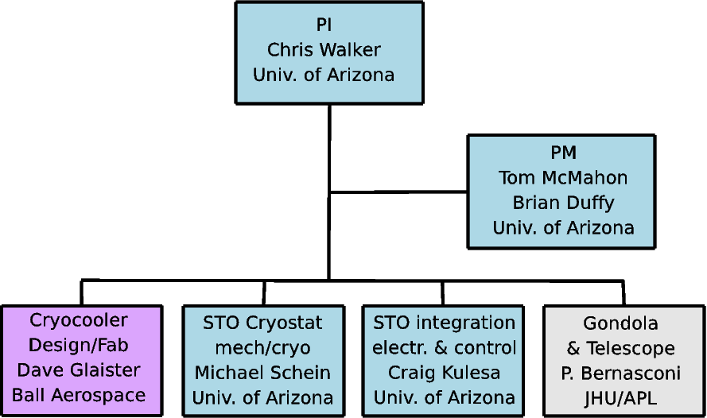
Figure 9. STO ULDB Cryocooler Organization Chart

4.2 Master Schedule

The project network flow diagram in Figure 10 shows the major task elements and the responsible parties.
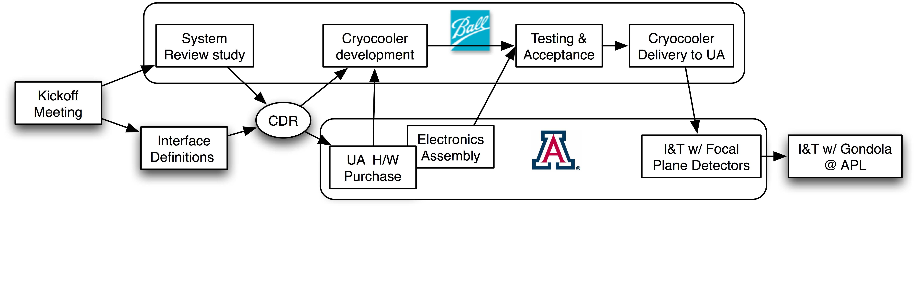

Figure 10: Network Flow Diagram
The master schedule shown in Figure 11 identifies the project's major milestones and development activities. Starting at the January 1, 2010 start date, the project would launch into a focused 6 month risk-reduction phase where all aspects of the cooler design and interface requirements will be carefully reviewed. A Critical Design Review (CDR) will be conducted in mid-June 2010. The scope of the CDR covers the entire cryogenic system and its implementation on STO. During the 12 months following the CDR, all required components for the cryocooler are procured or fabricated, integrated, and tested. To reduce cost, the UofA will procure the off-the-shelf components for the system and assemble the cooler drive electronics using existing Ball designs. The drive electronics will be built by the UofA to balloon thermal, launch load, and operating condition specifications and provide the necessary mechanical and electrical interface to the STO gondola. Ball will assemble the cryocooler itself and verify its performance using the drive system built at the UofA. Integration of the cryocooler into the STO flight cryostat will occur between June and December 2011. Performance tests of the STO focal plane detectors with the upgraded cryogenic system will take place at the UofA from January to June 2012, after which the instrument will be sent to APL for integration into the STO gondola.

A separate proposal will be submitted to the suborbital program in March-April 2011 to support an extended (~40 day) Antarctic flight of STO in December 2012.

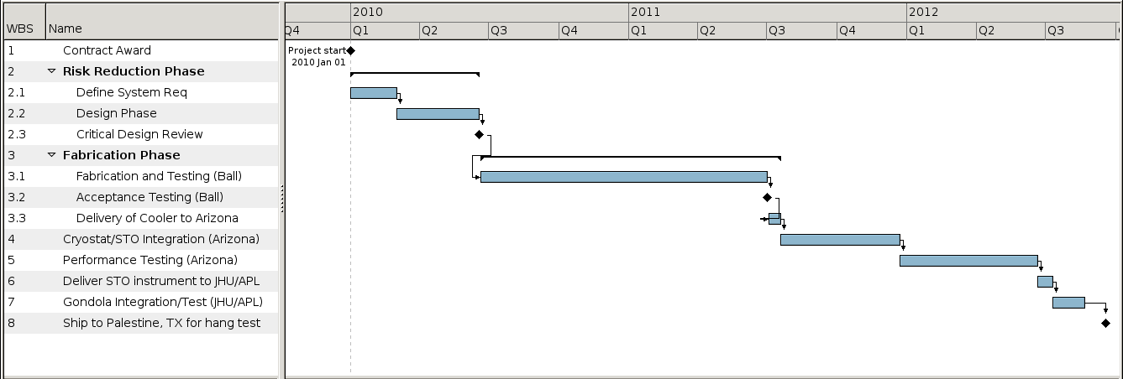
Figure 11. Project Schedule

References

¹Masi, S., Cardoni, P., de Bernardis, P., Piacentini, F., Raccanelli, A., Scaramuzzi, F., 1999, `` A Long Duration Cryostat Suitable for Balloon Borne Photometry’’, Cryogenics, 39, 217.

²Walker, C. K., Kulesa, C. A., Groppi, C. E, Young,, E. T., McMahon, T., Bernasconi, P.,. Lisse, C., Neufeld, D, Hollenbach, D., Kawamura, J., Goldsmith, P., Langer, W.,. Yorke, H., Sterne, J.,
Skalar, A., Mehdi, I., Weinreb, S., Kooi, J., Stutzki, J., Graf, U.,, Honingh, N., Puetz, P.,
Martin, C., Wolfire, M., 2008, ``The Stratospheric TeraHertz Observatory’’ in Proceedings of 19th International Symposium on Space Terahertz Technology, ed. Wolfgang Wild, Groningen, 28-30 April 2008, (https://www.sron.nl/files/LEA/ISSTT2008/Proceedings_ISSTT2008.pdf), p.28.

³ Wolfire, M.G., McKee, C.F., Hollenbach, D., & Tielens, A.G.G.M., “
Neutral Atomic Phases of the Interstellar Medium in the Galaxy”, 2003, ApJ, 587, 278

⁴ Leroy, A., Bolatto, A.D., Stanimirovic, S., Sandstrom, K., Simon, J.D., Bot, C., Shah, R., & Jackson, J.M., “Dust, Atomic, and Molecular Gas in the Nearest Primitive Environment”, 2008, Infrared Diagnostics of Galaxy Evolution, 381, 173

⁵ Benford, et al., “First astronomical use of multiplexed Transition Edge Bolometers”, LOW TEMPERATURE DETECTORS: Ninth International Workshop on Low Temperature Detectors. AIP Conference Proceedings, Volume 605, pp. 589-592 (2002).

6 Day, Peter K., LeDuc, Henry G., Mazin, Benjamin A., Vayonakis, A., & Zmudzinas, J., "A broadband superconducting detector suitable for in large arrays" (2003), Nature 425, 817.

