X axis motor (nearest window) moves
tip/tilt pickoff mirror in the direction shown
by the arrow
CCW
CW

Y axis motor moves tip tilt mirror UP toward the
motor feedthroughs if turned CW and DOWN towards
the cold plate if CCW

The motion of the tip/tilt mirror can be viewed with the science camera. The motion of the occulting mirror seen on the PC screen is as follows:
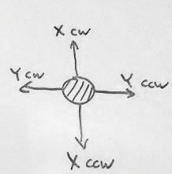

The conclusion is that:

“DOWN” on the array is “away from the t/t array”
“UP” on the array is “toward the t/t array”
“RIGHT” is down and toward the cold plate
“LEFT” is up and away from the cold plate

Seeing the center of the faux-slit mirror in the middle of the TOP/RIGHT detector quadrant would mean that the centroid is down and left of the mirror center. That means it's away from the tip/tilt detector and high, away from the cold plate, w.r.t. the slit center. How does this propagate to the slit plane?

