Photo of “empty” ARIES top spectrometer vessel ...and with a notional 135x265mm grating in place...
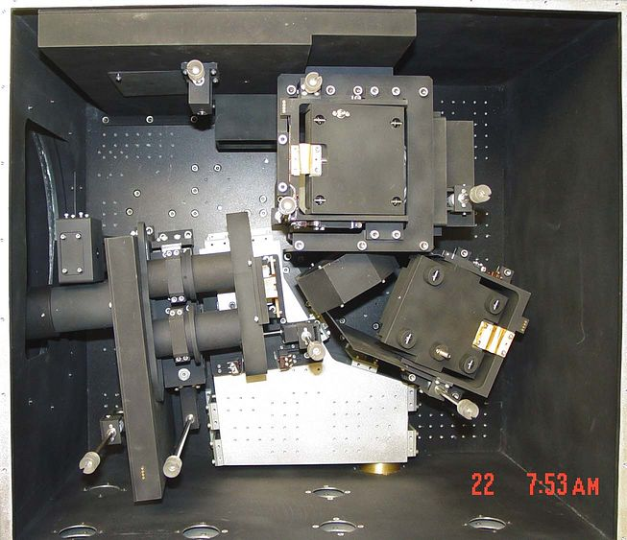
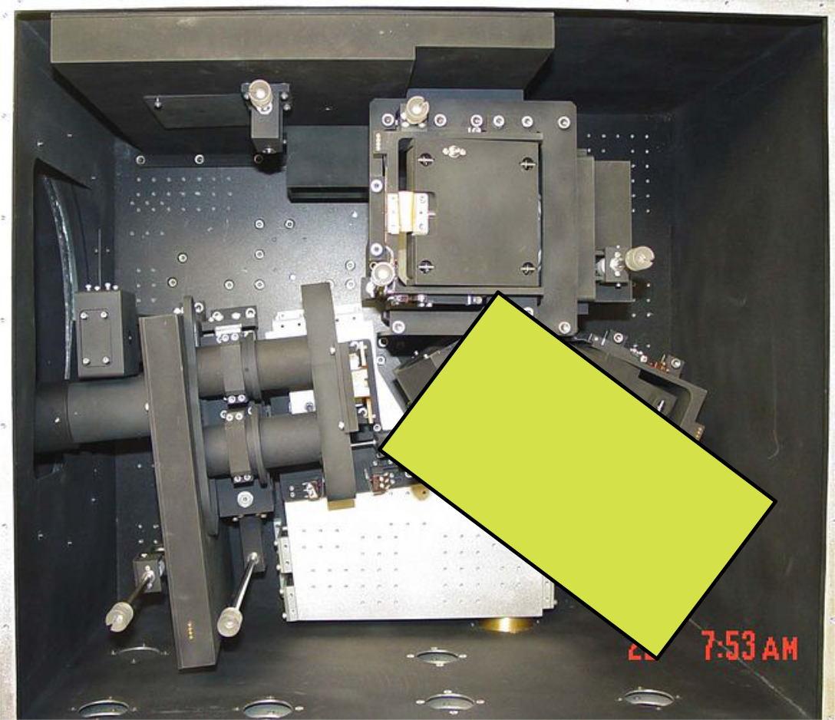

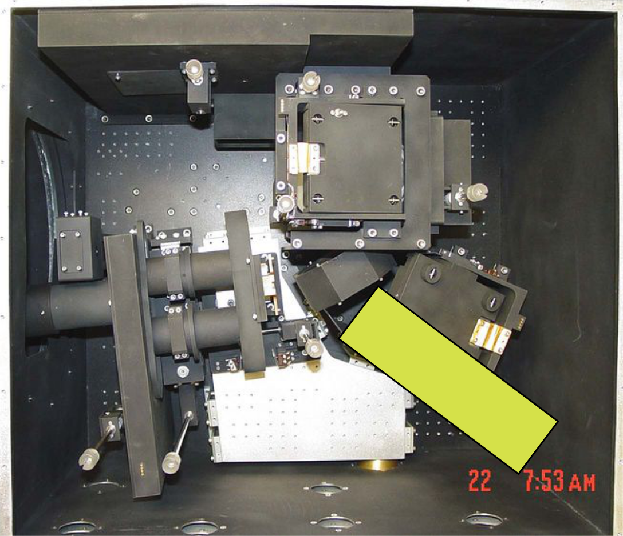

Strict adherence to the collimated beam projected onto the 81 deg grating may work

especially if we can move the prism mount deeper into the grating selection mirror assembly

