ARIES Upgrade Plan for MAPS
Draft 4, rev 5/18/2022

Executive Summary:

To support MMT-AO development and science as embodied in the MAPS proposal, a minimal ARIES upgrade plan is proposed. This plan maximizes the science return from the instrument on an accelerated schedule that yields an instrument that can be commissioned on-sky with the new f/15 secondary in January 2023. Pisces can be substituted as a first light imager for runs prior to January 2023. The implementation of a ZnSe+sapphire cross-dispersing prism, a long-wave 1-5 um H2RG detector, improved video processing, reworked through-slits in silicon, and an integrated calibration unit is suggested. The deliverable of this effort would be a well-characterized echelle spectrometer with steerable, high-bandwidth coverage from 1-5 um at R=30,000 with a 0.2”-wide slit and an optimized “zoom mode” with a 0.14”-wide slit at R~50,000. Existing long-slit, low-dispersion spectroscopy and AO imaging capabilities should ideally be preserved.

Requirements & Assumptions

- The MMT AdSec overhaul understandably dominates the MAPS effort. ARIES must provide an attractive upgrade path that meets MAPS science goals with a non-distracting budget (<10% of the total).
- A suitable H2RG FPA must be available from NIRCAM on this timescale.
- Practical use of the long-wave IR response must be realized (effective means of sky subtraction, etc.).
- Data taken with the upgraded instrument must be readily usable for MAPS science. Potential upgrades to ARIES operations include spilt-light slit guiding, seeing-limited slits, and a contemporaneous, remotely-operated calibration (flats+arcs) capability. Quicklook data visualization, data processing scripts, enroute to a full pipeline, should be made available.
- The highest possible instantaneous bandwidth at the highest practical dispersion is desired by the well-reviewed MAPS science case. The full MAPS implementation requests 1) a new R6 echelle grating to replace the current R2 grating, 2) ZnSe+Sapphire cross-dispersing prism to level the order placement and 3) new f/9 optics to provide a higher resolution “zoom mode”.

Descoping the minimal MAPS upgrade for ARIES

Upgrade | Enables What Capabilities? | Risk / Effort / Cost Assessment | Recommendation
H2RG LWIR array | 1-5 um sensitivity, wider FoV | Low / Medium / Low | Pursue
New f/9 optics | Zoom mode for H2RG, R=50,000 with R2 grating | Low / Med / Med | Pursue
ZnSe + Al₂O₃ cross-disperser | Better spacing of orders on array, allow BG subtraction on longer slit for LM bands. | Med / Med / High | Pursue
R6 echelle grating | Yields higher dispersion (R=65,000 to 130,000) with good order placement | High / High / High | Defer
In-house thru-slits in Si | Better delivered spectral resolution and throughput, cheap fabrication | Low / Medium / Low | Pursue,  best effort basis
Calibration unit atop ARIES | Flat-field data in-situ with low observational overhead and much better quality | Low / Med / Med | Pursue
2nd axis adjustment of echelle grating | Selection of YJHK or KLM bands without opening instrument | Med / Med / Low | Pursue
Spilt-light slit guiding | Better tracking, especially through transit | Low / Med / Low | Pursue,  best effort basis
Improve electronics integration | Make ARIES supportable at telescope. Broaden support team | Low / Med / Low | Pursue
Data reduction pipeline | More efficient pathway to publication | Low / Med / Med | Pursue,  best effort basis

Descoping the R6 grating
All major O/IR spectrometers use R2 gratings. Going to higher incidence angle, particularly to an R6 grating, represents significant technical risk. Such gratings are exceptionally unforgiving of any ruling defects. Diamond tool wear can generate ghosts which become a problem for the larger substrates. However, larger substrates are required since the grating appears quite short in projection at an 80.7 degree incidence angle. Operation at Littrow is a strong requirement; deviations from Littrow rapidly yield facet shadowing, and distortions such as line curvature, line tilt, and anamorphism.

Since this represents a relatively high cost effort with significant technical risk, deferring to Phase II is recommended.

Maintaining cross-disperser upgrade and new slits on best effort basis
The current silicon cross-disperser provides order spacing that becomes ever more tightly compressed at long wavelengths. Unfortunately this is the opposite of the desired order placement – it is the L and M bands which want the longest slit to allow background subtraction along-the-slit. This can be better accommodated with the proposed ZnSe+sapphire cross disperser. Fabrication of thru-slits in silicon can be performed either on campus or via outside vendor and will allow better spectral resolution and throughput, in addition to providing slits that match the new cross-disperser.
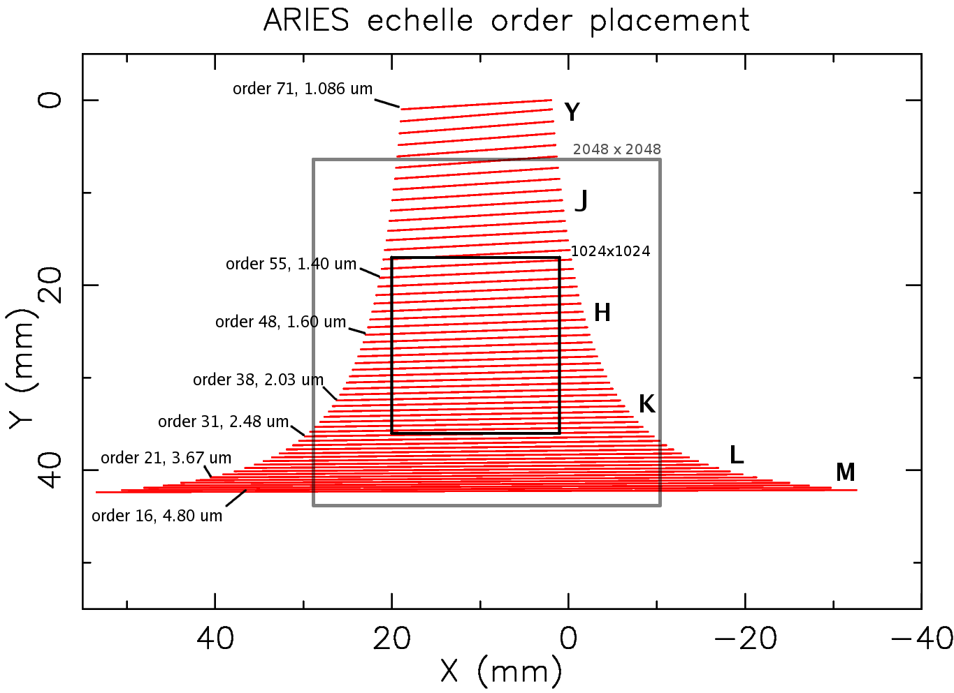Figure 1: Current ARIES echelle order layout with the footprints of a H1 and H2RG FPA overlaid.
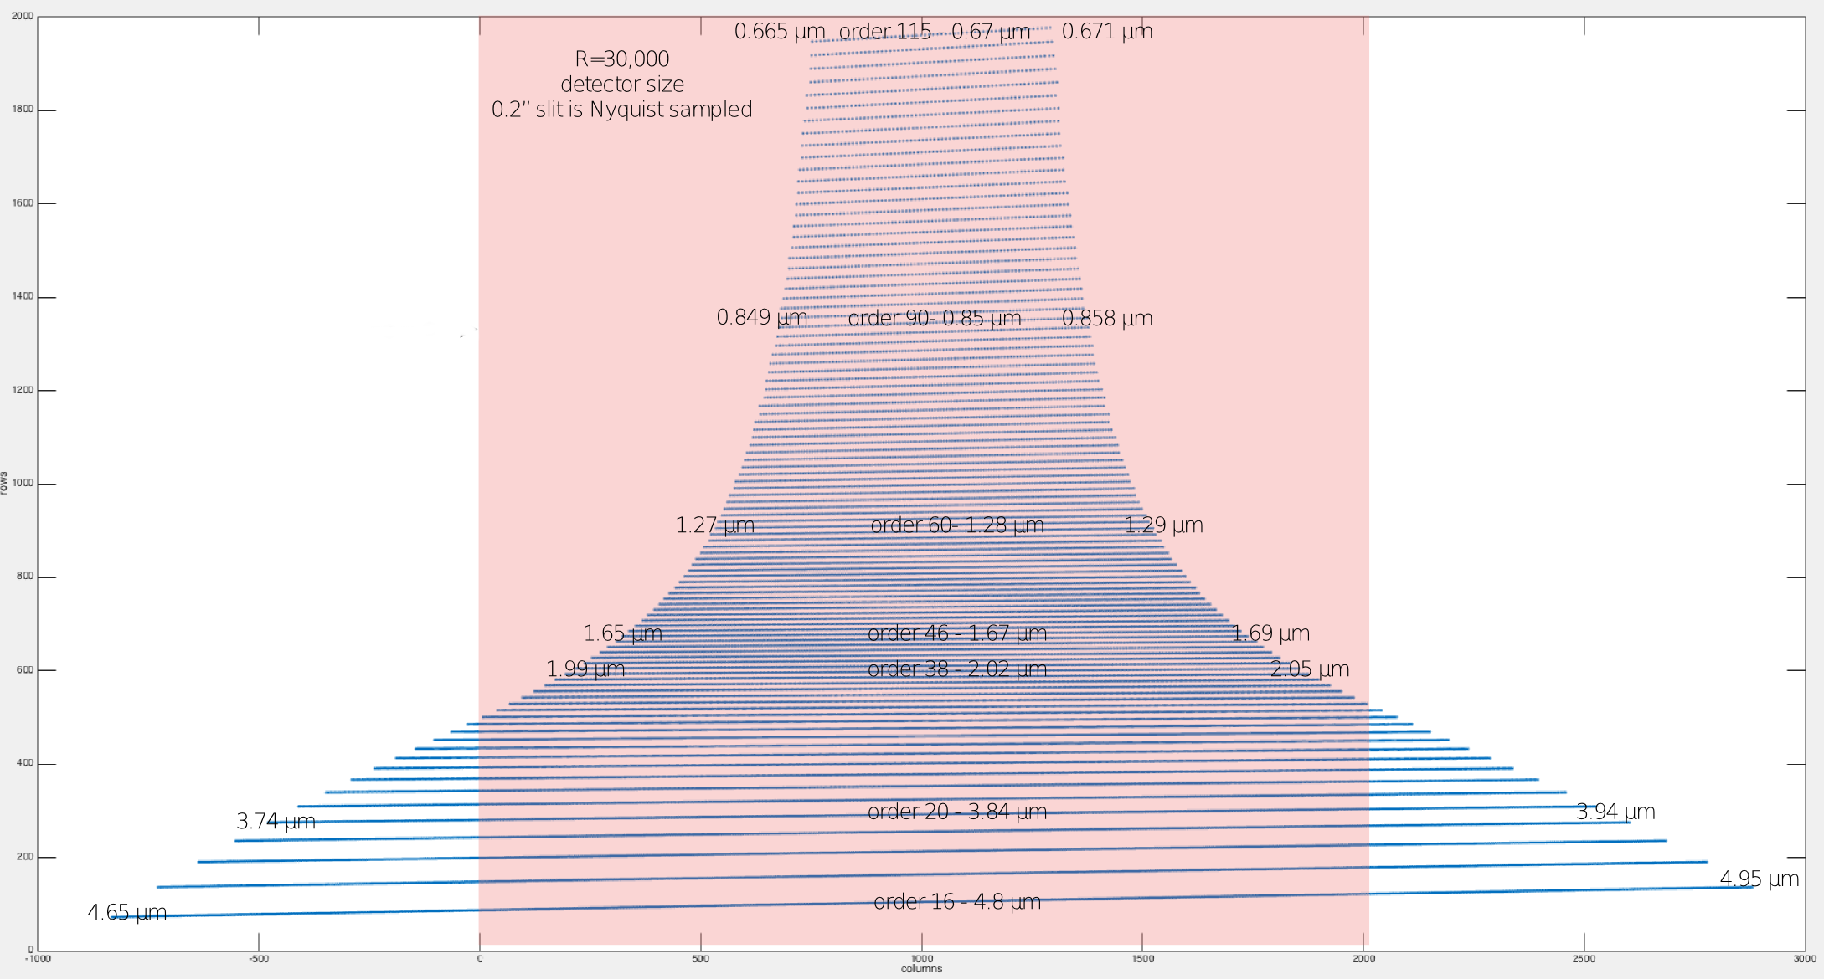Figure 2: Order layout for a putative ZnSe-Al₂O₃ cross-disperser (from P. Hinz). This dispersion is a bit too tight but can be optimized to pass 1.0-4.8 um at R=30,000 with an f/11 zoom mode at R=60,000 while allowing for background subtraction along-the-slit at L and M bands.

Draft Schedule

The following draft schedule shows a draft development profile that begins in earnest Summer 2022 and ends in time for a January 2023 run at the MMT. Pisces will serve as a replacement for ARIES for any earlier MMT runs.

Estimate of WBS-3 labor hours
Role | Nominal assignment | CBE hours, no reserve
Systems/Software/Integration | Craig Kulesa | 540
Optical Engineering (OE) | Oli Durney | 320
Mechanical Engineering (ME) | Elliot Solheid (LBT) or TBD | 400
Electronics Tech (ElectT) | Ken Don | 40
Machinist | Mitch Nash  or URIC or UCryo | 260

Month by month activity and procurement schedule
Month | Detector Activity | Optical Activity | Mechanical Activity | Integration Activity
Jun 2022 | - H1 to H2RG electronics preparation  - DSP and userspace coding for H2RG | - Critical prism design (prep for procurement)  - Begin f/9 optics  - Placement of echelle grating for MechE | - Mechanical design of prism mount  - Mechanical design of echelle mount  -Design calibration slider and window | -AVC cryocooler controller, $6k  - Procure new cryocooler controller
Jul 2022 |  | - Prism goes out for procurement  - f/9 optics design finalized, procurement started  - Procure new AR-coated window | - Continue prior activities  - Begin fab for prism mount  - New window mount  - Identify slit mfr and process | -Design of electronics consolidation effort  and procurement  - Replacement motors and/or controllers  - Calibration unit redesign and procurement  - Spares assessment
Aug 2022 | Cold testing of SWIR and then LWIR array | - Procurement complete for f/9 zoom optics | -Assemble calibration unit  - begin fab for echelle mount  - f/9 optics mounts  - Slit development
Sep 2022 | Detector reserve | Optical reserve | - mounts out for fab | Integration reserve
Oct 2022 | Prep dewar for internal rework |  | - deliver mounts and reworked shields for integration  - slit development | - Integrate calibration unit and warm test  - Cryostat open: Optics integration begins
Nov 2022 |  |  | Mechanical reserve | - Optics integration and laser alignment continues  - initial cold test likely  - Rackmount electronics I&T
Dec 2022 |  |  |  | - Closeout remaining dewar items  - cold testing  - software I&T
Jan 2022 |  |  |  | Integration reserve.  System ready to install

WBS 3.1
F/9 focal expander to support R>45,000 operations

Statement of purpose:
ARIES currently supports a spectroscopic “zoom mode” that is comprised of a 2-element refractive focal expander comprised of one BaF2 lens and one ZnSe lens immediately in front of the Hawaii-1 detector array (Figure 3), built into the baffle tube separating the filter wheel and the detector mount. An adjacent empty baffle tube supports the nominal f/5.6 focus using only the 3-mirror reflective camera and a 2-pixel resolving power of about R=33,000 with a 0.2” slit. The refractive camera yields an f/10.3 focus and a resolving power that varies somewhat across the array because of field distortion (Figure 4) but in the range of R=60,000 with a 2-pixel 0.1” slit.

The existing f/10.3 optics serve to illuminate the field of a 1024x1024 HgCdTe array with significant but deterministic field distortion. However, the working field of view must now be expanded to accommodate a larger 2048x2048 array.

One recommendation is to start with the current R=30,000 zemax model, the f/10.3 two-lens reimager model, and modify the optical prescription (larger lenses, re-optimization of curvatures) to illuminate as much of a 2048x2048 array as possible at R>45,000 with a 2-pixel 0.14” slit, minimizing field distortion (e.g. no worse than Figure 4) while possibly preserving the ability to utilize the existing optics slide stage. If insufficient, the existing 2-element lens design can be replaced with an alternate design.

Flow of effort:
- Examine and understand the existing R=30,000 echelle design. Determine the limiting source(s) of vignetting on the 2048x2048 array and recommend any modest 1-element changes that will yield a significant improvement in FoV.
- Apply a 2-lens BaF2 and ZnSe pair per the current f/10.3 zemax model and adjust to increase the effective field of view, taking f/10 to f/11 as the desired output f#.
- Explore trade study of solutions versus output f# and field distortion over the 2048x2048 array.
- Determine if the existing baffle tube stage can accommodate on-the-fly switching between R=30,000 and R=50,000.
- Transfer optical design to CAD and handoff to Mechanical to make necessary mechanical alterations to baffle tubes, optics stage, mechanical feedthrus as needed.
- Identify a vendor for the optical substrates, figuring, and 1-5 um AR coating.

Inputs available now:
- Zemax R=30,000 f/5.6 optical model and “probably not current” f/10.3 optical model
- Mechanical throw of existing optical stage

Requirements:
- Illumination of 2048x2048 HgCdTe array with 18 um pixels.
- R>45,000 with 2 pixel, 0.14” slit
- <10% field distortion over the whole field
- If possible, preserve ability to switch between R=30,000 and R=50,000 on the fly using (existing?) optics stage. This is important to preserve non-MAPS science modes.
Any conflicts in requirements should be resolved by trade study, to illuminate the best path forward.
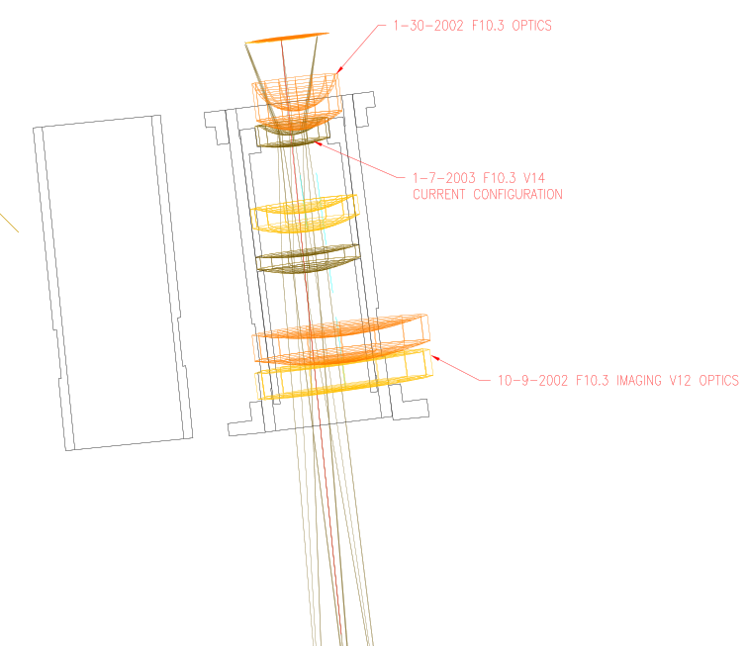
Figure 3: Overlay of zemax optical path for v14 of the refractive f/10.3 baffle tube. Three configurations are shown; ignore all but the CURRENT CONFIGURATION in green.
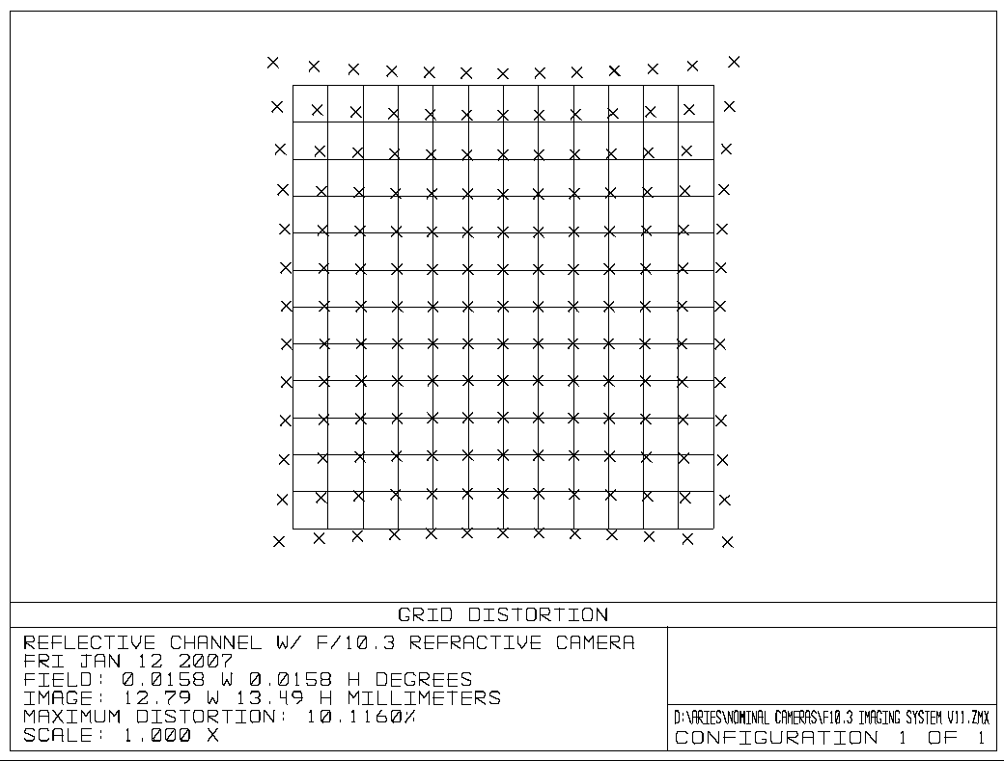
Figure 4: Field distortion of the current f/10.3 refractive focal expander in zemax

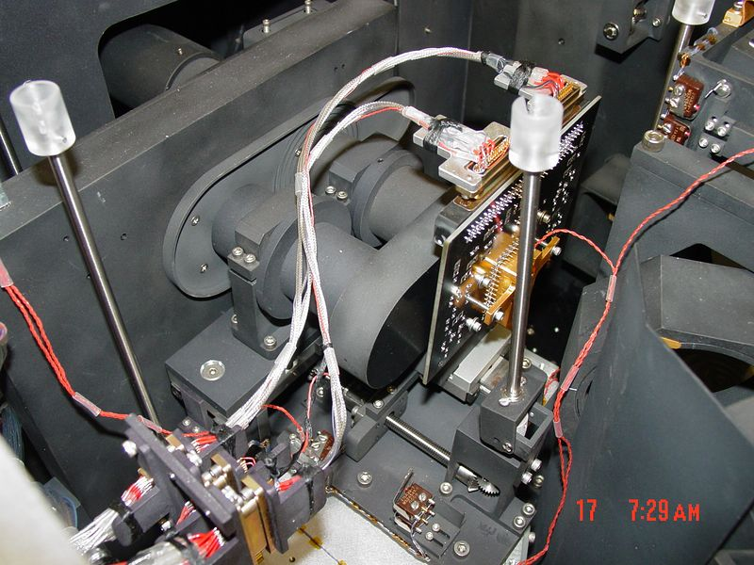Figure 5: Photo of installed filterwheel, dual baffle tubes, optics slide stage, and H1 detector fanout board.

Labor Estimate:

Optical design: 160 hours
Mechanical design: 160 hours
Machining: 80-120 hours
Integration: 80 hours

WBS 3.2
New Cross-dispersing Prism and mount for echelle grating

Statement of purpose:
ARIES currently cross-disperses its echelle spectrum with an AR-coated silicon prism. While this supports adequate cross-dispersion at short wavelengths, the orders pile up at 3-5 microns as the change in index of refraction decreases at long wavelengths (Figure 1). However, the opposite condition is more desirable, since there is considerable sky emission long-ward of K-band and nodding along the slit is essentially required, requiring a >1.5” slit length.

A hybrid ZnSe-Al₂O₃ cross-disperser could provide a more optimal arrangement of orders (Figure 2). Assessing the suitability of this design change and implementing it is the goal of this work effort.

Flow of effort:
- Explore the basic elements and trades of a ZnSe-Al₂O₃ cross-disperser and determine if the concept is realizable. Items to explore:
  - Trades to achieve 2” slit length at L & M bands (3-5 microns)
  - Optical throughput bare and AR-coated
  - Prism deviation angle; physically compatible with ARIES? See Figure 7 for the current prism.
  - Substrate availability and AR coating design, vendors. Who would make it?
- If design remains tractable, document best design including tolerances, begin procurement of all long-lead items and transfer effort to mechanical lead.
- Design opto-mechanical design for new prism mount, if required.
- Design new echelle grating mount with reduced backlash and 2-axis adjustment.
- Review overall opto-mechanical plan and begin fabrication, integration, and test.

Inputs available now:
- Zemax R=30,000 f/5.6 optical model

Requirements:
- 2” slit length desirable at L & M bands, with minimum of 1” length elsewhere
- Low-backlash, stable echelle grating mount with 2-axis adjustment. Current mount has 1-axis.

Labor Estimate:

Optical design: 160 hours
Mechanical design: 160 hours
Machining: 100 hours
Integration: 100 hours

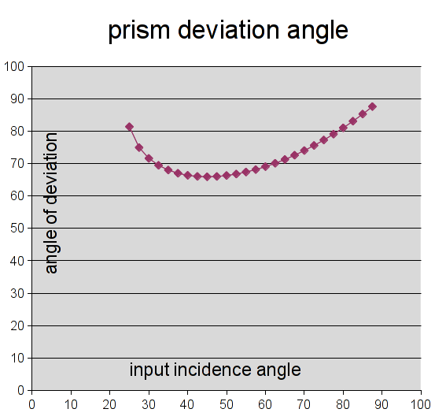Figure 7: Plot of deviation angle for the current silicon prism
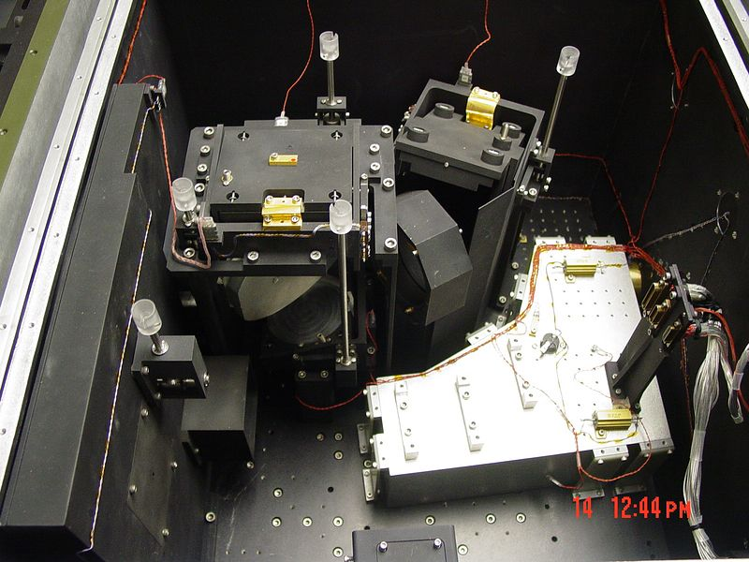
Figure 6: Grating selection mirror, prism mount, and echelle grating mount in the ARIES cryostat.

WBS 3.3
Calibration System

Statement of purpose:
ARIES currently has no way to perform automated science calibration observations for spectroscopy. This would include observations of arc lamps for spectral-line calibration and continuum sources for flat-fielding. Given that there is some level of flexure in the instrument, these observations might need to be taken at regular intervals during the night in addition to the morning/afternoon timeframes.

Such calibration sources are typically a part of the “top box” interface between the science instrument and the telescope, but the NGS AO top box does not have a spectroscopic calibration capability.

Adding this module to the top of ARIES, to fit in the optical path above the dichroic and below any AO topbox mechanical or optical elements, is the goal of this effort.

Flow of effort:
- Determine “keepout zones” for the mechanical implementation, add arc and continuum lamps, and motorized linear track to drive pickoff mirrors into/out-of position.
- Design mounts to affix the calibration unit to ARIES. May require drilling into dewar case or a simple “clamp” interface may be sufficient.

Inputs available:
- ARIES case CAD model
- AO topbox model
- Arc lamp is available

Requirements:
- 1-track motorized pickoff mirror to direct f/15 beam of calibration lamps to dichroic.
- System cannot machanically interfere with the existing AO topbox.
- ARIES’ computer controlled AC switch used to activate elements of the calibration system under s/w control.
- Calibration system should be magnetically retained in the “out of beam” position so that the system can be completely powered off when not in use.

Labor Estimate:

Optical design: 0 hours
Mechanical design: 40 hours
Machining: 0-40 hours
Integration: 80 hours

WBS 3.4
Supporting electronics consolidation & simplification

Statement of purpose:
ARIES has a number of supporting electronics modules installed into a standalone rack >10m from the instrument and connected by massive cabling harnesses. While functional, these elements complicate ARIES’ integration onto the telescope and frustrate automated operation.

The goal is to eliminate the standalone rack and all cable harness runs, and integrate them into a single 3U module which can be installed onto the instrument itself. This would reduce the number of required cable runs through the MMT cable tray to 1) one Ethernet connection and 2) one A/C power connection. If a mounting plate were to be devoted to ARIES, the instrument could be installed with two cables and 6 bolts, which goes a long way toward making ARIES a more facility-like instrument and one that could be (de)installed by MMT staff.

Flow of effort:
- Install Sunpower AVC into shielded box with 15A/28VDC supply with direct connection to control computer or serial terminal.
- Consolidate motor controllers to either a single 2U box or onto a wire-frame of smart motors and cables directly installed onto the cryostat. We can simplify the system by only operating one motor at a time.
- Install computer-controlled AC switch to support remote control of all elements of ARIES.
- Integrate control software to support seamless use of the new system and support easy remote monitoring via the web.

Requirements:
- System cannot introduce pickup noise to the detector system.
- System must have lower power consumption than the current system.
- A smart-motor setup (e.g. Schneider Electric Motion) must have self-contained connector and cabling so that the motors can be removed to allow opening of the cryostat.

Labor Estimate:

Optical design: 0 hours
Mechanical design: 40 hours
Machining: 0-40 hours
Integration/Software: 160 hours

WBS 3.5
Long-wave H2RG integration

Statement of purpose:
ARIES currently uses a 1024x1024 1-2.5 um H1 array for spectroscopy. MAPS science requires full 1-5 um operations; maximizing instantaneous bandwidth requires a 2048x2048 H2RG array. This array will be allocated from the NIRCAM spares and several potential arrays are available.

Flow of effort:
- Install temporary short-wave H2RG into ARIES and perform warm tests using existing GenIII SDSU electronics.
- Perform cold testing of the SWIR H2RG array.
- Acquire the ‘final’ LWIR array and install it into the ARIES H2RG mount
- Perform cold testing and optimization of the LWIR H2RG array.

Requirements:
- Read noise must not be higher than the current H1 setup (~20 e-)
- Well depth and readout speed must be consistent with ground-based requirements for saturation and linearity. Expecting to use a 300 kHz read clock for ~3 second minimum integrations
- Crosstalk must be managed and corrected in software.
- Subarray readout firmware to be explored on a best effort basis

Labor Estimate:

Optical design: 0 hours
Mechanical design: 0 hours
Machining: 0 hours
Integration/Software: 160 hours

