Current Status and Performance of the ARIES echelle mode
C. Kulesa, 10 July 2008

The ARIES echelle mode has undergone continuous adjustment since its first light in December 2006. A coarse figure showing the most useful alignments of the current HAWAII-1 1024x1024 array is shown in Figures 1-2 below. The black rectangle in each figure represents the focal plane array footprint. The grating is motorized in one axis and can move left and right in the diagram. It is possible to move the array footprint up and down (as shown in the two figures) by making optical alterations inside the cryostat between observing runs.
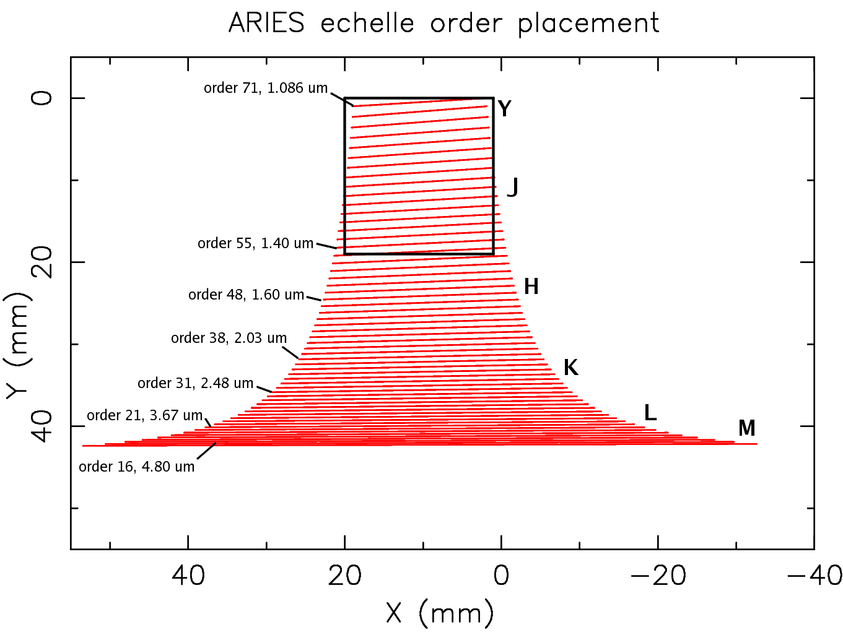Figure 1: Alignment of the 1024² focal plane array for near-contiguous instantaneous coverage of the Y and J bands.
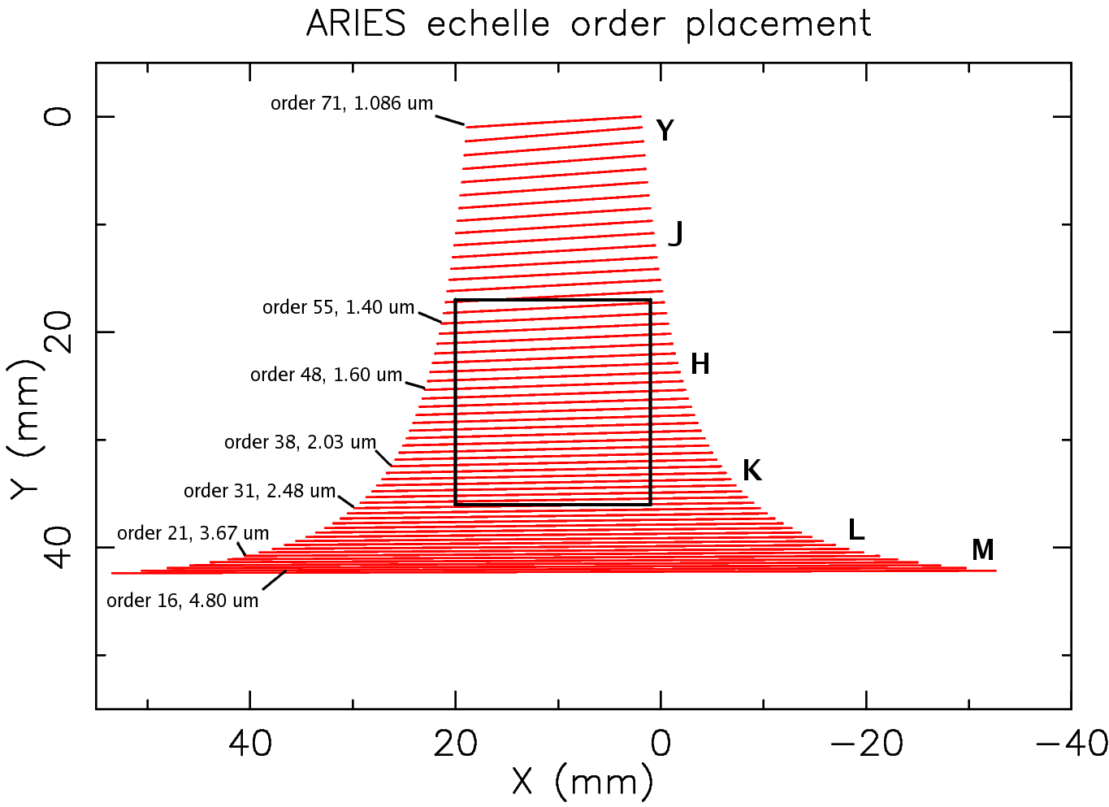Figure 2: Alignment of the 1024² focal plane array for coverage of the long-J, H, and K bands in two grating settings.
Initial laboratory and first-light measurements at the MMT demonstrated that the focal plane array was centered on the KLM bands, and not JHK as originally intended. Thus, most of the effort on the echelle mode in 2007 (McCarthy, Kulesa) has gone into cold testing and evaluation of its optical alignment. As of January 2008, the designed echelle coverage of 1.35 to 2.5 microns was achieved (Figure 2). However, it has not yet seen astronomical light at the MMT because of weather. Additional machining of the echelle grating mount in February and March 2008 allowed extension of the wavelength coverage (Figure 1). In April, the first echelle science run (1.06 to 1.37 microns) was achieved in the Y and J bands for an SAO observing team. Since then, the echelle grating has been returned to its nominal JHK configuration.

Figures 3a-3c demonstrate the echelle orders of a blackbody source seen through standard J, H, and K filters using the default 0.2” wide x 1” long echelle slit. Figure 4 shows the normal unfiltered response.

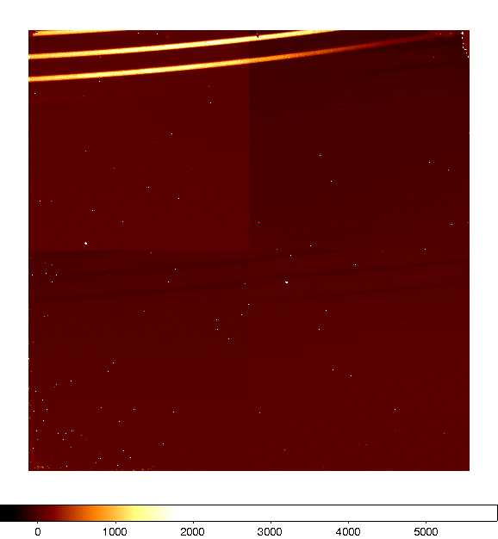Figure 3a: A blackbody source observed through a J-band filter, using the echelle setup in Figure 2.
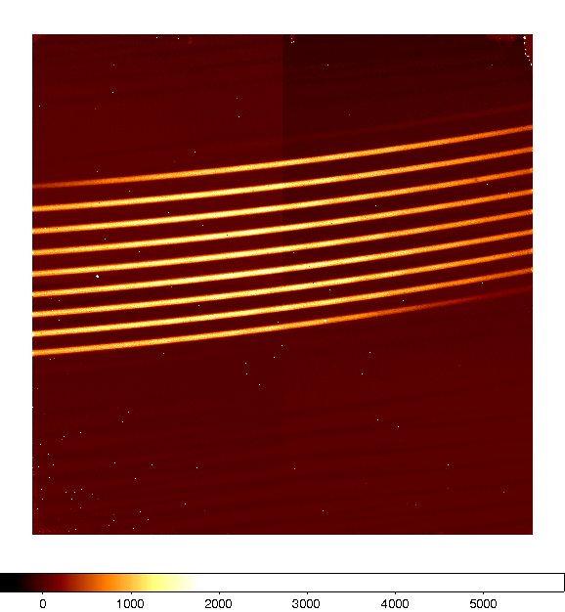Figure 3b: the same blackbody source observed through an H-band filter.
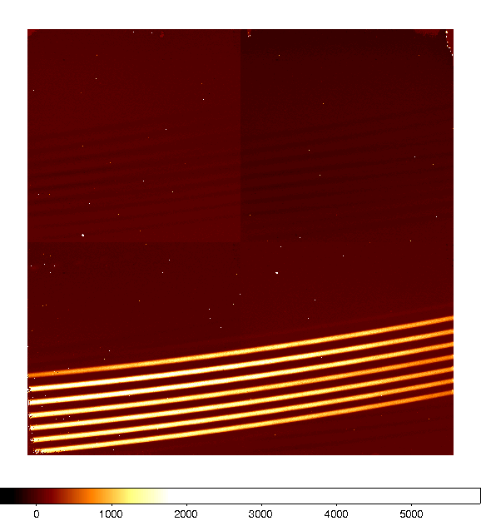Figure 3c: the same blackbody source observed through a K-band filter.
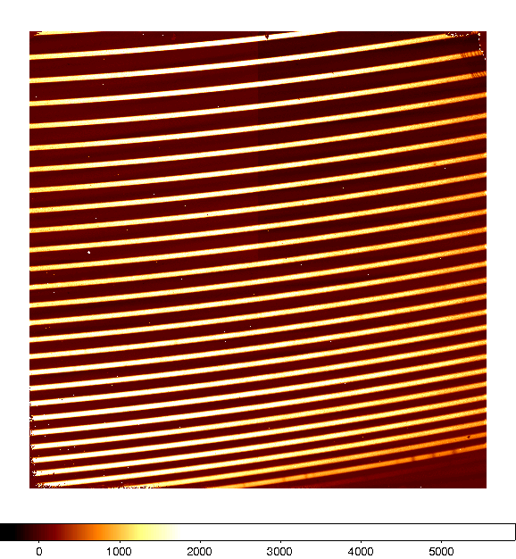Figure 4: Unfiltered blackbody source observed with the JHK alignment of the echelle grating. The loss of light at the bottom-right corner of the array reflects the sensitivity cutoff of the Hawaii-1 HgCdTe FPA at ~2.5 microns.



